SENIOR FIVE TERM 2 PHYSICS 2026

TOPIC 1/7: FLUID MECHANICS
Competency: The learner investigates the effect of molecular forces in fluids, fluid pressure and

their applications in fluid systems.

Surface tension

Common observation explained by surface tension

- A drop of water, on closing a tap remained dinging on the tap, as if the water was held in a bag.
- A thin needle can be made to float on the surface as though it is denser than water
- Mercury gathers in small spherical drops when poured on a smooth surface.
- When a capillary tube is dipped in water, water is seen rising up in a tube
- Insects can walk on the surface of water
- A. Rain water forms beads on the surface of a waxy surface, such as a leaf.
Water adheres weakly to wax and strongly to itself, so water clusters into drops. Surface tension gives them their near-spherical shape, because a sphere has the smallest possible surface area to volume ratio.

All the above observation show that a liquid surface behaves as if it was or it is in a state of tension. The phenomenon is called surface tension.

Surface Tension or Co-efficient of surface tension, γ
Is the force acting at right angle at one side of immaginary line of length 1m drawn in the surface of a liquid.

Or
Surface tension is an energy necessary to create a unit area of a surface under constant temperature, volume and chemical potential.

γ (gamma) 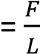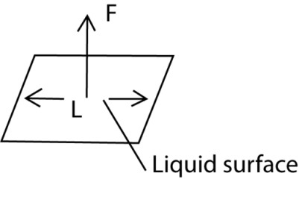
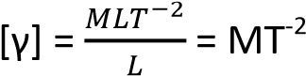
Units = Nm⁻¹

Molecular theory of surface tension The force F(r) between two molecules of a liquid varies with their separation r as shown
below

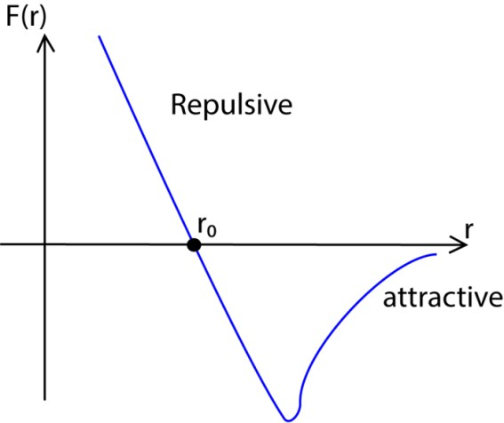
At the average equilibrium separation, r_{o}, F(r) =
0
For r> r₀ = the force is attractive to bring the distance between molecules to equilibrium separation, r₀.
For R < r₀ =the force is repulsive to restore the distance between molecules to equilibrium separation, r₀.

The corresponding potential energy variation
with molecular separation, r, is shown below

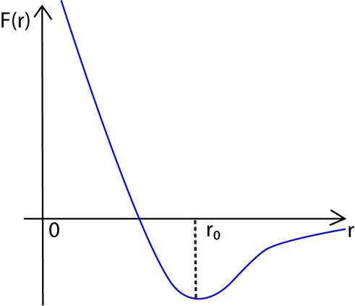

- The molecules within the body of the liquid (bulk) molecules is attracted equally by neighbors in all direction, hence, the force on the bulk molecules is zero, so the intermolecular separation for bulk molecules is r₀.
- For a surface molecules, there is a net inward force because there are no molecules above the surface to attract them equally.

- To the surface, work must be done against the inward attractive force, hence, a molecule in the surface of a liquid has a greater potential energy than a molecule in the bulk. The potential energy stored in molecules at the surface is called free surface energy.

- Molecules at the surface their separation r > r₀. The attractive forces experienced by surface molecules due to their neighbours put them in a state of tension causing the surface to contract and behave as a stretched skin. This tension is called surface
tension

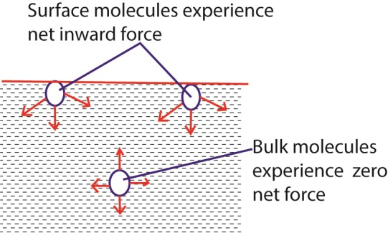

Surface energy and shape of a drop of a liquid

System arrange themselves to chieve the least potntial energy.

In liquids, the least potential energy is achieved by having the fewest number molecules at surface or by contraction of liquid surface to the smallest possible area.

For this reason, free liquid drops are spherical because the sperical shape for any volume of a liquid gives the least surface area.

A large drop however, due to its large weight flattens out in order to mimimize the gravitational potential energy which tends to exceed the surface energy.

Factors affecting surface tension
- High Temperature lowers surface tension of molecules because molecules are far apart and moving faster decreasing time to form temporary bonds.

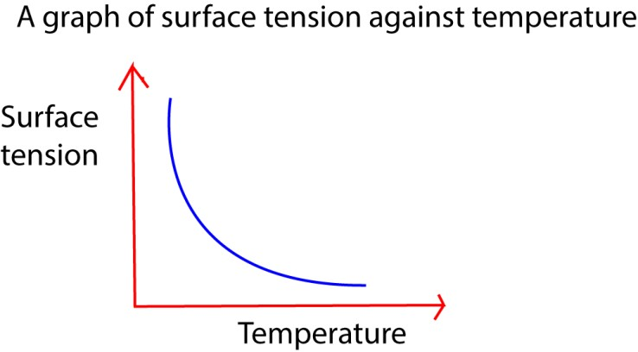

- Impurities: these lower the surface tension forces because they displace molecules from their equilibrium positions and breaking bonds between them.
- Detergents: reduce surface tension because they displace molecules from their equilibrium positions and break bond between them.

Angle of contact
This is the angle made between the solid surface and the tangent to the liquid surface at the point of intersection with the solid surface as measured through the liquid
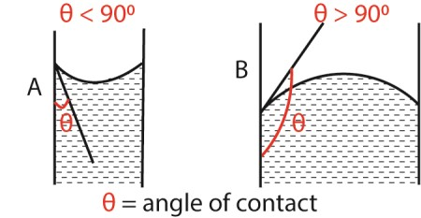

A liquid makes an acute angle of contact with solid surface when the adhesive force between the liquid and the solid are greater than the cohesive forces between the liquid molecules themselves.

A liquid makes an obtuse angle of contact with solid surface when the adhesive force between the liquid and the solid are less than the cohesive forces between the liquid molecules themselves.

A liquid that makes an acute angle with the solid is said to wet the solid surface for example water wets glass. While a liquid that makes obtuse angle with the solid does not wet it, e.g. mercury does not not wet glass but forms droplets on it.

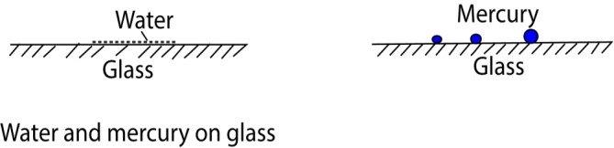

Addition of detergents to water reduces the angle of contact and that is why it helps in washing.

Pressure difference in a bubble or curved surface

(a) Liquid curved surface Consider a bubble formed inside a liquid as shown below

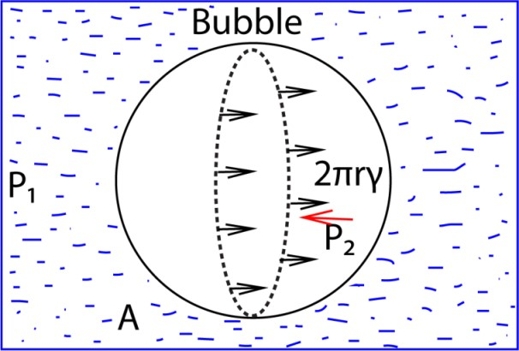

If we consider equilibrium of one half A,

The force of tension on A plus the force on A due to external pressure P₁ = the force on A due to the internal pressure P₂inside the bubble
Force = area x pressure
(since Pressure is force per unit area.)

The force on A due to pressure P₁ = πr² x
P₁ (where πr² is the area of circular face A

and

the force on A due to pressure P₂
= πr² x P₂

The surface tension force acts around the circumference of the bubble which has a
length 2πr, thus the force = 2πrγ

At equilibrium:
2πrγ + πr² x P₁ = πr² x P₂
2γ = r(P2 – P1)
Or 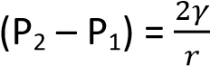

If p = (P₂ – P₁) , the excess pressure in the bubble over outside pressure
Then, p 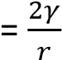 ……………………………… (i)

The same formula for excess pressure holds for any curved liquid surface or meniscus, where r is its radius of curvature and γ is its surface tension, provided the angle of contact is zero.

If the angle of contact is θ, the formula is modified by replacing γ by γcosθ.

Thus in general, excess pressure,
P = 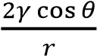 …………………………….. (ii)

(b) Excess pressure in a soap bubble

A soap bubble has two liquid surfaces in contact with air, one inside the bubble and the other outside the bubble.

The force on one half, A, of the bubble due to surfaces is thus = γ x 2πr x 2
= 4πrγ

For equilibrium of A, it follows that;
4πrγ + πr² x P₁ = πr² x P₂
Where P₂ and P₁ are pressure inside and outside the bubble respectively Simplifying
P₂ – P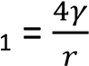
Therefore, excess pressure,
p 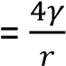 ………………………………………. (3)

Note that,
- the pressure on the concave side of the liquid is always greater than that on a convex side, e.g.

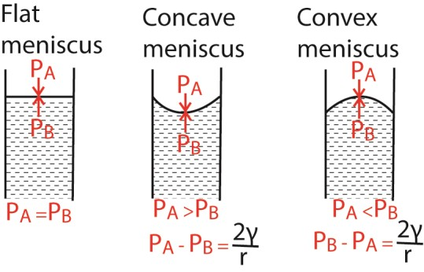
- When the atmospheric pressure exceeds pressure inside the bubble, it collapses.

Capillary rise

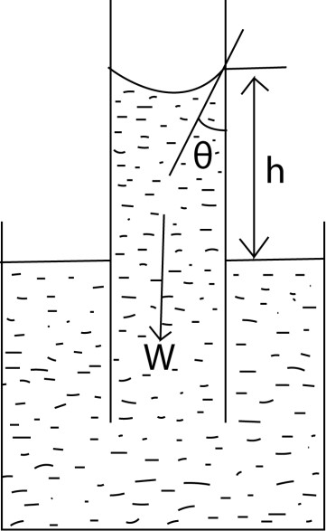

The liquid rises until the vertical component of the upward forces due to surface tension is equal to the weight of the liquid column. Fγcosθ = W γ =
F = γL
L = 2πr
But W = mg and m = Vρ (where ρ is the density of the liquid in kg/m³)
W = vρg = 2πr²hρg
Fγcosθ = 2πr²hρg
γ.2πrcosθ =2πr²hρg h = 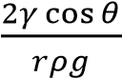 γ – coefficient of surface tension θ – angle of contact r – radius of capillary tube
ρ – density of the liquid

Example 1
A capillary tube is immersed in a liquid of density 13600kgm⁻³ and the angle of contact is 140⁰. Find the capillary rise if the surface tension is 0.52Nm⁻¹ and a diameter of the tube is 0.32mm
h = 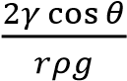
h = 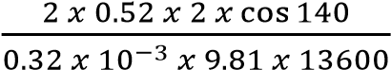
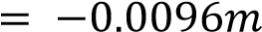
the negative implies there was a capillary depression of 0.0096m

Example 2
- Define what is meant by surface tension in terms of surface energy.
- (i)Calculate the work done against surface tension in blowing a soap bubble of diameter 15mm if the surface tension of the soap bubble is
3 x 10⁻²N/m
  - A soap bubble of radius r₁ is attached to another bubble of radius r₂. If r₁ is less than r₂, show that the radius of curvature of the common interface is
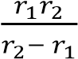
- (i) Sketch a graph of potential energy against separation of two molecules in
the liquid of a substance.
  - Explain the main features of the graph in(c)(i)

Solution
- Surface tension is an energy necessary to create a unit area of a surface under constant emperature, volume and chemical potential.
- (i) Work done
= surface tension x increase in surface area
Surface Area of a sphere = 4πr²
The soap buble has two surface in contact with air, and thus its surface area = 2 x 4πr²
increase in surface of the soap bubble
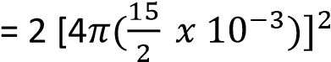
Hence work done
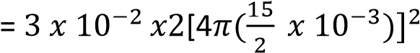
= 4.24 x 10⁻⁷J

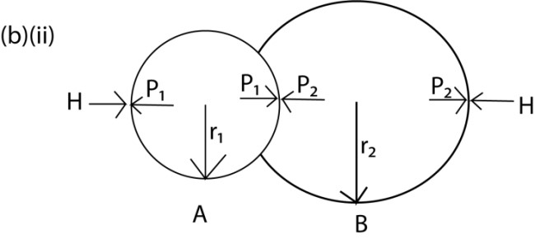
For Bubble of radius r₁: P₁ – H = 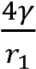 …………………………….. (i)
For bubble of radius r²:
P₂ – H = 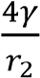 …………………………….. (ii)
Since r₁< r₂; P₁> P₂
From equations (i) and (ii)
P₁ – P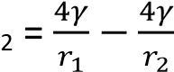 …………………… (iii)
But
P₁ – P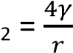 ……………………….. (iv)
From equation (iii) and (iv)

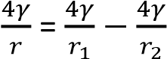

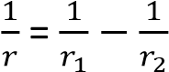

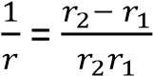

r = 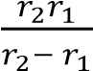

(c)(i)

(c)(ii) At r = r₀, the resultant force is zero and the corresponding potential energy is minimum. So r₀ is the equilibrium separation

For r < r₀, the net force is repulsive, whereas r > r₀, the net force is attractive in order to restore the e separation to the equilibrium separation of r₀.

Example 3
- Define surface tension and derive its dimensions
- Explain using the molecular theory, the occurrence of surface tension
- Describe an experiment to measure surface tension of a liquid by capillary tube method.
- (i) Show that the excessive pressure in a soap bubble is given by P = 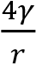
(ii) Calculate the total pressure within the bubble of air of radius 0.1mm in water if the bubble is formed 10cm below the water surface. And the surface tension of water is 7.27 x 102
N/m.(atmospheric pressure = 1.01 x
10⁵Pa)

Solution
Let the pressure at 10cm below the water surface be P’ P’ = H + hρg
= 1.01 x 10⁵Pa + 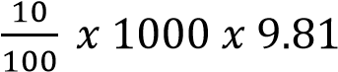
= 101981Pa
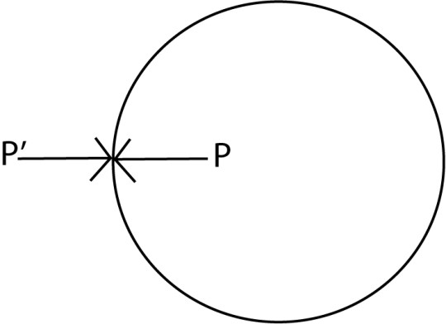
Excess pressure = P – P’, where P is the pressure inside the bubble
P = 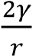 + P’
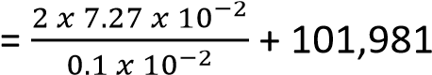
= 1.03 x 10⁵Pa

Revision exercise 1

- (a) (i) Define the term surface tension and angle constant. (02marks)
  - Surface tension is the force per metre length acting in the surface at right angles to one side of the line drawn in the surface.
  - Angle of contact is the angle between the solid surface and the tangent
plane to the liquid surface measured through the liquid.

(ii) Account for the temperature dependency of surface tension. (03marks)
Increase in temperatures increases the kinetic energy of liquid molecules and thus reduces the cohesive force and/or van der Waal forces among the molecules of the liquid thereby lowering the surface tension.
(b) When a capillary tube is held in a vertical position with one end just dipping in a liquid of surface tension, γ, and density, ρ, the liquid rises to a height h. Derive an expression for h in terms of γ, ρ and radius, r of the tube. Assume the angle of contact is zero. (04 marks)
The liquid rises until the vertical component of the upward forces due to surface tension is equal to the weight of the liquid column.
Fγcosθ = W but θ = 0 ⇨ Fγ = W γ =
F = γL
L = 2πr
But W = mg and m = Vρ (where ρ is the density of the liquid in kg/m³) W = vρg = 2πr²hρg
Fγ = 2πr²hρg
γ.2πr =2πr²hρg
h = 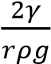 γ – coefficient of surface tension θ – angle of contact r – radius of capillary tube
ρ – density of the liquid

- (i) A capillary tube is held in a vertical position with one end dipping in a liquid of surface tension γ and density ρ. If the liquid rises to a height, h, derive an expression for h in terms of γ, ρ and radius r of the tube assuming the angle of contact is zero. (04marks)
The liquid rises until the vertical component of the upward forces due to surface tension is equal to the weight of the liquid column. Fγcosθ = W but θ = 0
⇨ Fγ = W γ =
F = γL
L = 2πr
But W = mg and m = Vρ (where ρ is the density of the liquid in kg/m³)
W = vρg = 2πr²hρg
Fγ = 2πr²hρg
γ.2πr =2πr²hρg h = 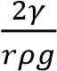 γ – coefficient of surface tension θ – angle of contact r – radius of capillary tube
ρ – density of the liquid

(ii) A mercury drop of radius 2mm falls vertically and on hitting the ground, it splits into two drops each of radius 0.5mm. Calculate the change in surface energy given that the surface tension of mercury is
0.52Nm⁻¹. (05marks)
Solution
Surface area of a drop = 4πr²
Surface area of a big drop = 4π(0.002)²
= 5.03 x 10⁻⁵m²
Surface area of two small drops
= 2 x 4π(0.0005)²
= 6.28 x 10⁻⁶m²
Change in area = 5.03 x 10⁻⁵ – 6.28 x 10⁻⁶m²
= 4.402 x 10⁻⁵m²
Change in surface energy
= change in area x coefficient of surface tension = 4.402 x 10⁻⁵ x 0.52
= 2.289 x 10⁻⁵J
(iii) State the effect of temperature on surface tension of a liquid. (01mark)

Increase in temperature lowers surface tension because increase in temperature increases kinetic energy of molecules and increases movement of molecules reduces the cohesive forces between them.
3. (a) (i) Distinguish between surface tension and surface energy (01mark)
- Surface tension is a force per unit length acting at right angle to one side of an imaginary line drawn in the liquid surface
- Surface energy is the work done in 4. increasing area of the surface by 1m² under isothermal conditions.
(ii) Show the surface energy and surface tension are numerically equal.
(03marks)

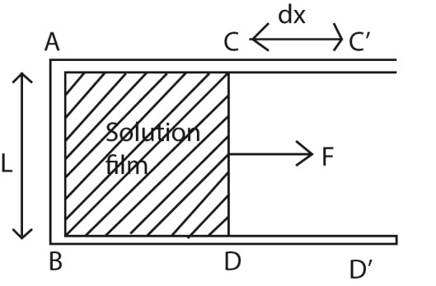
- F a wire frame ABCD is put in a solution of surface tension γ and a film of the solution forms on ABCD; and if a force F is used to extend the film to ABC’D’ ;
- Then surface tension, γ = 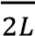
- Surface energy, ς = 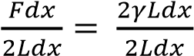 = γ
- Surface energy, ς = surface tension,
γ 5.
(iii) Explain why water dripping out of a tap does so in spherical shapes.
(03marks)
For any given volume, a sphere is a shape that offer minimum surface
area and therefore the most stable

(b) Two soap bubbles of radius 2.0cm and 4.0cm respectively coalesce under isothermal conditions. If the surface tension of the soap solution is 2.5x 10⁻²Nm⁻¹, calculate the excess pressure inside the resulting soap
bubble. (04marks)

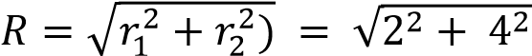= 4.47 cm
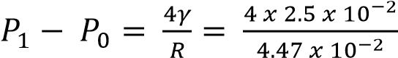2.24Pa
(a) (i) Define surface tension (01mark)
Is the force acting at right angle at one side of immaginary line of length 1m drawn in the surface of a liquid.
(ii) Explain the origin of surface tension.
(03marks)
- Liquid molecules attract each other.
- The molecules within the body of the liquid (bulk) molecules are attracted equally by neighbors in all direction, hence, the force on a bulk molecule is zero,
- For a surface molecule, there is a net inward force because there are no molecules above the surface to attract them equally.
- This net inward pull puts tension on surface molecules causing the surface to contract and behave as a stretched skin. The tension is called free surface energy or surface tension.

- Define the terms surface tension and surface energy. (01mark) It is the work done per unit area in increasing surface area of a liquid under isothermal conditions.
- (i) Calculate the work done against surface tension in blowing a soap bubble of diameter 15mm, if the surface tension of soap solution is 3.0 x 10⁻²Nm. (03marks)
New surface area created = 2 x 4πr²
Energy required = γA
= 3.0 x 10⁻² x 2 x 4π x (7.5 x 10⁻³)²
= 4.24 x 10⁻⁵J
  - A soap bubble of radius r₁ is attached to another bubble of radius r₂. If r₁ is less than r₂. Show that the radius of curvature of the common interface is 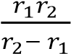.
(05marks)

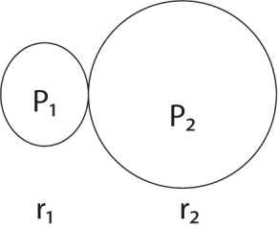

For A
P₁ – H = 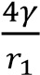 …………………….. (i)

For B
P₂ – H = 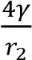 …………………….. (ii)
From equations (i) and (ii)
P₁ – P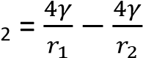 ……………. (iii)

P₁ – P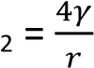 ………………….. (iv)
From equation (iii) and (iv)

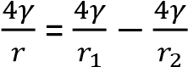

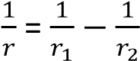

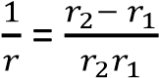

r = 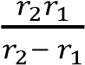
- (i) Sketch a graph of potential energy against separation of two molecules of a substance. (01mark)

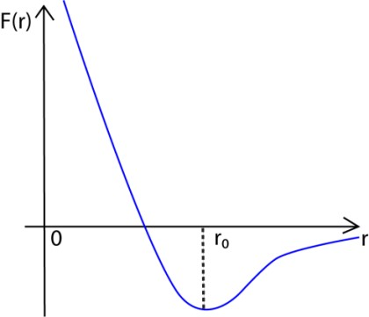

  - Explain the main features of the graph in (d)(i). (03marks)
At r = r₀, the resultant force is zero and the corresponding potential energy is minimum. So
r₀ is the equilibrium separation

For r < r₀, the net force is repulsive, whereas r> r₀, the net force is attractive in order to restore the e separation to the equilibrium separation of r₀.
  - Describe an experiment to measure surface tension of a liquid by capillary method.
(06marks)

The liquid rises until the vertical component of the upward forces due to surface tension is equal to the weight of the liquid column. Fγcosθ = W γ =
F = γL
L = 2πr
But W = mg and m = Vρ (where ρ is the density of the liquid in kg/m³) W = vρg = 2πr²hρg
Fγcosθ = 2πr²hρg
γ.2πrcosθ =2πr²hρg h = 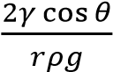 γ – coefficient of surface tension θ – angle of contact r – radius of capillary tube
ρ – density of the liquid

6. (a) Define surface tension and derive its dimensions (03marks)
Surface tension is the force per unit length acting perpendicularly to one side if an imaginary line.
γ = 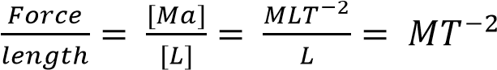
- Explain using the molecular theory the occurrence of surface tension. (04
marks)
Molecules at the liquid surface have greater molecular separation than the equilibrium separation. These molecules experience greater attraction from their neighbours. This puts them in a state of tension. Thus the liquid surface behaves like a stretched elastic skin, a phenomenon called surface tension
- Derive an experiment to measure surface tension of a liquid by the capillary tube method. (06marks)
A capillary tube of radius, r, is vertically placed in a liquid. The liquid rises until the vertical component of the upward forces due to surface tension is equal to the weight of the liquid column. Fγcosθ = W γ =
F = γL
L = 2πr
But W = mg and m = Vρ (where ρ is the density of the liquid in kg/m³)
W = vρg = 2πr²hρg
Fγcosθ = 2πr²hρg
γ.2πrcosθ =2πr²hρg
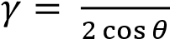
γ – coefficient of surface tension θ – angle of contact
ρ – density of the liquid

(d) (i) Show that the excess pressure in a soap bubble is given by P = 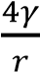, (03marks)
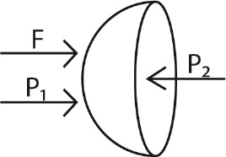
A soap bubble has two liquid surfaces in contact with air, one inside the bubble and the other

outside the bubble. below the water surface and surface tension of water is 7.27 x 10⁻
The force, F, on one half of the ²Nm⁻¹. [Atmospheric pressure = 1.01 x
bubble due to surfaces is thus 105Pa] (05marks)
= γ x 2πr x 2
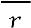
Excess pressure =
= 4πrγ
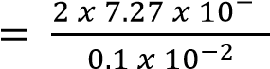
For equilibrium of A, it follows that.2 2 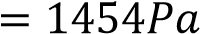
4πrγ + πr x P1 = πr x P2 Total pressure within the bubble

where P₂, and P₁ are pressure inside = atmospheric pressure + hρg + and outside the bubble respectively excess pressure Simplifying
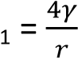
5 3
P2 – P = 1.01 x 10 + (0.1 x 10 x 9.81) + 1454
Therefore, excess pressure, P = 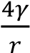 = 1.034 x 10⁵Pa
(ii) Calculate the total pressure within a bubble of air of radius 0.1mm in
water if the bubble is formed 10cm

Pressure in liquids
This is the force exerted normally per unit area. The SI units of pressure of liquids are
Nm⁻² or Pascals (pa)

The pressure in liquids is independent of the shape and cross sectional are as shown below
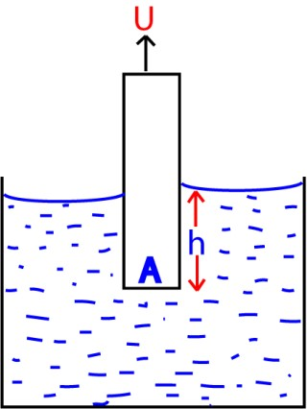
Volume of a liquid displaced
= Ah (A = cross section area)

Mass of the liquid displaced
= Ahρ (ρ = density of a liquid)

Weight of the liquid displaced
= Ahρg (g = acceleration due to gravity)
= upthrust
Pressure = 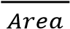
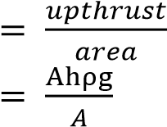
= hρg
Since, ρ and g are constant; P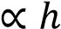

Floating objects

Archimedes principle
When a body is partially or fully immersed in a fluid, it experiences an upthrust which is equal to the weight of a fluid displaced.

Consider a solid of cross section area A immersed in a liquid of density, ρ.
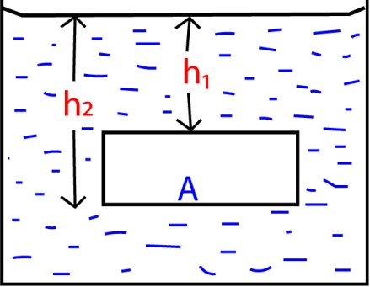

Total pressure at the top = H + h₁ρg
Force on top surface = (H + h₁ρg)A

Total pressure at the bottom = H + h₂ρg
Force on bottom surface = (H + h₂ρg)A

Resultant upward force
= upthrust
= (H + h₂ρg)A - (H + h₁ρg)A
= (h₂ – h₁) ρgA
But (h₂ – h₁) A = volume of the solid
= volume of the liquid displaced
(h₂ – h₁) Aρg = weight of liquid displaced

Hence, Upthrust = weight of the liquid displaced

Conclusion
Since there is no side way movement, the resultant horizontal force is zero. Therefore, up thrust is equal to the weight of fluid displaced.

Law of floatation
States that a floating object displaces a liquid equal to its own weight of the liquid in which it
floats

Example 4
A string supports a solid of mass 5kg totally immersed in a liquid of density 800kgm⁻³. Find the tension in the string if the object has a density of 2575kgm⁻³.

Solution
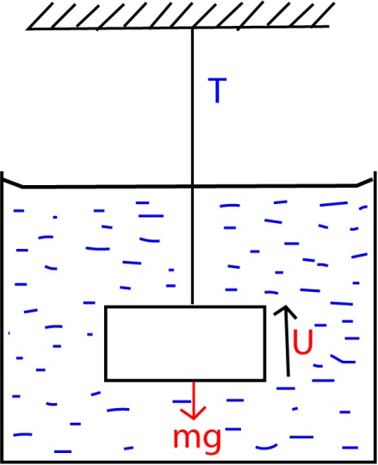
mg = T + U T = mg – U
U = weight of fluid displaced.
Volume of solid = volume of liquid displace
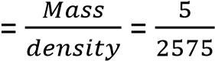
Mass of the liquid displaced
= volume x density
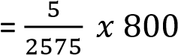
Weight of the liquid displaced, U
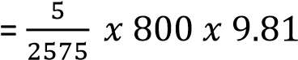
= 15.25N
Tension T = 5 x 9.81 – 15.24
= 33.81N

Example 5
A piece of metal of mass 2.60 x 10-³ kg and density 8.4 x 10³kgm⁻³ is attached to the block of mass of 1.0x 10⁻²kg and density 9.2 x 10²kgm⁻³. When the system is placed in a fluid, it floats with wax just submerged. Find the density of the fluid.

Solution
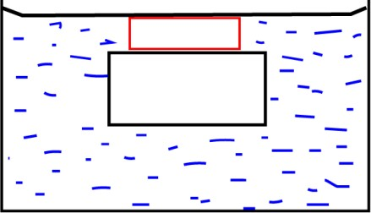

Volume = 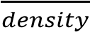

Volume of liquid displaced = volume of the metal + volume of wax
= 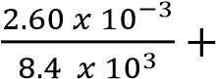
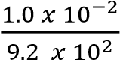
=1.118 x 10⁻⁵m³
Mass of the liquid displaced = mass of metal + mass of wax
= 2.60 x 10-³ + 1.0x 10⁻²
= 0.0126kg
Density of a liquid = 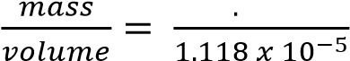=
1,127kgm⁻³

Example 6
A solid of density, ρ, floats at the interface of two liquids of densities ρ₁ and ρ₂ with 80% of its volume in liquid of density ρ₁. Show
that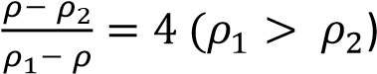
Solution
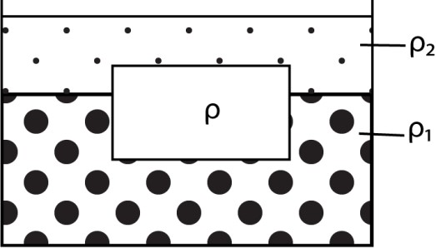

Let the volume of the solid be V
Volume of the solid in liquid of density, ρ₁ =
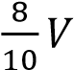

Volume of the solid in liquid of density, ρ₂ =
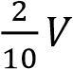

Mass of the solid = Vρ

Vρ = 0.8Vρ₁ + 0.2Vρ₂

ρ = 0.8ρ₁ + 0.2ρ₂ 0.8ρ + 0.2ρ = 0.8ρ₁ + 0.2ρ₂
0.2(ρ- ρ₂) = 0.8(ρ₁ –ρ)
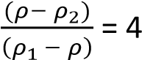

Relative density (R.D)
This is the ratio of mass of a substance to the mass of equal volume of water.
R.d = 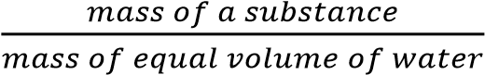

R.d = 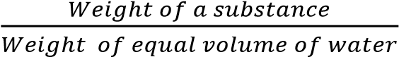

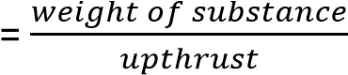
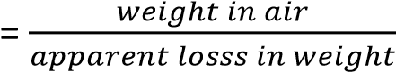

Example 7
A solid of mass 0.2kg is suspended from a spring balance when the block is immersed in water the spring reads 0.84N. When the block is immersed in a liquid of unknown density, the spring balances reads 0.95N. Find
- Density of the block
- Density of the liquid

Solution
R.D = 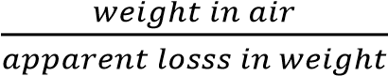
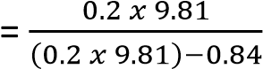
= 1.749

Density of the solid = 1.749 x 1000
= 1749kgm⁻³

(ii) For liquids
R.D = 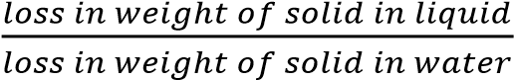
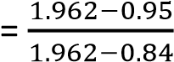
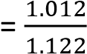
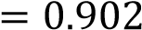

Density of the liquid = 0.902 x 10000
= 902kgm⁻³

Experiment to determine the relative density of a substance that floats in water

Apparatus: thread, spring balance, object,
sinker and water

By means of a thread tied to the object, determine the weight, W₁, of an object in air using a spring balance.

Attach a sinker to the object and immerse the two in water and determine the weight, W₂, of the body and the sinker.

Determine the weight of the sinker, W₃.

R.D = 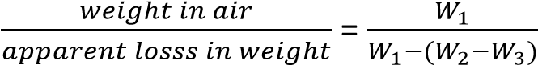

Density of the substance, = R.D x 1000kgm⁻³

Experiment to determine the relative density of a liquid
By means of a thread, determine the weight of solid in air, liquid, and water = W₁, W₂, and W₃ respectively.

R.D = 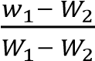

Density rod
This is a rod used to compare densities of two liquids. The higher the rod floats, the higher the density of the liquid. A density rod floats with height h₁, submerged in water. In oil, it floats with height, h₂, submerged. Show that the relative density of oil is 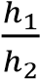.

Solution
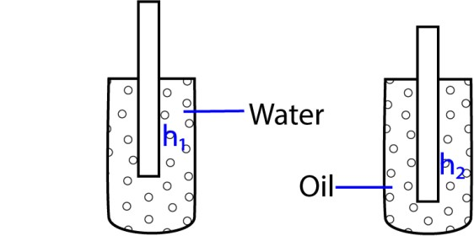

Mass of the rod = mass of water displaced
= mass of oil displaced
Let the rod have a cross sectional area = A
Ah₁ρ_{w} = Ah₂ρ_{o}
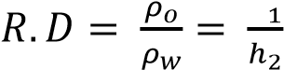

Example 8
An object of mass 30g and density 2g/cm³ has a uniform cross section area of 3cm² floats in water and oil leaving a height of 1.5 and 0.5cm respectively above the surfaces. Calculate the relative density of oil.

Solution

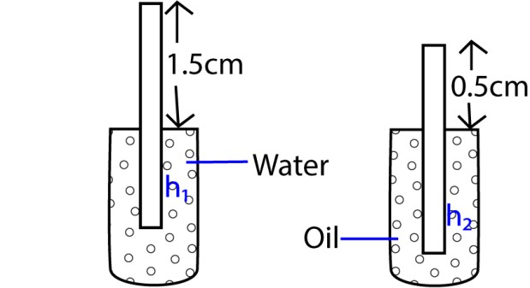

Ah₁ρ_{w} = Ah₂ρ_{o}
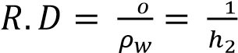
But V = 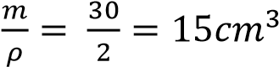
V = Ah 15 = 3h h = 5cm

h₁ = 5 – 1.5 = 3.5cm h₂ = 5 – 0.5 = 4.5cm
R.D = 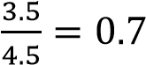

Hygrometer
It consists of a bulb that floats upright above a liquid surface. Lead shots are placed in the bulb to ensure that the system floats upright.

Example 9
A hygrometer floats on water with 72% of its volume submerged in a liquid. It floats with 68% of its volume submerged. Find the
relative density of the liquid

Mass of hygrometer = mass of water displaced
= mass of liquid displaced

Let the volume of hygrometer = V
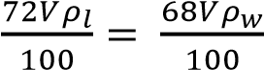
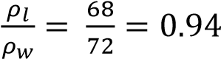

Types of flow

(i) Laminar flow
Laminar flow occurs when the fluid flows in tiny parallel layers with no disruption between them. The successive particles passing a given point have the same velocity.
The velocity of particles may change from
one streamline to another

(ii) Turbulence/turbulent flow/non uniform flow
In turbulent flow the speed of the fluid at a point is continuously undergoing changes in both magnitude and direction.

Common examples of turbulent flow are blood flow in arteries, oil transport in pipelines, lava flow, atmosphere and ocean currents, the flow through pumps and turbines, and the flow in boat wakes and around aircraft-wing tips.

Experiment to demonstrate laminar and turbulent flow
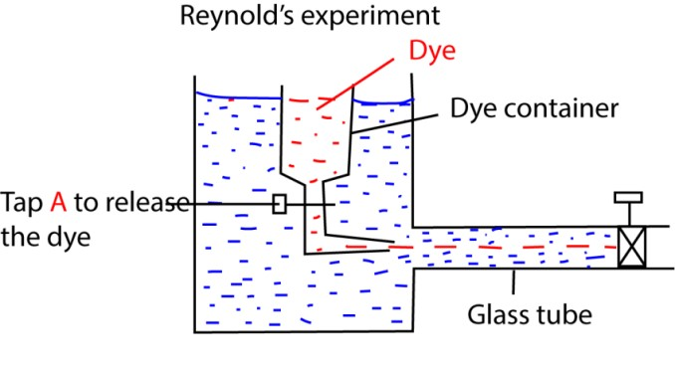
Water is kept flowing at a constant velocity from a constant water tank.

The rate of flow of a dye is controlled by a tap A.

At low water velocity a streamline of a dye is observed flowing through water. This is
laminar flow

A turbulent flow is observed when the velocity of water is increased here the dye mixes with water.

Viscosity

This is the frictional force that opposes the relative motion between different fluid layers. It is the result of intermolecular forces between particles within a fluid which necessitates work to be done when layer move over one another.

Factors affecting the magnitude of viscosity
- Temperature: increase in temperature reduces intermolecular forces due to increased kinetic energy. This reduces viscosity.

In gases viscosity increases as temperature increases due to molecular diffusion from one layer to another of different velocities. As the temperature increases, the rate of diffusion also increases and the drag exerted on each layer by the other increases.

- Chemical composition
The viscosity of liquids generally depends upon the size, shape and chemical nature of their molecules. It is greater with larger than with smaller molecules; with elongated than with spherical molecules.
Large amounts of dissolved solids generally increase viscosity. Small amounts of electrolytes lower the viscosity of water slightly.

- Colloid Systems:
The viscosity of lyophilic colloid solution is generally relatively high.

- Suspended Material:
Suspended particles cause an increase in the viscosity. The viscosity of blood is important in relation to the resistance offered to the heart in circulating the blood. The heart muscle functions best while working against a certain resistance. The viscosity of blood is due largely to the emulsoid colloid system present in plasma and to the great proportion of suspended corpuscles.

Velocity gradient
This is the change in velocity per unit length
Velocity gradient = 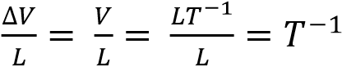

Newton’s law of viscosity
The frictional force between different fluid layers is directly proportional to the area of molecular layer.

F A ……………………………………. (i)
The frictional between different fluid layers is directly to velocity gradient
F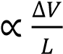 …………………………………… (ii)
Combining (i) and (ii)
F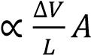 F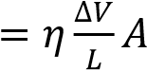
ղ 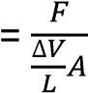
If A = 1m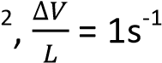, F = 1N
ղ = 1Nsm⁻²

Coefficient of viscosity of a liquid This is the frictional force per unit area exerted on the fluid in the region of a unit velocity
gradient
Or
It is the ratio of tangential stress exerted on layers of fluid to velocity gradient. Units are NM⁻²s or Ns/m². Other units are kgm⁻¹s⁻¹.

Example 10
A metal plate of area 0.25m² is connected to 8g mass via a light string that passes over a frictionless pulley. A lubricant with a film of thickness 0.6mm is placed between the plate and the horizontal surface. When released, the plate moves with a speed of 87ms⁻¹
- Find the coefficient of viscosity of lubricant
- State any assumptions made

Solution
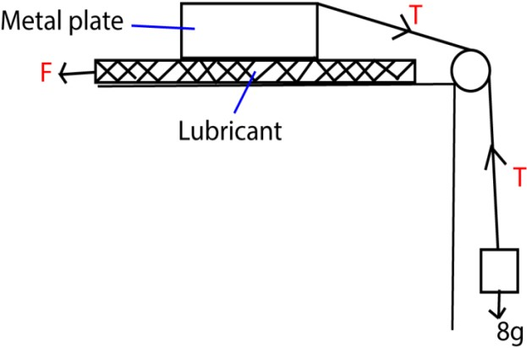
F = mg

F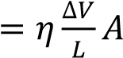

ղ 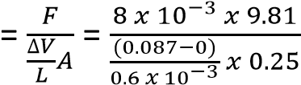

= 2.16 x 10⁻³Nsm⁻²

(ii) the top layer of the film is assumed to move with the same velocity as the metal plate while the bottom layer is stationary.

Viscous drag
This is the frictional force that oppose relative
motion between a solid and a viscous fluid

Stokes’ law
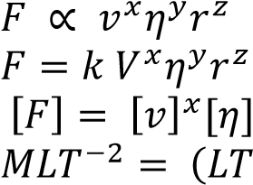
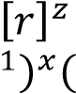
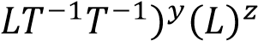

The viscous drag experienced by an object depends on the velocity, viscosity constant and the radius of an object.

For M: y = 1
For T: -2 = -x – y
x = 1
For L: 1 = x – y +z
Z = 1
From repeated experiments, k = 6π
⇨ F = 6πղvr

Example 11
The water drop of mass 10g falls through air of viscosity constant 1.0x 10⁻⁵Pa. Calculate the viscous drag, experienced by the droplet when it attains a terminal velocity of 2mms⁻¹

Solution
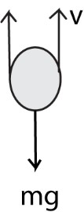

F = 6πղvr

m = volume x density

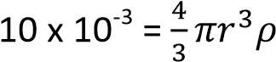
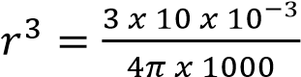

r = 0.0134m
F = 6πղvr = 6π x (1.0 x10⁻⁵) x (2 x 10⁻³) x 0.0134
= 5.04 x10⁻⁴N

Terminal velocity
Consider a spherical object dropped in a
viscous fluid
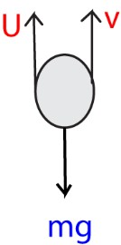
As the object drops, it is acted on by three forces, U= up thrust up, viscous drag up and weight, (mg) down.

F = mg – (U+v)
But U = 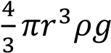 and v= 6πղvr
Where r = radius of the ball, ρ = density of fluid, ղ= viscous constant, v = velocity of the falling ball.

As the velocity increases, the viscous drag force increases. At a certain velocity v₀, known as terminal velocity, the resultant force acting at the body is zero. mg = U + v

Definition
Terminal velocity is the maximum constant velocity attained by an object falling through a viscous fluid.

A graph of the velocity of an object falling
through a viscous fluid against time

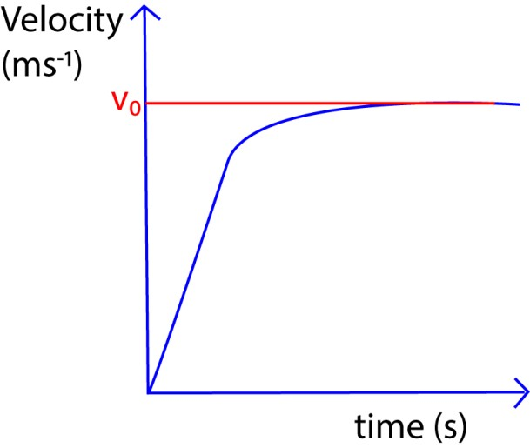

Example 12
Explain why raindrops hit the ground with less force than they should.

The drag force and up thrust reduce the force
by which raindrops would hit the grounds

Derivation of terminal velocity

Consider a spherical object of radius r and density, ς, falling through a viscous fluid of density, ρ, viscous constant, ղ, and v₀ =
terminal velocity
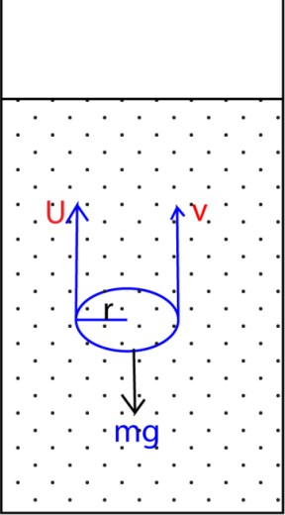

mg = U + v

mg = 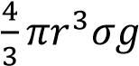
U = weight of fluid displaced
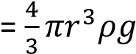
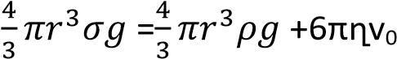r
6πղvr =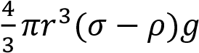
v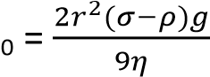

Example 13
A spherical ball of radius 2.5mm and density 900kgm⁻³ fall through air of viscosity constant 1.88 x 10⁻³.calculate the terminal velocity if (i) Density of air is 1.29kgm⁻³.
(ii) Density of air is negligible.

Solution v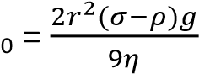
- v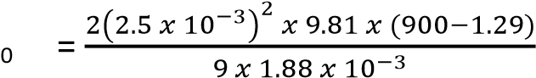
= 6.513ms⁻¹
- v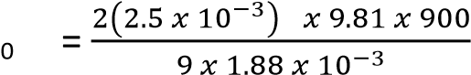
= 6.523ms⁻¹

Example 13
Eight similar water drops fall with a terminal velocity of 5mms⁻¹. And when mid-way, they coalesce forming a big droplet. Calculate the terminal velocity of a big droplet if the density of air is negligible.

Solution
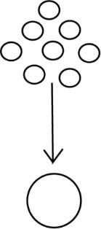

v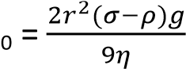
When density of air is negligible, terminal velocity v_{r} for small droplets is given by
Vr = 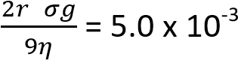 …………………………. (i)
Terminal velocity for big droplet v_{R} is given by
V_{R} 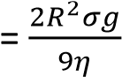
By conserving volume

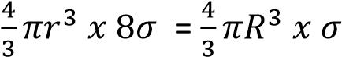

R³ = 8r³ R = 2r
V_{R} 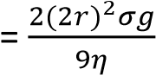 ………………………………….. (ii)
Dividing Eqn (ii) with Eqn (i)
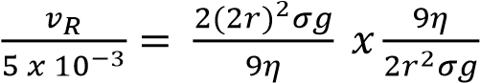

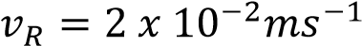

Example 14
A metallic ball of mass 0.9g and diameter 8mm is dropped in oil of density 780kgm⁻³ attaining a terminal velocity of 0.07ms⁻¹. A ball falls with terminal velocity of 0.03ms⁻¹ when oil is replaced with water of density 1000kgm⁻³. Find the ratio of the coefficient of viscosity of oil to that of water at the same temperature.

Solution
Density of the ball, ς = 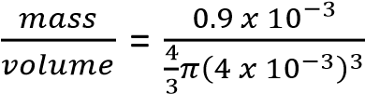 =
3.35x10³kgm⁻³

ղ 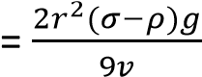

For oil,
ղ_{o} 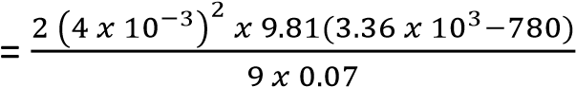
For water,
ղ_{w} 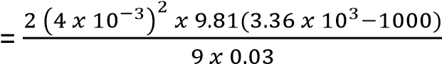

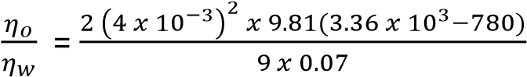x
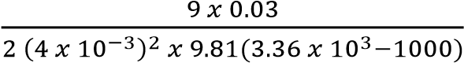

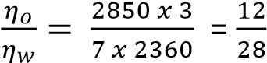

Experiment to determine the coefficient of viscosity of a viscous fluid such as heavy oil
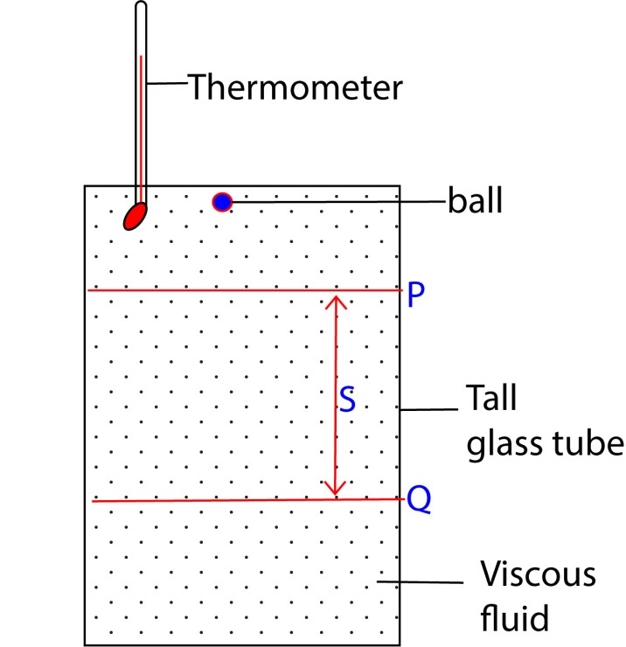

- A viscous fluid of density, ρ, at constant temperature is put in a tall glass jar with reference marks P and Q a distance, S, apart.
- A ball bearing of density, ς, and radius, r, is dropped into the fluid.
- Time taken, t, taken for the ball bearing to drop from P to Q is noted
- Assuming the ball bearing travels with a terminal velocity, v, between P and
Q, then
v = 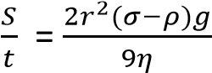
ղ 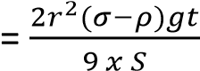

Experiment to determine the coefficient of viscosity of a viscous liquid using the graphical method

- A viscous fluid of density, ρ, at constant temperature is put in a tall glass jar with reference marks P and Q a distance, S, apart.
- A ball bearing of density, ς, and radius, r, is dropped into the fluid.
- Time taken, t, taken for the ball bearing to drop from P to Q is noted
- Assuming the ball bearing travels with a terminal velocity, v₀, between P and Q, then, v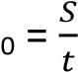
- The procedure is repeated for different ball bearing having various radii.
- The results of t, r, v_{o}, r² are tabulated.
- A graph of v⁰ against r² is plotted.

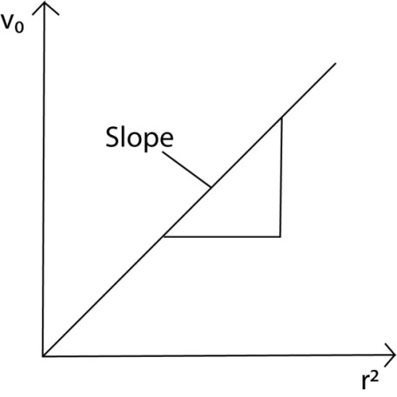Slope =

ղ

=

Experiment to compare the coefficient of viscosity of two viscous fluids

- A viscous fluid 1 of density, ρ₁, at constant temperature is put in a tall glass jar with reference marks P and Q a distance, S, apart.
- A ball bearing of density, ς, and radius, r, is dropped into the fluid.
- Time taken, t₁, taken for the ball bearing to drop from P to Q is noted
- Assuming the ball bearing travels with a terminal velocity, v₀, between P and Q, then, v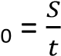.
- Procedure 1, 2, 3, 4 are repeated for viscous fluid 2 of density ρ₂ and time t₂ to fall from P to Q is determined v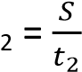

ղ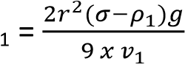

ղ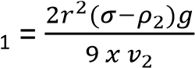

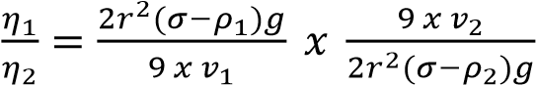

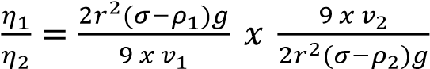

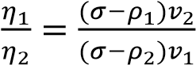

Poissulle’s law
During steady flow, the rate of flow of a liquid through a pipe depends on; (i) Coefficient of viscosity of the fluid
- Radius of the pipe
- The pressure gradient across the pipe
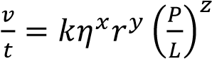

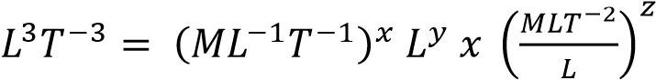
Solving x = -1 z = 1 y= 4

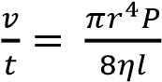, k =

Example 15
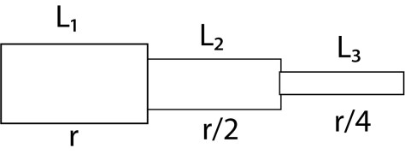

Three pipes are arranged in some area as shown above. If the pressure in the first pipe is P1, deduce the pressure in the second and third pipe assuming there is a steady flow and
2l₁ = 3l₂ = ½ l₃

Solution
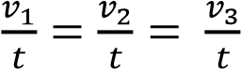

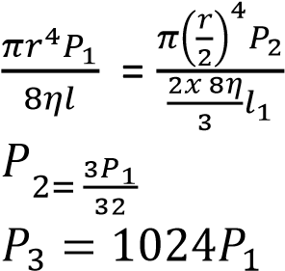

Experiment to determine coefficient of viscosity of non-viscous liquid

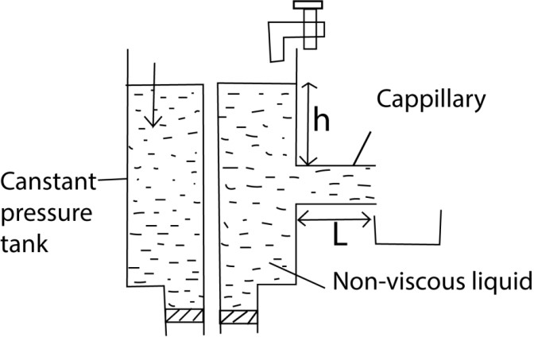
- One end of capillary tube whose diameter, r, is known is connected to constant pressure apparatus
- The liquid is allowed to flow in a capillary tube until a steady state is reached when height, H, is stable
- Volume of liquid V flowing out in time t is measured.
- The pressure height, h, in the capillary tube is measured.

For steady flow,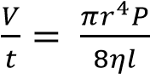
But P = hρg
r =
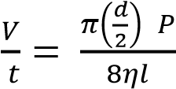

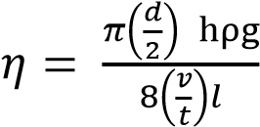

Incompressible liquid
This is the liquid whose density does not change with change in pressure.

Continuity equation
Consider a non-viscous incompressible liquid flowing through a tube of non-uniform cross sectional area.

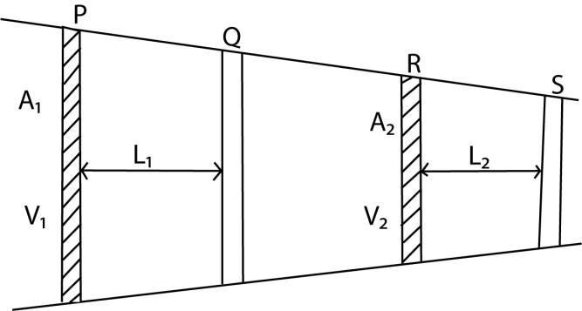

Volume of a liquid between P and Q = volume of a liquid between R and S
A1L1 = A2L2
But L₁ =V₂∆t
A₁V₁∆t = A₂V₂∆t
AV = constant
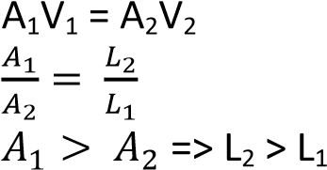

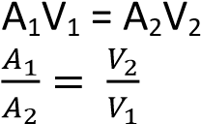
A₁ > A₂, V₂ > V₁

Liquids travel longer distances with high velocity in pipes of small diameter compared to those of large diameters.
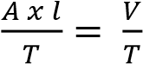
V 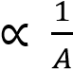
For a streamline, the velocity of a liquid at any section of the pipe is inversely proportional to
the area of cross section at that point

Bernoulli’s principle
For a streamline flow, the sum of pressure, kinetic energy per unit volume and potential energy per unit volume is constant at all points for a non-viscous incompressible fluid.

Bernoulli’s equation
A moving liquid has 3 types of energies
- Kinetic energy: energy possessed by a liquid due to motion
- Potential energy: energy possessed by a liquid due to its position in the field of force
- Pressure energy: energy posed by a liquid due to its pressure at particular point.

P + 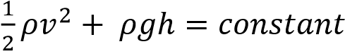

Derivation of Bernoulli’s expression

  - Considering a moving incompressible liquid, if the viscosity is negligibly small, there are no frictional forces to overcome.
  - In this case the work done by the pressure difference per unit volume of a fluid flowing along a pipe steadily is equal to the gain of kinetic energy per unit volume plus the gain in potential energy per unit volume.
  - Assuming the area is constant at a particular place for a short time of flow; the work done by a pressure in moving a fluid through a distance
= force x distance moved
= (pressure x area) x distance moved = pressure x volume moved,
  - At the. beginning of the pipe where the pressure is 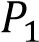, the work done per unit volume on the fluid is thus 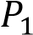;
  - At the other end, the work done per unit volume by the fluid is likewise 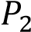
  - Hence the net work done on the fluid per unit volume = 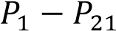
  - The kinetic energy per unit volume 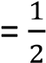 mass per unit volume x velocity² 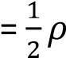 x velocity², where ρ is the density
of the fluid.
.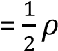 x velocity²
  - Thus if v₂ and v₁ are the final and initial velocities respectively at the end and the beginning of the pipe, the kinetic energy gained per unit volume
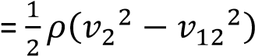.
  - Further, if h₂ and h₁, are the respective heights measured from a fixed· level at the end and· beginning of the pipe, the potential energy gained per unit volume
= mass per unit volume x g x (h₂ - h₁)
= pg(h₂ - h₁).

  - Thus, from the conservation of energy
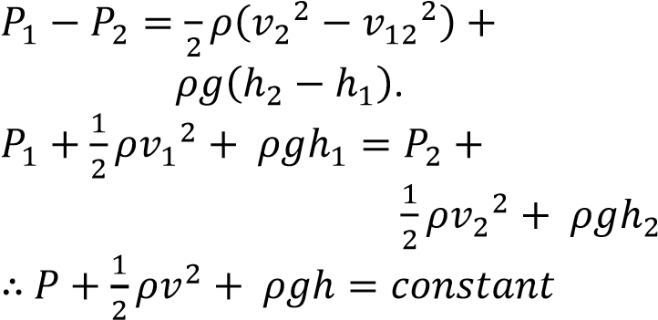

Hence for streamline motion of an incompressible non-viscous fluid
“The sum of the pressure at any part plus the kinetic energy per unit volume pus potential energy per unit
volume is always constant.”

Example 16
Explain why Bernoulli’s equation only applies for a non-viscous incompressible fluid.

Solution
For the viscous fluid, energy is not constant while for compressible liquids, the density keeps on changing.

Example 17
Water enters a house through a supply pipe of diameter 2cm at a velocity of 0.1ms⁻¹. The internal house connection pipe has the diameter of 1.0cm.
Calculate
- Speed of water as it enters the house
- The rate of mass flow of water it has a density of 1000kgm⁻³.

Solution
- A₁V₁ = A₂V₂ π(0.01)² x 0.1 = π(0.005)²V₂
V₂ = 0.4ms⁻¹

- Volume per second = AV
Mass per second = AVρ
= π(0.01)² x 0.1 x 1000
= 0.0314kgs⁻¹

Example 18
A compound sprinkler has 8 holes each of cross sectional area of 0.05cm² is connected to a supply pipe of area 2.5cm². If the speed of water in the pipe is 4ms⁻¹, calculate the speed with which water jets out of the sprinkler into the grass.

Solution

A₁V₁ = A₂V₂
(2.5 x 10⁻⁴) x 4 = 8 (0.05 x 10⁻⁴)V₂
V2 = 25ms⁻¹

Example 19
Water flows along a horizontal pipe of cross sectional area 48cm² with a pressure of 10⁵Pa. The pipe has a constriction of area 12cm² at one point. If the speed of water at the
constriction is 4ms⁻¹. Calculate

- speed of water in the pipe in the pipe
- The pressure at the constriction

Solution
A₁ = 48cm² |  | A₂ = 12 cm²
V₁ = ? |  | V₂ = 4ms⁻¹
P₁ = 10⁵Pa |  | P₂ = ?



h
1

h
2

- A₁V₁ = A₂V₂
(48 x 10⁻⁴)V₁ = (12 x10⁻²) x 4
V₁ = 1ms⁻¹

- From P + 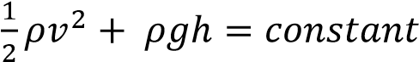
But h₁ = h₂ =h
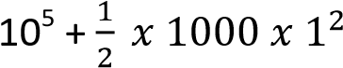+ 1000 x 9.81h
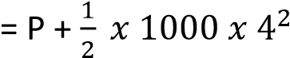+ 1000 x 9.81h

P = 10⁵ - 8000 + 500
= 9.25 x 10⁴Pa

Example 20
Water flows through a horizontal pipe with a velocity of 10ms⁻¹ and pressure of 10⁴Pa. the water flows out through a jet with pressure of
10Pa. Calculate the active velocity

Solution
V1 = 10ms⁻¹
P1 = 10⁴Pa
V
2

=
?

P₂ = 10Pa

From P + 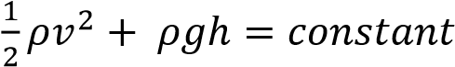
But h₁ = h₂ =h
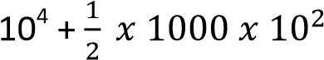+ 1000 x 9.81h
= 10 + 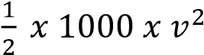 + 1000 x 9.81h
V₂ = 10.95ms⁻¹

Static pressure
This is the pressure exerted by a fluid at rest

Dynamic pressure
This is the pressure exerted by a fluid due to its velocity. Dynamic pressure is given by 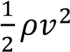
Experiment to determine static and dynamic pressure, hence velocity of the liquid in a pipe using Pitot Static tube.
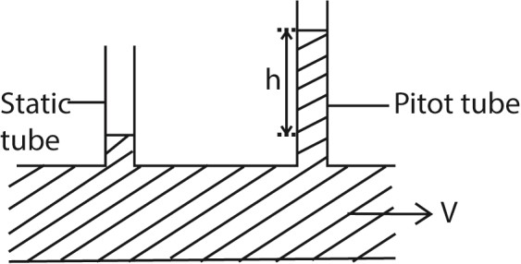

It consists of a static tube which measure the static pressure and the pitot tube that measures the total pressure. Total pressure is the sum of static and dynamic pressure.

From P + 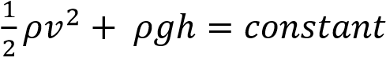
Static pressure = P + ρgh
Dynamic pressure = 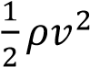
Total pressure, P_{y}
= static pressure (P_{x}) + dynamic pressure
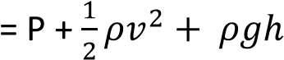
For horizontal tube, h is constant
But, Total pressure, P_{y}
= static pressure (P_{x}) + dynamic pressure
P_{y} 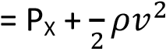
(P_{y} –P_{x}) = 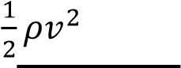
V = 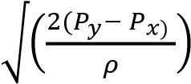

The assumption when using Pitot static tube
- The fluid is non-compressible
- The pitot tube is placed in the center of the fluid because velocity is highest in the middle of lamina flow
- velocity is low and pressure difference is small.

Application of pitot tube
It can be used to measure the airspeed of aircraft, the speed of boats, or the flow of gases and liquids in pipes.

Example 21
A pitot static tube fitted with a pressure gauge is used to measure the speed of the boat at the sea. Given that the speed of the boat does not exceed 10m⁻¹ and the density of seawater is 1050kgm⁻³. Calculate the maximum pressure of the gauge.

Solution
Dynamic pressure = 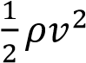
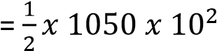= 52500Pa

Example 22
Water flowing in a pipe on aground with velocity 8ms⁻¹ and a gauge pressure of 2 x 10⁵Pa is pumped in a water tank 10m above the ground. Calculate the velocity with which
water enters the tank at pressure of 1 x 10⁵Pa

Solution

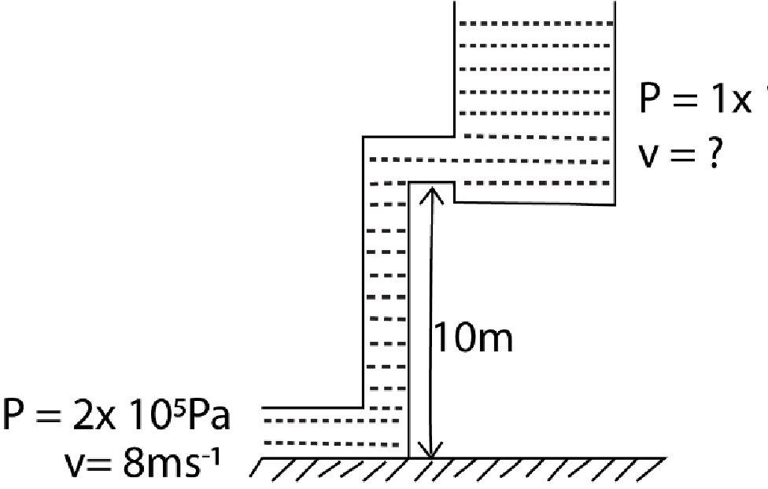

From P + 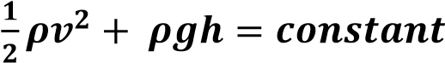 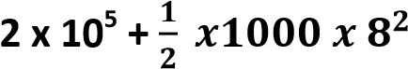 + 1000 x 9.81 x 0

= 1 x 10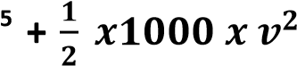 + 1000 x 9.81 x
10

v = 8.23ms⁻¹

Venturimeter
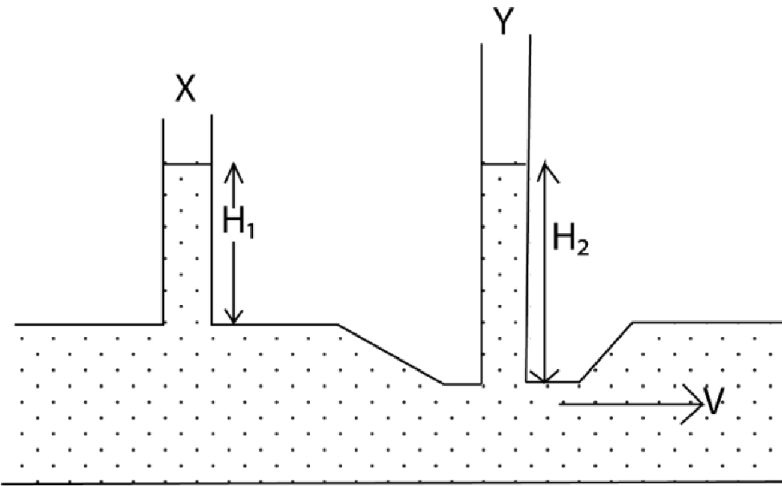
This consist of the horizontal tube with a constriction at one point. Vertical manometers are inserted into the tube and at the constriction to measure respective pressures. Then
P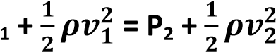
Since h₁ = h₂ P₁ = (H + H₁) ρg P₂ = (H + H₂) ρg
(H + H₁) + 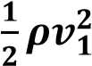 = (H + H₂) + 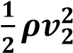 A₁V₁ = A₁V₂ V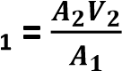
(H + H₁) + 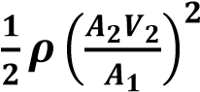 = (H + H₂) + 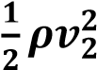

(H₁ – H₂) = 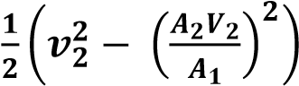
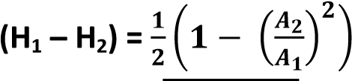
V = 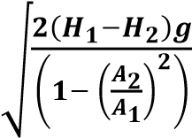

Application of Bernoulli’s principle
(i) Origin of the lift force on wings of an aero plane

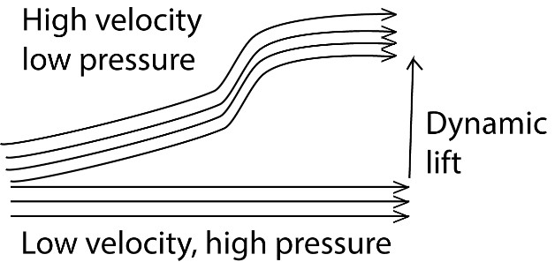

The curved nature of the wings of an aero plane ensures that at the takeoff, the air above the wing has higher velocity than that below. From Bernoulli’s principle, the pressure above the wing is less than that below. This difference in pressure creates a net upward force on the wings.

Example 23
Explain why a spinning ball takes a curved path.

Solution
Air on the upper side is in opposite direction to that of the spin. The resultant velocity of the air is reduced. The air below is in the direction of the spin which increases velocity.

From Bernoulli’s principle, the resultant pressure above the spinning ball is higher than that below it. The difference in pressure creates a net downward force on the ball making it to take on a curve path.

Principle of working of a spray
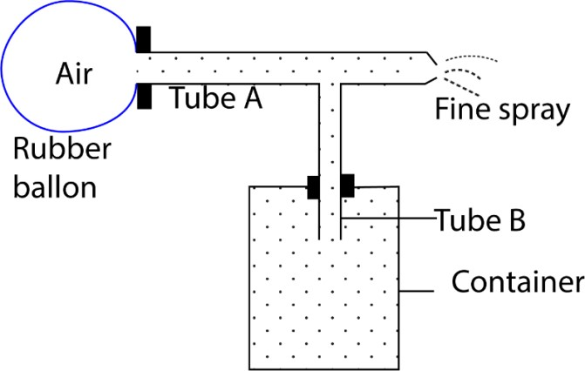

- Pressing the rubber balloon forces the air out of the horizontal tube A at high velocity.
- From Bernoulli’s principle, this decreases the pressure in the horizontal tube to below atmospheric pressure.
- The liquid rises up in the vertical tube B from the container.
- The liquid collides with the fast speeding molecules of air sucked and breaks into fine spray particles.

Example 24
- (i) Define coefficient of viscosity and determine its dimensions.
(ii) the resultant, F, on a steel ball bearing of radius, r, falling with speed, V, a liquid of viscosity, η, is given by F = kηrv, where K is a constant. Show that K is dimensionless.
- Write down Bernoulli’s equation for fluid flow, defining all symbols used.
- A venturimeter consists of a horizontal tube with a constriction which replaces part of the piping system as shown below.
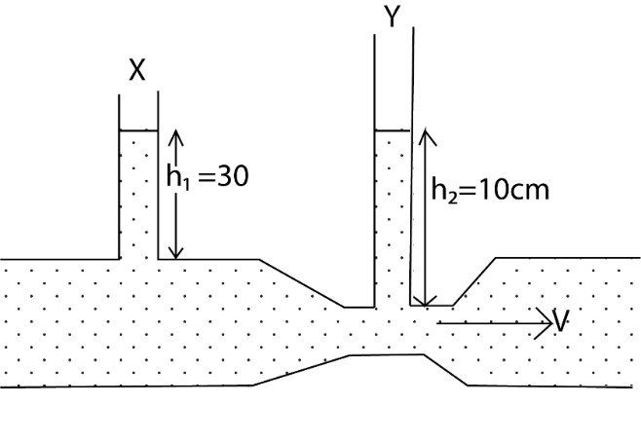
If the cross sectional area of the main pipe is 5.81 x 10⁻³ m² and that of the constriction is 2.58 x 10⁻³ m². Find the velocity V₁ of the liquid in the main pipe
- Explain the origin of the lift on an aero plane at takeoff.

Solution
From P + 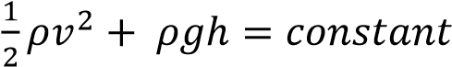
Since h is constant

P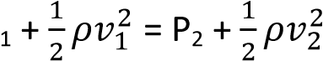
But P₁ =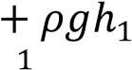, P2 = 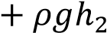
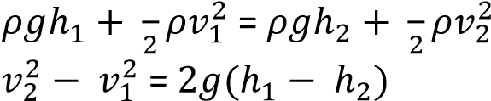

A₁V₁ = A₁V₂ V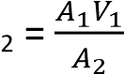
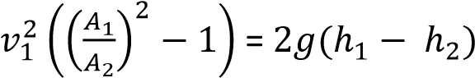

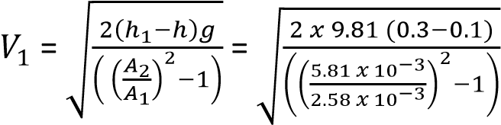= 0.983ms⁻¹

Example 25
Explain why the acceleration of a ball bearing falling through a liquid decreases continuously until it becomes zero.

Solution
For a ball bearing falling through a liquid, it has three forces acting on it namely the up thrust,

U, the weight of the bearing, mg, and viscous force, v, acting as shown above.

Viscous force, v, increases with velocity reducing the accelerating force, F = mg – (U+v) which reduces the acceleration to zero when mg = (U +v).

Revision exercise
1. (a) (i) Define the term static pressure and dynamic pressure as applied to fluid flow. (02marks)
- Static pressure at a point is the pressure which the fluid would have if was at rest.
- Dynamic pressure is the pressure due to fluid motion.
(ii) Describe how the speed of flowing water can be obtained using Pitot-
Static tubes. (05marks)
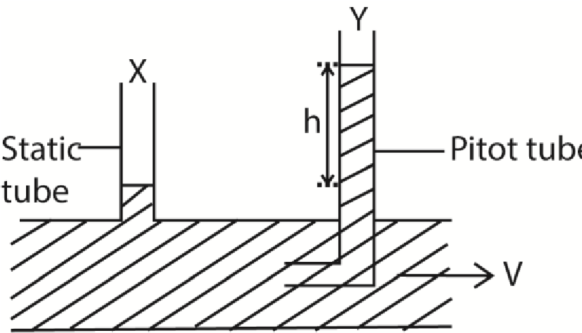

Pitot-static tube consists of a static tube which measures the static pressure and the pitot tube that measures the total pressure. Total pressure is the sum of static and dynamic pressure.

From P + 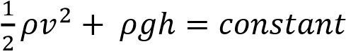
Static pressure = P + ρgh (where P is atmospheric pressure) Dynamic pressure = 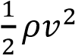
Total pressure, P_{y} = static pressure (P_{x}) + dynamic pressure
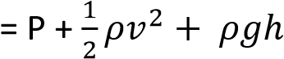
For horizontal tube, h is constant
But, Total pressure, P_{y}
= static pressure (P_{x}) + dynamic pressure
P_{y} 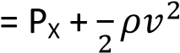
(P_{y} –P_{x}) = 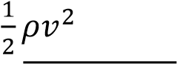
V = 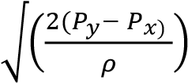

(iii) State the assumption made in (a)(ii)
(01mark)
- The fluid is non-compressible
- The pitot tube is placed in the center of the fluid because velocity is highest in the middle of lamina flow
- velocity is low and pressure difference is small.
(b) (i) State Bernoulli’s principle. (01mark) Bernoulli’s Principle states that for a streamline motion of an incompressible non viscous fluid, the sum of pressure at any point and kinetic energy per unit volume is always constant.
(ii) Explain why gas in a Bunsen burner does not escape from the base of the burner but continues burning at the top. (03marks)
- Upward Flow: The gas is forced to flow upward through the burner tube due to the high pressure from the gas supply. This upward flow ensures that the gas does not escape from the base.
- Venturi Effect: The design of the burner creates a Venturi effect, where the gas velocity increases as it passes through a narrow section, drawing in air through the side holes and mixing with the gas. The Fast flow of the gas creates low pressure causing in flow of air thus preventing gas escape through the air holes
(iii) A large tank contains water to depth of 1.0m. If a small hole is drilled in the tank at a depth of 20cm below the top surface of the water, calculate the speed at which the water emerges
from the hole. (03marks)

Using Torricelli’s theorem It statesthat thespeed ofinflux of a fluid under gravity through an orifice at a depth h below the surface of the fluid is given by
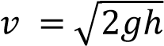
Where is the acceleration due to gravity (9.81ms⁻²) h is the depth of the hole below the
surface of the water = 20cm =0.2m
substitution

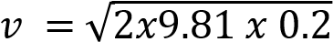
= 1.98ms⁻¹

(c)(i) State Archimedes’ principle (01 mark)
When a body is partially or fully immersed in a fluid, it experiences an up thrust which is equal to the weight of a fluid displaced.
(ii) An alloy of mass 588g and volume
100cm³ is made of iron of relative
density 8.0 and alumimium of relative density 2.7. Find the proportion by volume of the alloy. (04marks) Data given
- Total mass of the alloy (m) = 588g
- Totalvolume of the alloy (V): 100cm³
- Relativedensity of iron (ρ₁) =8.0
- Relative density of aluminium (ρ₂) =2.7
Converting relative density to actual density (since relative density is the ratio of the density of of substance to density of water, which is 1g/cm)
- Density of iron (ρ₁) =8.0 g/cm³
- Density of aluminium (ρ₂) =2.7g/cm³ Let the volume of iron be V_{i} and the
volume of aluminium be V_{a}
V = V_{i} + V_{a}
Expressing the mass of iron and aluminium in terms of their densities
and volumes
Mass of iron (mi) = ρ_{i}.V_{i}
Mass ofaluminium (ma) = ρ_{a}.V_{a}

The total mass of the alloy is the sum of the masses iron and aluminum m = mi + ma
588 = 8.0 xV_{i} + 2.7 x V_{a}…………………. (i) Total volume = volume of iron + volume of aluminium
V = V_{i} + V_{a}
100 = V_{i} and V_{a} ……………………(ii)
Solving equations (i) and (ii)
Vi = 60cm³
Va = 40cm³
Hence the volume of Iron in the alloy is 60cm³ and that of aluminium is
40cm³
2. A sphere of radius, r, and of material of density, ρ, falls vertically through a liquid of density, σ, and viscosity, η. Derive an expression for the terminal velocity in terms of the quantities given and acceleration due to gravity, g. (04 marks)

Solution
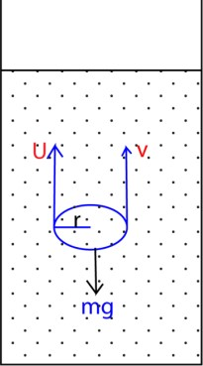
mg = U + v

mg = 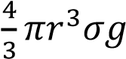
U = weight of fluid displaced
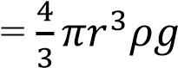
v = drag force = 6πղv₀r
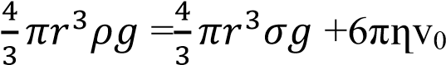r
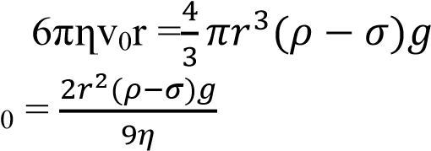
v
3. (a) (i) State Bernoulli’s principle. (02 marks)
For non- viscous incompressible fluid, flowing steadily, the sum of the pressure, kinetic energy and potential energy per unit volume is constant.
(ii) Explain with the aid of a diagram, why air flows over the wings of an
aircraft causes a lift. (02 marks)

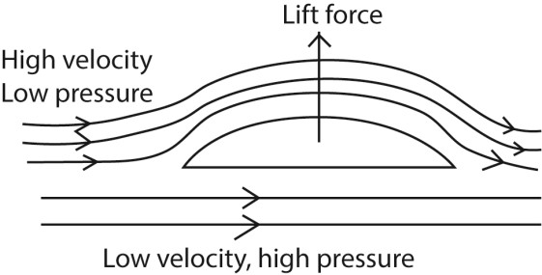
- Air flows above the wing of a plane at high velocity hence low pressure.
- Below the wings, air flows at low velocity and hence high pressure.
- The difference in pressure causes a lift force, therefore net upward force.

- Air flows over the upper surface of an aircraft’s wings at a speed of 135ms⁻¹ and passed the lower surfaces of the wing at a speed of 120ms⁻¹.
  - Calculate the pressure difference due to the flow. (02marks)
From P + 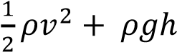
Assuming the difference in height is negligible; Difference in pressure =
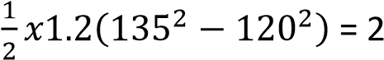,295Pa

  - Determine the lift force on the aircraft if the total wing area is
28m². (Assume the density of air is
1.2kgm⁻³) (02marks) F = pressure x area
= 2.295 x 28
= 64, 260N
- (i) What is meant by streamline flow? (02marks)
Laminar/streamline flow occurs when the fluid flows in tiny parallel layers with no disruption between them. The successive particles passing a given point have the same velocity.

(ii) With the aid of a labeled diagram, describe how the velocity of a fluid can be measured. (05 marks)

Experiment to determine the velocity of fluid

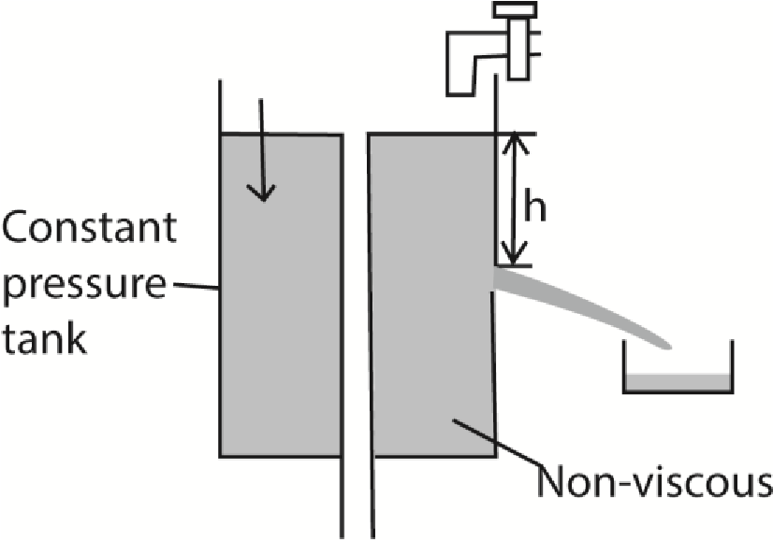
- A hole of diameter, r, is known is made through constant pressure apparatus
- Volume of liquid V flowing out of the hole in time t is measured.
- Velocity of the fluid =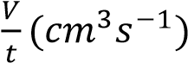
Or

Using pitot static tube
Pitot static tube is placed in the center of moving uncompressible liquid moving in horizontal direction

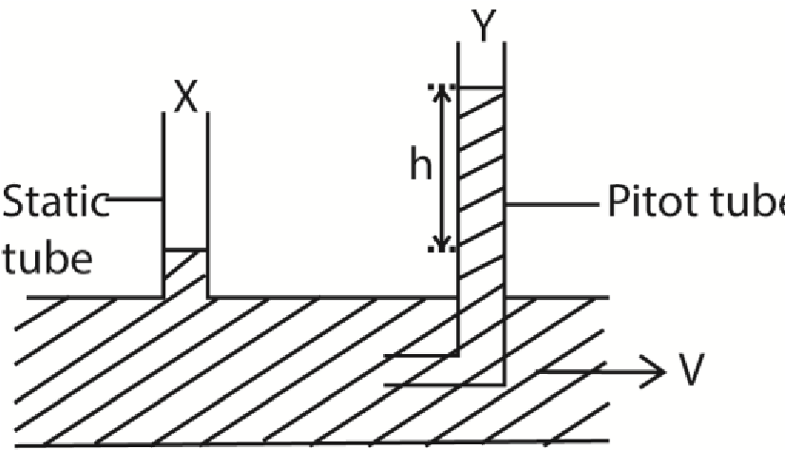

Pitot-static tube consists of a static tube which measures the static pressure and the pitot tube that measures the total pressure. Total pressure is the sum of static and dynamic pressure.

From P + 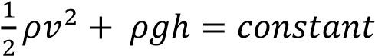
Static pressure = P + ρgh (where P is atmospheric pressure) Dynamic pressure = 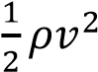
Total pressure, P_{y} = static pressure (P_{x}) + dynamic pressure
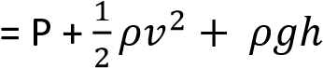
For horizontal tube, h is constant
But, Total pressure, P_{y}
= static pressure (P_{x}) + dynamic pressure
P_{y} 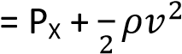
(P_{y} –P_{x}) = 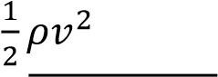
V = 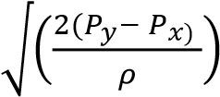

(d) The depth of water in a tank of a large cross-sectional area is maintained at 2.0m. If the water emerges out of the tank continuously through a hole of diameter 5mm drilled at a height of 10cm above the base of the tank, calculate the;
- Speed at which water emerges out from the hole. (03marks)
Height of water above the hole = 2 – 0.1 = 1.9m
Pressure of water at the hole
= hρg
= 1.9 x 1000 x 9.81
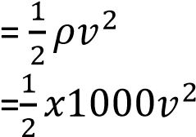 v = 61.1ms⁻¹
- rate of mass flow of water from the hole. (02marks)
Volume per second = Area of hole x speed of water
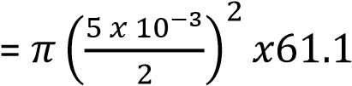
= 1.2 x10⁻³m³s⁻¹

4. (a) Define the following:
- Pressure. (01 mark)
Pressure is force over area
- Relative density (01 mark)
Relative density is the ratio of the mass of any volume of a substance to the mass of an equal volume of water
- (i) State Archimedes Principle
(01 mark)
When a body is partially or fully immersed in a fluid, it experiences an up thrust which is equal to the weight of a fluid displaced.
(ii) Describe an experiment to determine the relative density of a liquid. (04marks)
By means of a thread, determine the weight of solid in air, liquid, and water = W₁, W₂, and W₃ respectively.

R.D = 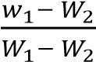
- (i) Derive the expression for
Bernoulli’s equation. (05marks) Derivation of Bernoulli’s
expression

    - Considering a moving
incompressible liquid, if the viscosity is negligibly small, there are no frictional forces to overcome.
    - In this case the work done by the pressure difference per unit volume of a fluid flowing along a pipe steadily is equal to the gain of kinetic energy per unit volume plus the gain in potential energy per unit volume.
    - Assuming the area is constant at a particular place for a short time of flow; the work done by a pressure in moving a fluid through a distance
= force x distance moved
= (pressure x area) x distance moved
= pressure x volume moved,
    - At the. beginning of the pipe where the pressure is , the work done per unit volume on the fluid is thus P₁
    - At the other end, the work done per unit volume by the fluid is likewise, P₂
    - Hence the net work done on the fluid per unit volume = P₂ – P₁
    - The kinetic energy per unit volume 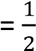 mass per unit volume x velocity² 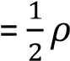 x velocity², where ρ is the density of the fluid.

    - Thus if v₂ and v₁ are the final and initial velocities respectively at the end and the beginning of the pipe, the kinetic energy gained per unit volume
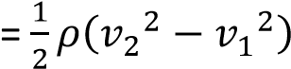.
    - Further, if h₂ and h₁, are the respective heights measured from a fixed· level at the end and· beginning of the pipe, the
potential energy gained per unit volume = mass per unit volume x x (h₂ - h₁)
=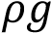 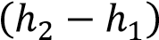.

    - Thus, from the conservation of energy
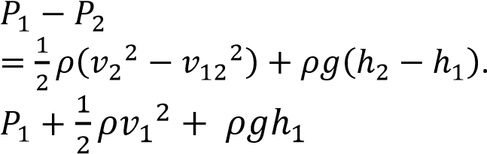
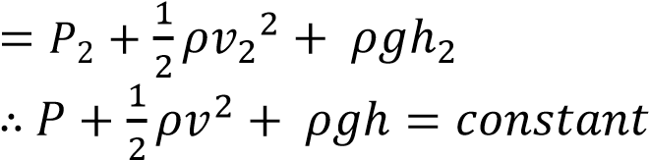

Hence for streamline motion of an incompressible non-viscous fluid
“The sum of the pressure at any part plus the kinetic energy per unit volume pus potential energy per unit volume is always constant.”

(ii) Explain why a person standing by the road side may be pulled towards the road when a very fast moving bus passes by. (03marks)
      - Air close to fast moving bus has high velocity and hence lower pressure compared to the still air around a stationary person
      - The difference in air pressure between the low-pressure area near the bus and the higher-pressure area around the person causes a net force that pulls the person towards the bus.
- A water tight drum tied to a cable anchored on the sea-bed floats 500m beneath the sea surface as shown in figure 1.
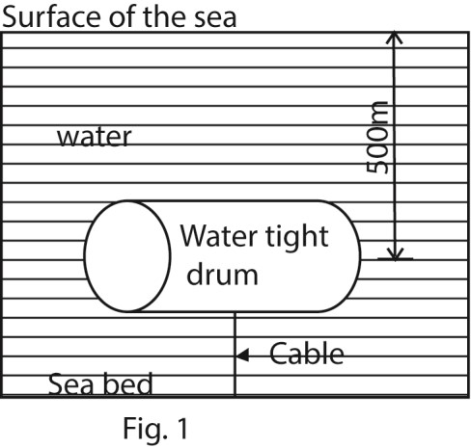
If the weight of the drum is 500N and its volume 25m³, calculate the;
(i) pressure on the drum due to sea water. (02 marks) Upthrust = weight of displaced water
= mg
= vρg
= 25 x 1000 x 9.81
= 245,250N (ii) tension in the cable assuming it is vertical. (03 mark) T = upthrust – (weight of the
drum ) = 245,250N – 500N
= 244,750N
5. (a) State and illustrate Archimedes’ principle. (05marks) Archimedes’ Principle: when a body is wholly or partially immersed in a fluid, it experiences an up thrust force equal to the weight of the fluid displaced.

(b)(i) State the law of flotation (01 marks) A floating body displaces its own weight of fluid in which it floats.
(ii) Describe an experiment to verify the law in (b)(i). (05marks)
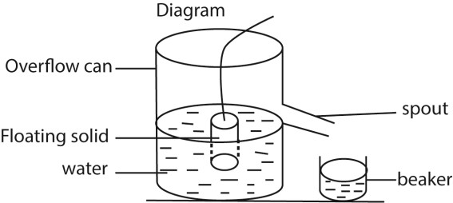

- Overflow can is filled with water up to spout level
- An object is lowered in the can until it floats.
- The displaced water is collected in the beaker.
- The weight of the displaced water is determined and found to be equal to the weight of the object.
(c) (i) Write Bernoulli’s equation and define each term in the equation. (02marks)
P + 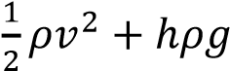 = constant
Where P= pressure, 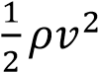 = kinetic
energy, hρg = potential energy per unit volume.
(ii) Explain the origin of lift force on the wings of a plane. (03marks)
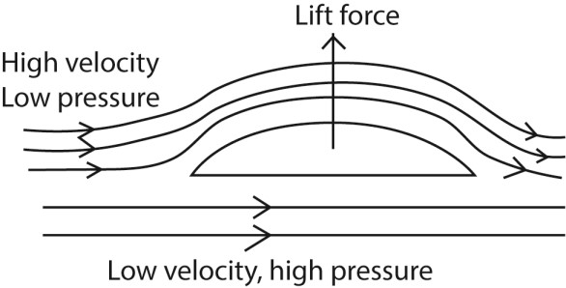
- Air flows above the wing of a plane at high velocity hence low pressure.
- Below the wings, air flows at low velocity and hence high pressure.
- The difference in pressure cause a lift force, therefore net upward force.

(i) Air flows over the upper surfaces of the wings of an aeroplane at a speed of 120ms⁻¹, and past the lower surface of the wings at 110ms⁻¹.Calclate the lift force on the aeroplane if it has a total wing area of
20m². Density of air = 1.29kgm⁻³)
P = 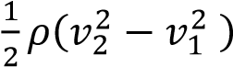
F = PA
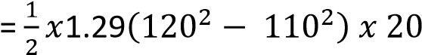
= 2.97 x 10⁴N

6. (a) (i) State two factors on which the rate of flow of a fluid through a tube depends.
(02marks)
- viscosity of fluid
- diameter/radius or cross sectional area of the tube
- pressure difference between its end
(ii) Describe an experiment to measure the coefficient of viscosity of a liquid using Ponselle’s formula
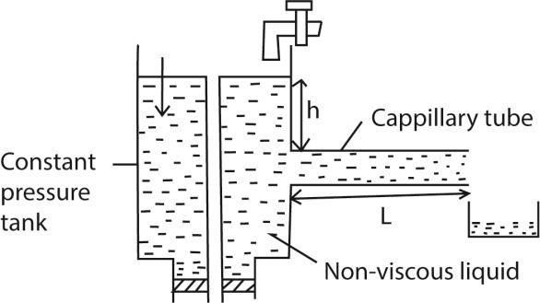
- the liquid of density, ρ, passes slowly from a constant head tank through a capillary tube of length, l and radius r.
- for a height, h, of the tube, the volume V is collect in time t.
- the flow rate R = is calculated
- the experiment is repeated for different value of V and h.
- A graph of R against h is plotted and slope S is obtained
For steady flow, slope 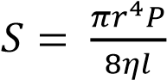
But P = hρg r =
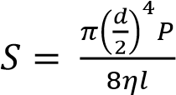

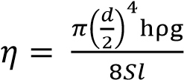

(d) Find the time take for an oil drop of diameter 6.0 x 10⁻³mm to fall through a distance of 4.0 cm in air of coefficient of viscosity 1.8 x 10⁻⁵Pa.
[The density of oil and air are 8.0 x 10³kgm3 -3
and 1kgm respectively]
v = 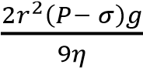
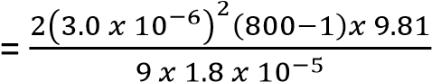
= 8.7 x 10⁻⁴ms⁻¹
time = 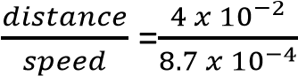 = 45.98s

7. (a) (i) What is meant by fluid element and flow line as applied to fluid flow? (02mark)
- A fluid element is a molecule (the smallest volume) of the fluid which follows the flow.
- A flow line is the path which individual molecule in a fluid element describes.
(ii) Explain why some fluids flow more easily than others (03marks) Fluid flow involves different parts of a fluid moving at different velocities. Different parts of the fluid therefore slide past each other in layers. There exists frictional force between the layers which affects the flow rate. Liquids with low friction or viscosity flow faster than those with high viscosity.
(b) (i) State Bernoulli’s Principle. (01mark) Bernoulli’s Principle states that for a streamline motion of an incompressible non viscous fluid, the sum of pressure at any point, the kinetic energy per unit volume is always constant.
(ii) Explain how a Pitot-static tube works
(04marks)
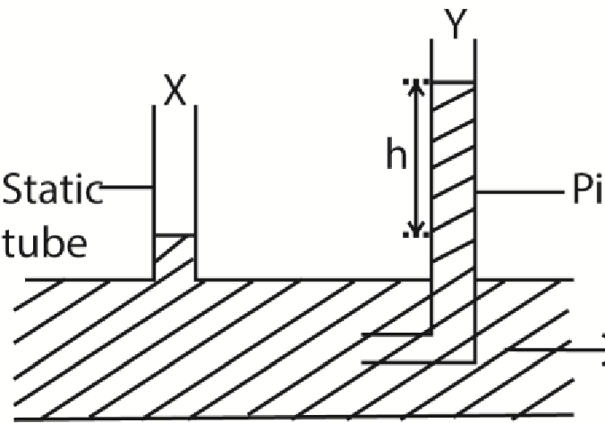
From P + 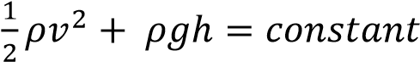
Static pressure = P + ρgh (where P is atmospheric pressure) Dynamic pressure = 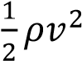
Total pressure, P_{y}
= static pressure (P_{x}) + dynamic pressure
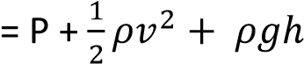
For horizontal tube, h is constant
But, Total pressure, P_{y}
= static pressure (P_{x}) + dynamic pressure
P_{y} 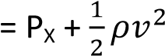 (P_{y} –P_{x}) = 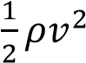
V = 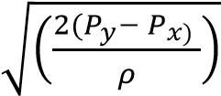

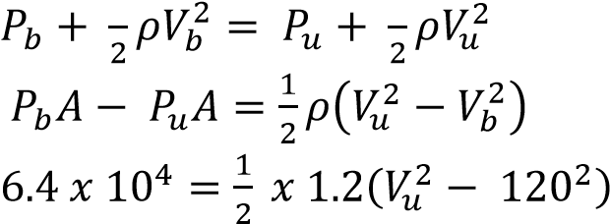
- Air flowing over the upper surface of an air craft’s wing causes a lift force of 6.4 x 10⁵N. The air flows under the wing at a speed of 120ms⁻¹ over an area of 28m². Find the seed of air flow over an equal area of the upper surface of the air craft’s wings. *Assume density of air = 1.2kgm⁻³) (04marks)
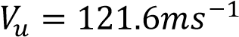
angle of contact of a liquid? (02marks)
- Surface tension is the force per metre length acting in the surface at right angles to one side of the line drawn in the surface.
- Angle of contact is the angle between
the solid surface and the tangent
Pitot-static tube consists of a static tube which measures the static pressure and the pitot tube that measures the total pressure. Total pressure is the sum of static and dynamic pressure. | plane to the liquid surface measured through the liquid.  (ii) A water drop of radius 0.5cm is broken up into other drops of water each of radius 1mm. assuming isothermal conditions, find the total work done to break up the water drop. (04marks)

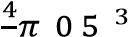
- (i) What is meant by surface tension and Number of drops formed = 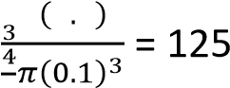
Total surface area = 125 x 4πr²
= 125π x 4 x (0.1 x 10⁻²)²
= 1.57 x 10⁻³m²
Initial surface area = 4πR²
= 4π(0.5 x 10⁻²)²
= 3.14 x 10⁻⁴m²
Work done = γ x change in surface area
= 7.0 x 10⁻² (1.57 x 10⁻³ – 3.14 x 10⁻⁴)
= 8.8 x 10⁻5J
8. (i) State Bernoulli’s principle (0marks) Bernoulli’s Principle states that for a streamline motion of an incompressible non viscous fluid, the sum of pressure at any point and kinetic energy per unit volume is always constant.
- Explain how wind at a high speed over the roof of a building can cause the roof
to be ripped off the building. (03marks)

Wind blowing at a high speed over the roof of a building causes pressure above the roof to decrease below the pressure in the building where the wind is slow. This difference in pressure causes a resultant force that pushes the roof off the building.

- An aeroplane has a mass of 8,000kg and wing area of 8.0m². When moving through still air, the ratio of its velocity to that of the air above its wings is 0.25. At what velocity will the aeroplane be able to just lift off the ground? (Density of air = 1.3kgm⁻³)
- Minimum force to lift an aeroplane = 8000 x
9.81 = 78480N
- If v is the velocity of the aeroplane, then velocity of air below the wings v_{b} = v.
- Velocity of the air above the aeroplane ,
-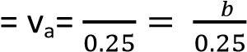 or v_{a} = 4v
- From Bernoulli’s Principle,
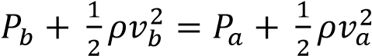
P_{b} – P_{a} 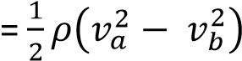
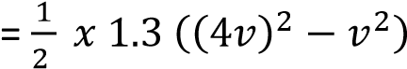= 9.75v²
- But force = pressure x area
⇨ 78480 = 9.75v² x 8 v = 31.72ms⁻¹
9. (a) Define coefficient of viscosity and state its units. (02marks)
Coefficient of viscosity is the frictional force on unit area of a liquid in a region of unit velocity gradient. Units Pas or Nsm⁻²
- Explain the origin of viscosity in air and account for the effect of temperature on it. (05marks)
In air, molecules are further apart and have negligible intermolecular forces. Therefore the molecules move randomly colliding with one another and continuously transferring momentum to the neighbouring layers. The transfer of momentum constitute viscosity of air. When the temperature increases the molecules move faster, their kinetic energy increases and make more frequent collision. This increases the transfer of momentum and lead to increase in viscosity.
- Describe, stating the necessary precautions an experiment to measure the coefficient of viscosity of a liquid using Stroke’s law. (07marks)

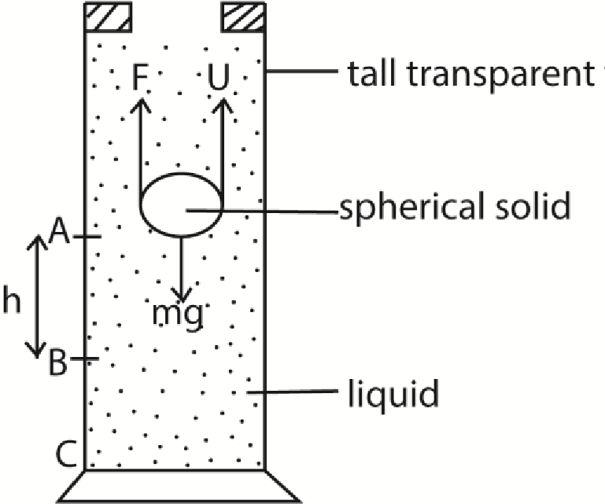
- A liquid of known density, ρ, is put in a tall transparent glass with reference marks A and B, h metres apart
- A spherical solid of radius a and density, ς, is dropped into the liquid and time t taken to drop from A to B is determined.
- Terminal velocity, v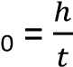
- The coefficient viscosity, 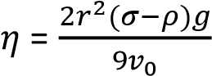

Assumptions
- The spherical solid moves with terminal velocity by the time it reaches A

Precautions
- The glass tube should be very wide compared to the diameter of the ball.
- The point C should be far away from the top of the tube
- Temperature is constant
(d) A steel ball bearing of diameter 8.0mm falls steadily through oil and covers a vertical height of 20.0cm in 0.56s. If the density of steel is7800kgm⁻³ and that of oil is 900kgm⁻³, calculate the
- up thrust on the ball (03marks)
U = 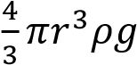
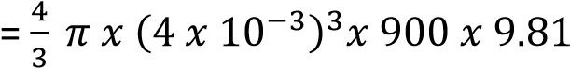
= 2.37 x 10⁻³N
- viscosity of the oil (03marks)
From 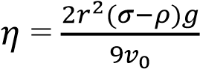
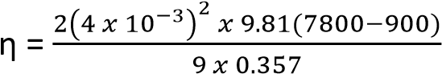
= 0.674Nsm⁻²
10. (a) Define terminal velocity (01mark) Terminal velocity is the maximum velocity attained by a body falling through a viscous fluid.
- Explain laminar flow and turbulent flow (03marks)
Laminar/streamline flow occurs when the fluid flows in tiny parallel layers with no disruption between them. The successive particles passing a given point have the same velocity. Turbulent flow is the type of flow where equidistant layers of a fluid from the axis of flow have varied velocities. The flow lines are not parallel and the flow is disorderly.
- Describe an experiment to measure the coefficient of viscosity of water using Ponselle’s formula. (07marks)
- the liquid of density, ρ, passes slowly from a constant head tank through a capillary tube of length, l and radius r.
- for a height, h, of the tube, the volume V is collect in time t.
- the flow rate R = is calculated
- the experiment is repeated for different value of V and h.
- a graph of R against h is plotted and slope S is obtained
For steady flow,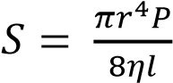
But P = hρg
r =
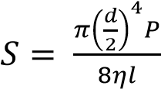

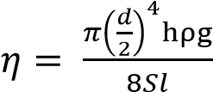

(d) (i) State Bernoulli’s principle (01 mark)
For non-viscous incompressible fluid flowing steadily, the sun of pressure plus kinetic energy per unit volume Plus potential energy per unit volume is constant.

(ii) Explain why a person standing near a railway line is sucked towards the railway line when a fast moving train passes. (03marks)
Between the man and the train, the velocity of air is increased due to the motion of the train resulting in a decrease in pressure according to Bernoulli’s Principle. Behind the man, the flow velocity is lower and pressure is higher. This results in a resultant force towards the train, hence the man is sucked in
(e) A horizontal pipe of cross sectional area
0.4m², tapers to a cross section area of 0.2m². The pressure at the large section of the pipe is 8.0 x 10⁴Nm⁻² and the velocity of water through the pipe is 11.2ms⁻¹. If the atmospheric pressure is 1.01 x 10⁵Nm⁻², find the pressure at the small section of the pipe. (05marks)
A₁V₁= A₂V₂
0.4 x 1.2 = 0.2 x V₂
V₂ = 2.4ms⁻¹
P
Since h1 = h2
P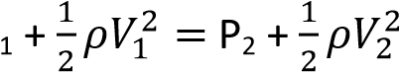
8.0 x 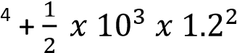10
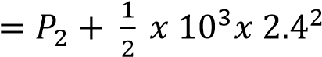
P₂ = 7.784 x 10⁴Pa

11. (a)(i) What is meant by the following terms, steady flow and viscosity? (02marks)
  - Steady flow is the flow where the velocity of the liquid past any given point is constant.
  - Viscosity is the friction between layers of a fluid in motion.
(ii) Explain the effect of increase in temperature on viscosity of a liquid.
(03marks)
- When temperature rises, the molecular separation of liquid molecules increases and the intermolecular forces decrease. The resistance to flow then decreases hence a decrease in viscosity.
(b) (i) Show that the pressure, P, exerted at a depth, h, below the free surface of a liquid of density, ρ, is given by P =hρg. (03marks)
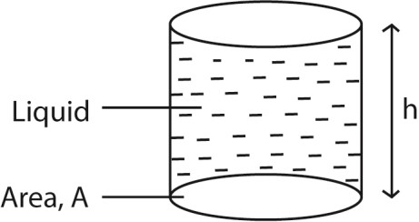

Weight of a liquid above A = mg
But = Ahρ
⇨ Weight = Force = Ahρg
Pressure = 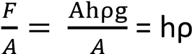g
(ii) Define relative density. (01mark)
Relative density is the ratio of the mass of any volume of a substance to the mass of an equal volume of water
(ii) A U-tube whose ends are open to atmosphere, contains water and oil as shown in the figure below
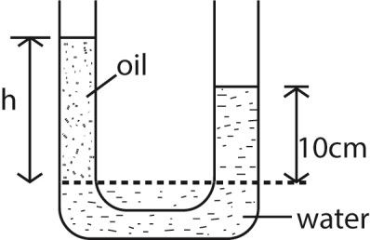
Given the density of oil is 800kgm⁻³, find the value of h. Pressure of oil and that of water at the dotted line are equal, if the density of oil = ς and that of water = ρ, then hςg = 0.1ρg
h = 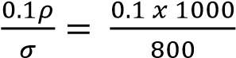
= 0.125m

(c) A metal ball of diameter 10mm is timed as it falls through oil at a steady speed. It takes 0.5s to fall through a vertical distance of
0.3m. Assuming that the density of metal is
7500kgm⁻³ and that of oil is 900kgm⁻³, find
- the weight of the ball (02marks)
Weight
= volume x density of the ball x acceleration due to gravity
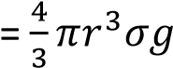
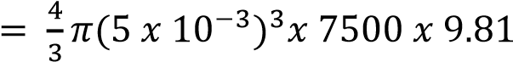
= 3.85 x 10⁻²N
- the up thrust on the ball (02marks)
Up thrust = volume of water displaced x density of water x acceleration due to gravity
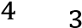
= 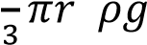
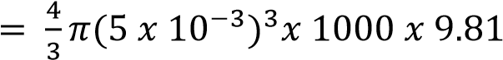
= 4.62 x 10⁻³N
- the coefficient of viscosity of the oil
(03marks) W = U + F mg = U + 6πrηv₀
But v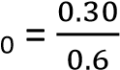 = 0.6ms⁻¹
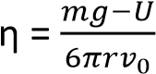
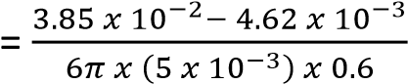
= 0.6Pa (or 0.6Nm⁻²s)
[Assume the viscous force = 6πηrv₀ where η is the coefficient of viscosity, r is the radius of the ball, v₀ is the terminal velocity]
12. (a) (i) State Archimedes’ Principle.
(01mark)
Archimedes’ Principle states that when an object is wholly or partially immersed in a fluid, it experiences an up thrust equal to the weight of the fluid displaced.
(ii) Use Archimedes’ Principle to derive an expression for resultant force on a body of weight, W, and density, ς, totally immersed in a fluid of density, ρ. (04marks)
Up thrust (U) = weight of fluid displaced
= mg
= Vρg Resultant force Fr = W – Vρg
but V =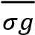
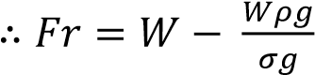
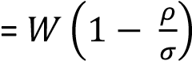
- A tube of uniform cross sectional area of 4 x 10⁻³m² and mass 0.2kg is separately floated vertically in water of density 1.0 x 10³kgm⁻³ and in oil of density 8.0 x 10²kgm⁻³. Calculate the difference in the lengths immersed (04marks) m = PV = ρAL
For water, L_{w} 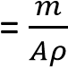
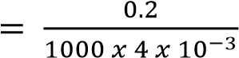
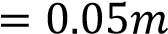
For oil, L_{o} 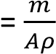
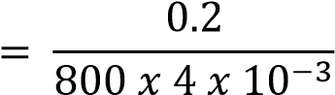
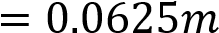
Difference in length = 0.0625 – 0.05
= 0.0125m

- (i) Define surface tension in terms of work (01mark)
Surface tension is the work done to increase the surface area of a liquid under isothermal conditions.
(ii) Use the molecular theory to account for surface tension of a liquid. (04marks)
      - Liquid molecules attract each other.
      - The molecules within the body of the liquid (bulk) molecules is attracted equally by neighbors in all direction, hence, the force on the bulk molecules is zero,
      - For a surface molecules, there is a net inward force because there are no molecules above the surface to attract them equally.

      - To the surface, work must be done against the inward attractive force, hence, a molecule in the surface of a liquid has a greater potential energy than a molecule in the bulk. The potential energy stored inmolecules at the surface is called free surface energy or surface tension.

      - Due to the attractive forces experienced by surface molecules due to their neighbours put in a state of tension; the liquid surface behave as a stretched skin.

    - Explain the effect of increasing temperature of a liquid on its surface tension. (04marks)
When a liquid is heated, the average kinetic energy of its molecules increase. So the intermolecular of attraction decrease because molecules spend less time in the neighbourhood of a given molecule. At the same time, more molecule enter the liquid surface which lowers the potential energy of the surface thereby lowering the surface tension.
    - Calculate the excess pressure inside a soap bubble of diameter 3.0cm if the surface tension of the soap solution is
2.5 x 10⁻²Nm⁻¹. (02marks)
Excess pressure = 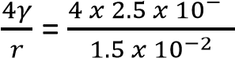
= 6.67Pa
13. (a)(i) State Archimedes’ Principle. (01mark)
Archimedes’ Principle states that when a body is fully or partially immersed in a fluid, it experiences an up thrust equal to the weight of the fluid displaced.
- Describe an experiment to determine the relative density of an irregular solid which floats in water
  - Weigh the solid in air = W
  - Attach a sinker to irregular solid and weigh them when the solid is outside but the sinker immersed in water = W₁
  - Weigh the solid and the sinker when the both completely immersed in water= W₂.
  - Upthrust on irregular solid in water = W₁ – W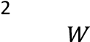 Relative density = 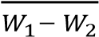
- A block of wood floats at an interface between water and oil with 0.25 of its volume submerged in oil. If the density of the wood is 7.3 x 10²kgm⁻², find the density of oil. (04marks) From mass = volume x density
Mass of water displaced
= 0.75V x 1000 where V = volume of wood Mass of oil displaced = 0.25Vρ where ρ = density of oil
Mass of water displaced + mass of oil displaced = mass of wood 0.75V x 1000 + 0.25Vρ
= 7.3 x 10²V ρ = -80kgm⁻³

(b) (i) State Bernoulli’s Principle. (04marks)
For non- viscous incompressible fluid, flowing steadily, the sum of the pressure, kinetic energy and potential energy per unit volume is constant.
(ii) Explain the origin of the lift force on the wings of an aeroplane at take-off. (04marks)

- Air flows above the wing of a plane at high velocity hence low pressure.
- Below the wings, air flows at low velocity and hence high pressure.
- The difference in pressure cause a lift force, therefore net upward force.
- Water flowing in a pipe on the ground with a velocity of 8ms⁻¹ and at gauge pressure of 2.0 x 10⁵Pa is pumped into a water tank 10m above the ground. The water enters the tank at a pressure of 1.0 x 10⁵Pa. Calculate the velocity with which the water enters the tank. (03marks)
From P +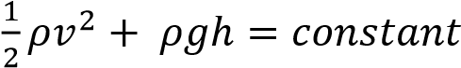
where P = atmospheric pressure+ gauge pressure
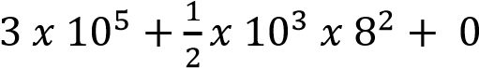
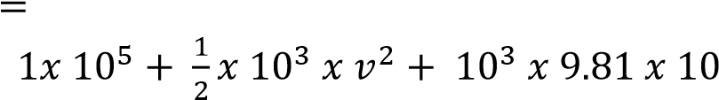
V = 16.4ms⁻1
- Describe how terminal velocity can be measured. (04marks)
- A viscous fluid is filled in a tall jar

- A spherical ball is dropped centrally into the fluid and time t taken by the ball to fall through known distance, d, between known points is determined.
- Terminal velocity, 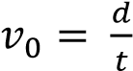
- The experiment is repeated to obtain average value.

C 2/7: MECHANICAL PROPERTIES OF MATTER
Competency: The learner explores the effects of force on the strength of different materials in order to guide on the selection of appropriate materials for construction work.

Mechanical property of matter and Hooke’s law These are properties of material under the action of force
- Strength: this is the ability of a material to resist breaking when a force is applied. E.g. metals
- Stiffness: this is the ability of a material to resist change in shape or size when a force is applied to it e.g. glass, dry wood.
- Elasticity is the ability of a material to regain its original shape and size after its deforming force has been removed. E.g. rubber, nullified spring.
- Plasticity: This is the ability of a material to remain permanently deformed when a deforming force has been removed e.g. plasticine, wet clay
- Ductility: this is the ability of a material to be changed into various shapes without breaking or is the ability of a material to be
deformed without breaking e.g. metals

Ductile materials undergo both elastic and plastic deformation.

- Brittleness: this is the ability of a material to break easily or suddenly when a force is applied to it e.g. dry clay, glass, chalk.
Brittle materials bend very little and break. Therefore they undergo only elastic deformation and their elastic region is very small.
- Hardness/toughness: this is the ability of a material to resist wearing e.g. rubber and metals

Hooke’s law
This states that the extension produced in a wire is directly proportional to the force applied provided the elastic limit is not exceeded.

F
F = ke k= where k = force constant Units of k
k = 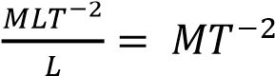 or ks⁻¹ or Nm⁻¹

Force constant, k, is the force required to change length of material by 1m.

Graph of force against extension versus load

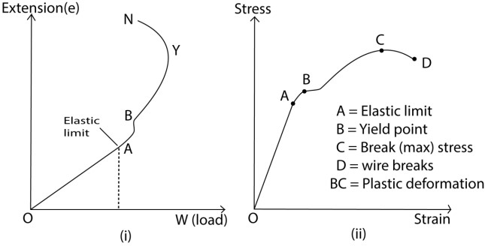

Description of section of stress- strain curve for ductile material above

Elastic limit: This is the stress/load/point beyond which a material stops undergoing elastic deformation.
Yield point: Is the stress/load/point beyond which a material stops undergoing plastic deformation
NB. At yield point, there is a sudden increase in extension even though a small force is used.

Region OA
Extension is directly proportional to the force applied (stress is directly proportional to strain).
The material regains its original length and shape when a force/stress is removed. Extension produced is due to the molecules being displaced from their equilibrium position.

Region AB
Material regains its original shape when the force /stress are removed.

Stress is not proportional to strain or extension is not directly proportional to applied force therefore the material does not obey Hooke’s law.

Region BC
The material does not fully regain its original shape and length when the force/stress is removed. Therefore Hooke’s law is not obeyed.

The extension produced is due to the atoms of molecules being pulled apart breaking the bond between them. When the stretching forces are removed, these bonds are never recovered therefore; the material does not fully regain its original length.

Region CD

The material remains permanently stretched or deformed when the force/stress is removed. The bonds between the molecules are broken completely.

Region DE
The wire breaks in this region with any further increase in force or stress.

At breaking point the wire thins out, become hot. i.e. heat is given out.

Elastic deformation
During elastic deformation, molecular separation increases. This increases elastic potential energy when the force/stress is removed; the molecules regain their equilibrium position. Initial elastic potential energy is regained and stability is restored.

Plastic deformation
During plastic deformation, molecular separation increases leading to gain in elastic potential energy. Some of this energy is then lost in form of heat. When the force/stress is removed, the lost heat is never regained and therefore stability is never restored.
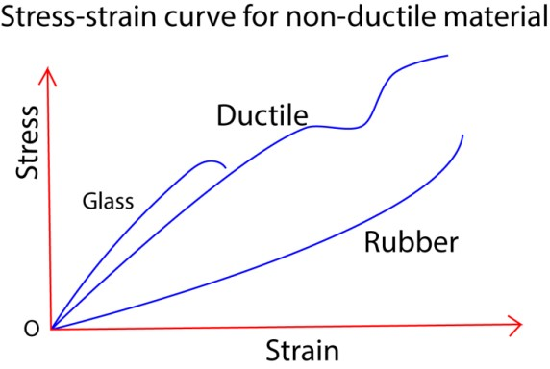

Glass: has he smallest elastic region and no plastic deformation regions. Glass is brittle due to small cracks on its surface. Any concentration of tensile stress/force on any of these cracks makes the glass break.

Rubber
Stretches easily without breaking and has a greatest range of elasticity. It does not undergo plastic deformation

Unstretched rubber consist of coiled molecules when a tensile force is applied, they uncoil, become straight and hard. Any further increase in tensile force makes the rubber to break.

Work – hardening
When a metal is repeatedly deformed, it becomes brittle and its resistance to plastic deformation increases. This is called work- hardening of a metal.

Stress
This is the force acting on an area of 1m² of a material or it is force per unit area
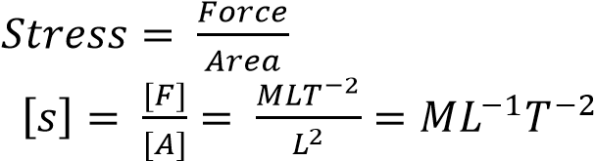
Units = kgm⁻¹s⁻², Nm⁻² or Pascal (Pa)

Strain
This is the change in length per unit original length or is the change in length per 1m of
original length

Strain = 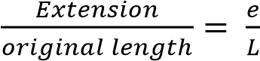(no units)

Young’s modulus of elasticity Young’s modulus, E, is the ratio of tensile stress to tensile strain

E = 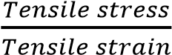

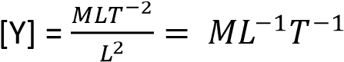

Units = kgm⁻¹s⁻², Nm⁻² or Pascal (Pa)

Or
- = 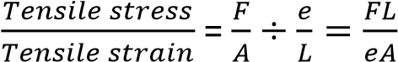

Then

- = 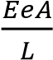

Example 1
A mass of 2kg attached to the end of a wire 2m and diameter 0.64mm causes an extension of 0. 6mm. Find the Young’s modulus.

F = 2 x 9.81 = 19.62N, A =
2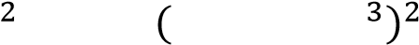 3.22 x 10⁻⁷m²

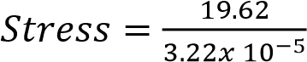= 6.1 x 10⁷Nm⁻²

And
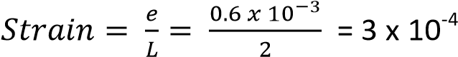

E = 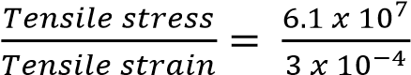 = 2.03 x 10¹¹ Nm⁻²

Alternatively
E = 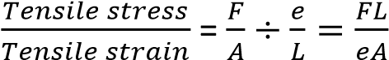
E = 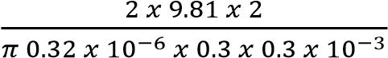 = 2.03 x 10¹¹Nm⁻²

It should be notes that Young’s modulus, E, is calculated from ratio stress/ strain with the elastic limit of the material.

Example 2
Find the maximum load in kg in which may be placed on a steel wire of diameter 0.10cm if the permitted strain must not exceed 0.001 and Young’s modulus for steel is 2.0 x 10¹¹
Nm-2.

E = 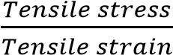
Maximum stress = maximum strain x Young’s modulus
= 0.001 x 2 x 10¹¹
= 2 x 10⁸Nm⁻²
Area of cross-section in m²
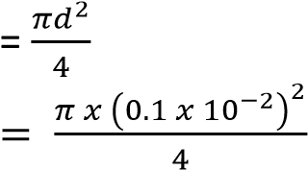
= 7.85 x 10⁻⁷m²

Stress = 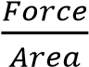

Force = stress x area
= 2 x 10⁸ x 7.85 x 10⁻⁷
= 157N

Mass = 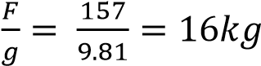

Force in bar due to contraction or expansion When a bar is heated, and then prevented from contracting as it cools, a considerable force is exerted at the end of the bar.

For a bar which is L m having Young’s modulus, E, a cross-sectional area, A, a linear expansivity of magnitude, α, and decrease in temperature, t⁰ C; the decrease length e if were free to
contract will be = αLt

E = 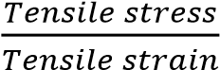
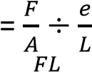
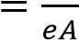
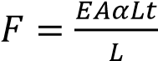
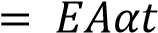

Example 3
A steel rod of cross section area 2.0cm² is heated to 100⁰C, and then prevented from contracting when it is cooled to 10⁰C. the linear expansivity of steel = 12 x 10⁻⁶K⁻¹ and Young’s modulus, E = 2.0 x 10¹¹Nm⁻². Find the force exerted.

Solution
A = 2cm² = 2 x 10⁻⁴ m², t = 100 – 10 = 90⁰C

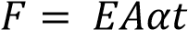
= 2 x 10¹¹ x 2 x 10⁻⁴ x 12 x 10⁻⁶ x 90
= 43200N

Energy stored in a stretching wire

When a wire is stretched by an amount, e, by applying a force, F without exceeding elastic limit. The average force = 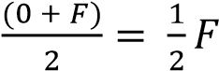

Work done/ work stored in a wire = force x distance = 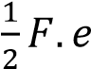

Work done per unit volume of a wire

The volume of the wire = AL

Energy per unit volume = 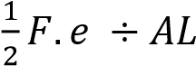
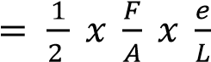

Energy stored per unit volume
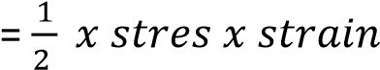

Experiment to determine Young’s Modulus for
a metal wire

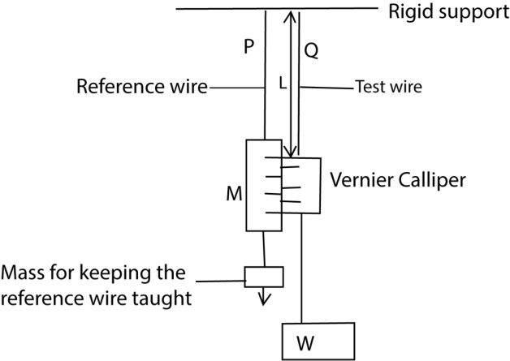

- Two thin, long wires of the same material and length P and Q are suspended from a rigid support.
- P carries a scale M in mm and its straightened by attaching a weight at its end.
- Q carries a vernier scale which is alongside scale M
- Various loads are added to the test wire and corresponding extensions caused are read off from a vernier scale.
- The diameter (2r) of the wire is obtained
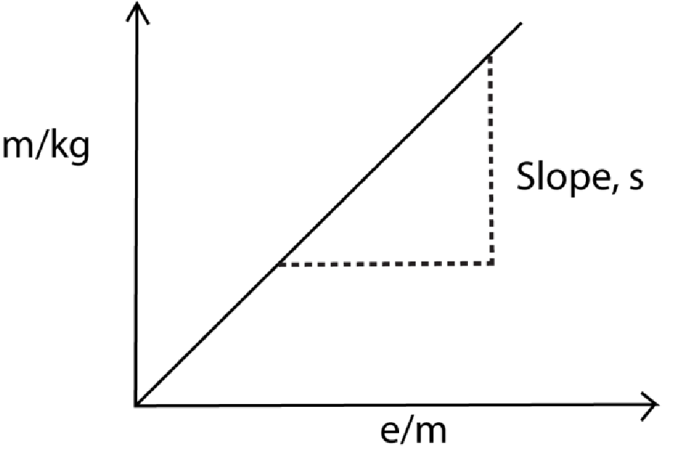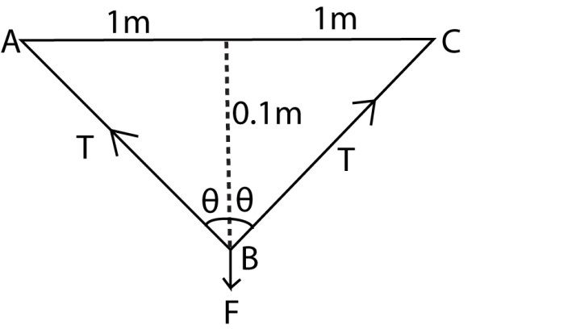Length ABC = 2AB = 2 x 1.005 = 2.01
by a micrometer screw gauge, and the
cross section area of the wire A =

(
vi
)

A graph of mass (m) of the load against
extension e is plotted

Young’s modulus, Y =

cos θ =

but

√
(

)

=
1.005m

cos θ =

Extension, e = 2.01
–

2
= 0.01m

Precaution in the experiement above
- After each reading, the load is removed to check that the wire returns to its original length, to ensure that elastic limit is not exceeded.
- Long wires are used to achieve measurable expansion
- Thin wires are used to produce high tensile stress
- Identical wires are used to eliminate error of expansion or contraction due to changes in temperature.

Example 4
A metal wire of diameter 2.0 x 10⁻⁴m and length 2m is fixed horizontally between two points 2m apart. Young’s modulus for the wire is 2 x 1011Nm-2.
- What force should be applied at the midpoint of the wire to depress it by
0.1m
- Find the work done

T = and A = 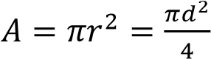
Resolving vertically F = 2Tcosθ
F = 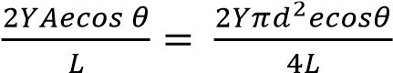

F =

(iii) Work done =
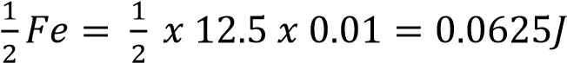

Example 5
A uniform bar of length 1.0m and diameter 2.0cm is fixed between two rigid supports at 25⁰C. If the temperature of the rod is raised to 75⁰C.
Find
- The force exerted on the supports.
- The energy stored in the rod at 75⁰C. (Young’s modulus for the metal = 2.0 x 10¹¹Pa, coefficient of linear expansion = 1.0 x 10⁻⁵K⁻¹)

Solution
- F = YAα∆θ
= 2.0 x 10¹¹ x (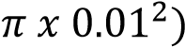 x 1.0 x 10⁻⁵ (75 – 25)
= 31400N
- Energy stored = 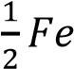 but e = αL∆θ
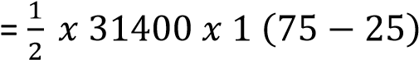
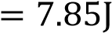
Revision Exercise
- (a) (i) What is an elastic material?
(01mark)
An elastic material is a type of material that can undergo significant deformation when subjected to an external force but will return to its original shape and size once the force is removed.
(ii) Show that the energy,E, stored in a stretched elastic material of elastic constant,k, is given by
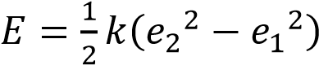, where e₂ and e₁ are extensions produced.
(04marks)
    - Elastic Potential Energy: The elastic potential energy stored in a material when it is stretched or compressed by an extension e is
given by 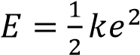(where k is the elastic constant of the material)
    - Energydifference,E: If the material is stretched from an initial e₁to a final extension e₂, the energy difference is given by
E = E₂ - E₁
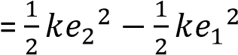
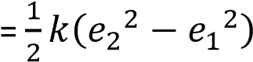 as required

(iii) Explain the energy transforation which occur during elastic deformation. (03marks)
      - When external force is applied to an elastic material, it deforms and the work done is stored as elastic potential energy or on molecular level; the atoms and molecules within the material are displaced from their equilibrium positions. The potential
energy is stored in the form of elastic bonds between these molecules when external force is applied.
      - For small deformations, the relationship between the force and the deformation follows Hooke’s Law, where the force is proportional to the displacement.
      - As long as the deformation is within the elastic limit of the material, the energy is stored without causing permanent changes to the material’s structure.
      - When external force is released, the stored elastic potential energy is released and the material returns to its initial state/shape.
(b)(i) State the easurements taken in an experieent to determine Young’s Modulus of a mateiralof a material in form of a wire. (02marks)
      - Initil length
      - Diameter of the wire
      - Final length
      - Applied force/load
  - Explain why in the experient in (b)(i), two identical wires are used.
(02marks)
  - To eliminate errors due to (i) the yielding of the support when loads are added to the test wire, (ii) changes of temperature.
  - (c) Two wires 2.0 m long, one of steel and the other of brass are suspended vertically from two points 0.10m apart in the same horizontal plane. Their lower ends ae fixed to a light horizontal bar at points 0.10m apart. When a force
of 100N is applied vertically downwards to the centre of the bar, the bar tilts by 2⁰ to the horizontal due to the brass wire of the brass wire stretching more than the steel.
Assuming tht the wires are vertical and the diameter of each wire is 0.80mm, calculate the;
  - Difference between the extensions in the wires. (02marks) Let the difference in extension be x


2
0

0.1
m

xm

Using cosine rule x² = 0.1²+ 0.1² -2 x 0.1 x0.1cos2 x = 0.0035m
  - Extension produced in the brass wire
[Young Modulus for steel = 2.0 x
10¹¹nm⁻²] (06marks)

Force on the steel wire
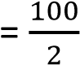
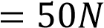
Crossection areaof steel wire ,
A = 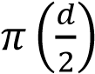

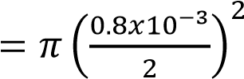

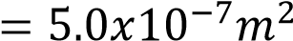
Extension = 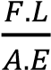
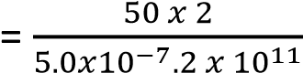
= 0.001m
Hence extension of brass = 0.001+0.0035
= 0.0045m
- (a) Define the following
(i) Brittleness (01 mark)
A brittle material is a hard substance that breaks easily when a force is exerted on it e.g. glass
  - Elasticity (01mark)
Elasticity is ability of a deformed material body to return to its original shape and size when the forces causing the deformation are removed.
- Stat Hooke’s law (01mark)
Hooke’s law states that the extension of a material is proportional to the stretching force provided the elastic limit is not exceeded.
- Figure 1 chows graphs of stress against strain for two metals X and Y.
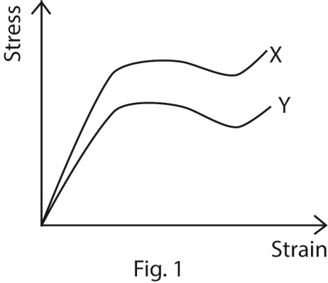
State and explain which metal;
- has a greater Young’s modulus, (02marks)
X has high stress per unit of strain
- is more ductile, (02 marks) Y stretches more per given stress leading to low Young’s modulus; often materials with low Young’s modulus are ductile like aluminium, although low Young’s modulus does not guarantee ductility; for instance, Glass fibers are flexible but brittle.
- is stronger than the other. (02marks)
X resists deformation. Usually stiff materials are strong, although ceramics is not. While rubber is strong but with low Young’s modulus
(d) Two wires P and Q of the same material have equal length but the radius of P is twice that of Q. Which wire;
- can withstand the greater load before breaking? (02marks)
P because the maximum load a wire can withstand is directly proportional to its cross-sectional
area. i.e. F_{max} = kA
- has the greater strain for a given load? (02 marks) Q because it experienced larger increase in length because it experiences large increase in length per unit load for unit length
- A copper wire of length 4m and cross sectional area 1.0 x 10⁻³mm² is fixed between two rigid supports A and B, 4m apart. What mass, when suspended at the middle of the wire will produce sag of 1.5m at that point?
(Young’s modulus of copper = 1.2 x 10¹¹Pa) (04marks)
Let the mass be M kg
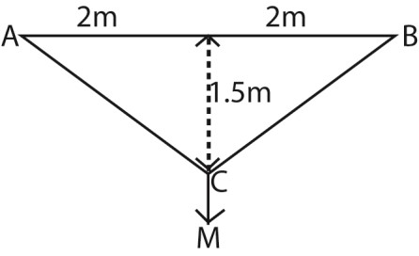
Length of the of the stretched wire
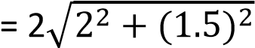
= 5m Extension = 5 – 4 = 1m
E = 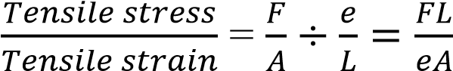

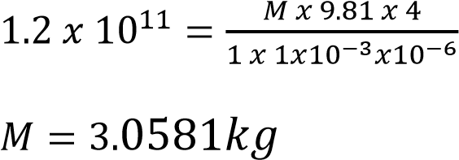

- Explain why water flowing out of a small hole at the bottom of a wide tank results in a backward force on the tank. (03marks)
Water flowing out of a small hole creates a backward force on the tank due to the conservation of momentum, where the water gains forward momentum as it exits, causing the tank to gain equal and opposite backward momentum (recoil), and also because of Newton's Third Law (actionreaction), as the water exerts a force forward, the tank pushes back equally and oppositely, similar to a rocket. The small hole forces the water out at high velocity, creating significant momentum in the water that must be countered by the tank.

3. A uniform wire of upstretched length 2.49m is attached to two points A and B which are two meters apart and in the same horizontal line. When 5kg mass is attached to the midpoint, c, of the wire, the equilibrium point of c is 0.75m between the line AB.
(Young’s modulus for the wire =2.0 x
10¹¹Pa)
Find
(a) Strain and stress in the wire
[strain = 0.00402, stress = 8.04 x 10⁸Pa]
(ii) Energy stored in the wire [Ans. 2.02 x
10³J]

- A thin steel wire initially 1.5m long and diameter 0.5mm is suspended from a rigid support. Calculate (i) extension (Ans. 3.53 x 10⁻³m)
(ii) the energy stored in the wire, when a mass of 3kg is attached to
the lower end. [ 5.19 x 10⁻²J]
(Young’s modulus = 2.0 x 10¹¹Nm2
]
- Two thin wires, one of steel and the other of bronze each 1.5mg and the diameter 0.2cm are joined end to end to form a composite wire of 3m. What tension will produce a total extension of 0.064cm? ( Young’s modulus for steel = 2.0 x 10¹¹Pa, Young’s modulus of bronze = 1.2 x 10¹¹Pa)
{Ans. 1009N]

4. (a) Define the following as applied to materials
  - Stress (01 mark)
Stress is force per unit area.
  - Young’s Modulus (01 mark)
Young’s modulus is the ratio of tensile stress to tensile strain
(b) The velocity of compressional waves travelling along a rod made of material of Young’s Modulus, E, and density, ρ, is given by V = 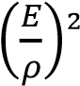.
Show that the formula is dimensionally consistent. (02 marks)
LHS, [V] = LT⁻¹ …………………… (i)
Since [E] = ML⁻¹T⁻² and [ρ] = ML⁻³
⇨ RHS = 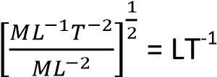 ….... (ii)
From eqn. (i) and eqn. (ii) the relation is dimensionally consistent.
(c) Derive an expression for the energy stored in a stretched wire within the elastic limit. (03marks)
Energy stored in the rod = 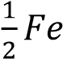
Energy stored per unit volume = 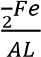
But F = 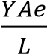
Energy store per unit volume = 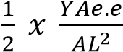
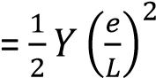
Or
For a small extension, dx Work done, dw = Fdx
From Hooke’s law, F = kx
Since, 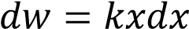
=> Total work done, w =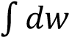
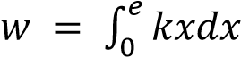
Energy store =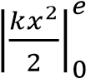, but k = 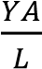
=> Energy stored = 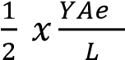
Energy stored per unit volume = 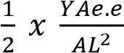
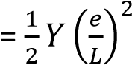
Where is Y is Young’s modulus, e = extension, L=initial length of the rod, A = cross section ‘area

- A uniform wire of length 2.49m is attached to two fixed points A and B, a horizontal distance 2m apart. When a 5kgmass is attached to mid-point C of the wired, the equilibrium position

of C is 0.75m below the line AB. Neglecting the weight of the wire and taking Young’s Modulus for the material to be 2 x 10¹¹Nm⁻², find the
  - strain in the wire (04 marks)

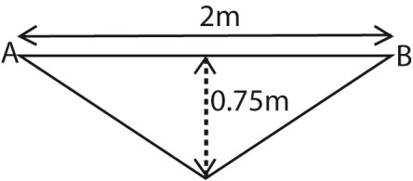
Final length of the wire
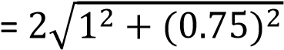
=2.5m
Extension, e = 2.5 – 2.49
= 0.01m
Strain = 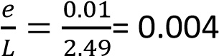
  - stress in the wire (02 marks)
Young’s modulus = 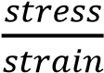
Stress = Young’s modulus x strain
= 2 x 10¹¹ x 0.25
= 8 x 10⁸ Nm⁻²
  - energy stored in the wire (04 marks)
Energy stored in the rod
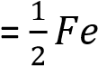
- (i) Sketch the stress-strain curve for glass and explain its shape. (02 marks)

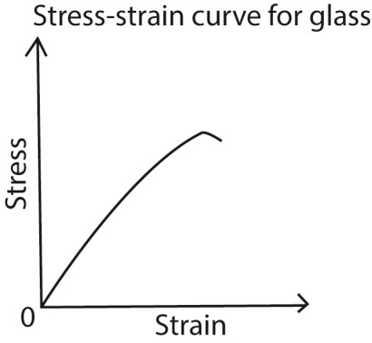
Glass: has the a very small elastic region and no plastic deformation regions.
(ii) Why does glass break easily? (01 marks)
Glass is brittle due to small cracks on its surface. Any concentration of tensile stress/force on any of these cracks makes the glass break.
5. (a) What is meant by a
  - Brittle material (01mark) A brittle material is a substance that breaks easily when a force is exerted on it e.g. glass
  - Ductile material (01marks) A ductile material is one that can be hammered, rolled or moulded into different shapes.
(b) Give one example of each of the materials in (a) (01mark)
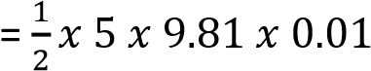 Ductile material: copper, aluminium
= 2.4525J (c) Explain why bicycle frame are hollow
(02mark)

Brittle material: glass, clay, cast iron, stone
Bicycle frame is hollow to reduce weight while maintain strength. A tube is significantly tougher to
bend than a rod of the same material.
- (i) Sketch a labeled graph of stress against strain for a ductile material (02marks)

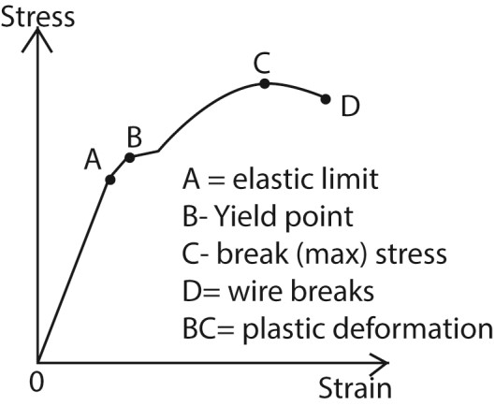
(ii) Explain the main features of the graph in (d)(i) (04marks)
  - OA – stress is proportional to strain and the material regains its length
  - AB - stress is not proportional to strain but the material regains its length
  - Beyond B the material becomes permanently stretched
  - CD the material undergoes plastic deformation
  - Beyond D the material breaks

- Derive the expression for the energy stored per unit volume in a rod of length, L, Young’s Modulus, Y, when stretched through distance, e.
(04marks)
Energy stored in the rod = 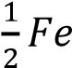
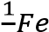
Energy stored per unit volume = 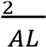
But F =
Energy store per unit volume
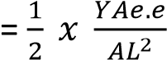
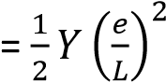
Or
For a small extension, dx Work done, dw = Fdx
From Hooke’s law, F = kx
=> Total work done, w
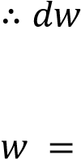
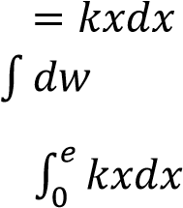
=

Energy store =, but k =
=> Energy stored = 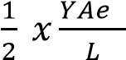
Energy stored per unit volume
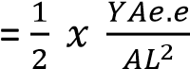
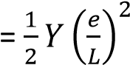
(f) A load of 5kg is placed on top of a vertical brass rod of radius 10mm and length 50cm. find
- decrease in length (03marks)
F = mg = 5 x 9.81 A = 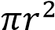 = π(10 x 10⁻³)² e = 
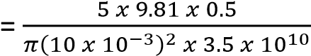
= 2.23 x 10⁻⁶m
- energy stored in the rod. (02marks)
E = Fe
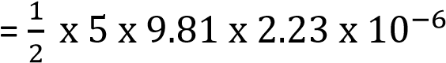
= 5.46 x 10⁻⁵J
6. (a)(i) Define elastic deformation and plastic deformation (02marks)
- Elastic deformation is when a material is deformed and it regains its original shape and size when the deforming force is removed.
- Plastic deformation occurs when a force is applied and the material does not regain its original shape and size
when the force is removed

(ii) Explain what is meant by work hardening. (02marks) Work hardening is the strengthening of a material by repeatedly deforming it. Atomic planes slide over each other; this increases plane dislocations which prevent further sliding of planes.

(b) (i) Sketch using the same axes, stressstrain curves for ductile material and for rubber (03marks)
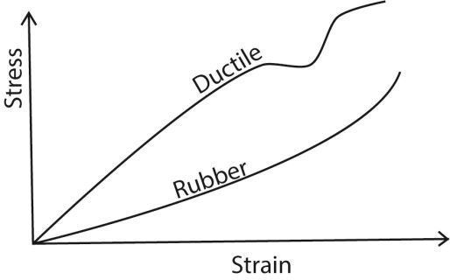
(ii) Explain the features of the curve for rubber. (03marks)

Rubber does not obey Hooke’s law except for a very small range; it stretches easily without breaking and has a greatest range of elasticity. It does not undergo plastic deformation Unstretched rubber consist of coiled molecules when a tensile force is applied, they uncoil, become straight and hard. Any further increase in tensile force makes the rubber to break.

7. (a)(i) What is meant by Young’s modulus?
(03marks)
Young’s Modulus is the ratio of tensile stress to tensile strain of a
material
  - State Hooke’s law (01mark) Hooke’s law states that the extension of a material is proportional to the stretching force provided the elastic limit is not exceeded.
  - Derive an expression for energy released in a unit volume a stretched wire in terms of stress and strain.
(04marks)

Suppose a force, F, stretches the wire
by extension x
Work done,
W = average force x extension
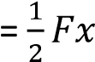= stored energy
Energy stored per unit volume 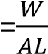; where AL is the volume of the wire Hence energy store
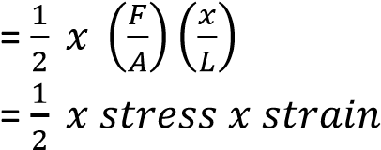

- A steel wire of length 0.6m and cross-section area 1.5 x 10⁻⁶m² is attached at B to a copper wire BC of length 0.39m and cross section area 3.0 x 10⁻⁶m². The combination is suspended vertically from a fixed point at A and supports a weight of 250N at C. find the extension in each

of the wires, given that Young’s the wire A = 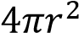
Modulus for steel is 2.0 x 10¹¹Nm⁻² (vi) A graph of mass (m) of the load and that of copper is 1.3 x 10¹¹Nm⁻². against extension e is plotted
(05marks)

From e = 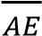
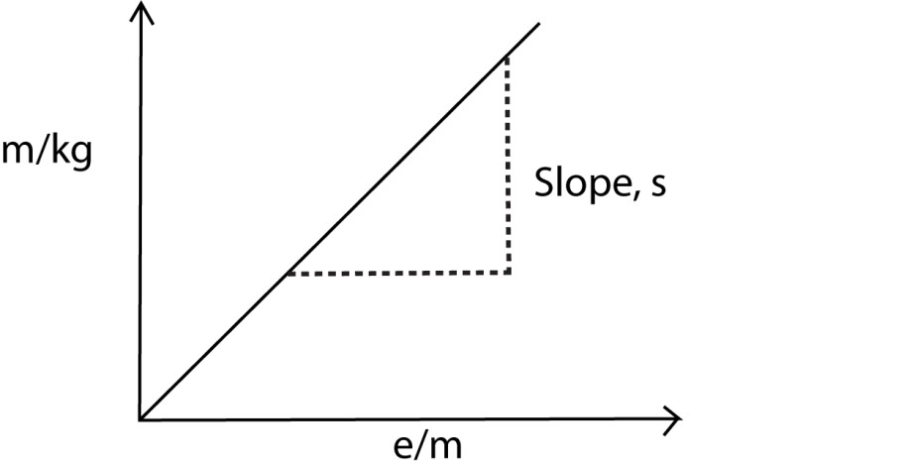
For steel, e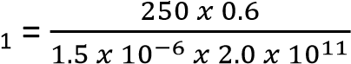

= 5.0 x 10⁻⁴m
For copper, e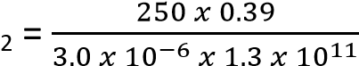
= 2.5.0 x 10⁻⁴m Young’s modulus, Y =

- With the aid of a labelled diagram, describe (d) Explain the term plastic deformation in an experiment to determine the Young’s metals (02marks)
Modulus of a steel wire (07marks) During plastic deformation, some
crystal planes slide over each other. The

Experiment to determine Young’s
Modulus for a metal wire movement of dislocation takes place
and on removing the stress, the original
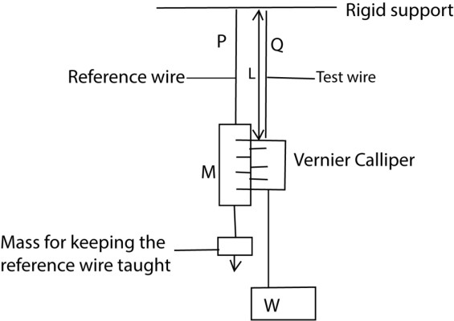
shape and size are not recovered due to energy loss in form of heat.

8. (a) State Hooke’s law. (01mark) Hooke’s law state that extension is proportional to the load provided the proportionality limit is not exceeded.
(b) A copper wire is stretched until it breaks.
(i) Sketch a stress- strain graph for the

wire and explain the main features of
the graph. (04marks)
- Two thin, long wires of the same material and length P and Q are suspended from a rigid support.
- P carries a scale M in mm and it’s straightened by attaching a weight at its end.
- Q carries a Vernier scale which is alongside scale M
- Various loads are added to the test wire and corresponding extensions caused are read off from a vernier scale.
- The diameter (2r) of the wire is obtained by a micrometre screw gauge, and the cross section area of

- OA – stress is proportional to strain and the material regains its length
- AB - stress is not proportional to strain but the material regains its length
- Beyond B the material becomes permanently stretched
- CD the material undergoes plastic deformation
- Beyond D the material breaks

(ii) Explain what happens to the energy used to stretch the wire at each stage. (04marks)
- During elastic deformation, atoms are slightly displaced from equilibrium position. When the load is applied to the wire, energy used to stretch wire becomes elastic potential energy
- When the wire is stretched beyond elastic limit, permanent displacement of atoms occurs. The energy is used to break some interatomic bond and some is released as heat.
- At the breaking point, energy is used to break the interatomic bonds.
(iii)Derive the expression for the work done to stretch a spring of force
constant, k, by a distance, 2. (03marks)
dw = Fdx Work done = 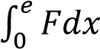
But F = kx
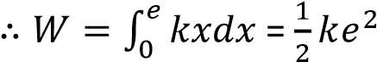
(c)(i) Define Young’s Modulus. (01mark)
Young’s Modulus is the ratio of tensile stress to tensile strain
(ii) Two identical steel bars A and B of radius2.0mm are suspended from the ceiling. A mass of 2.0kg is attached to
the free end of bar A. Calculate the temperature to which B should be raised so that the bars are again equal in length.
*Young’s Modulus of steel = 1.0 x 10¹¹Nm⁻², Linear expansivity of steal = 1.2 x 10⁻⁵K⁻¹] (05mark) e = 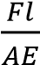, also e = αlΔθ where Δθ is temperature change
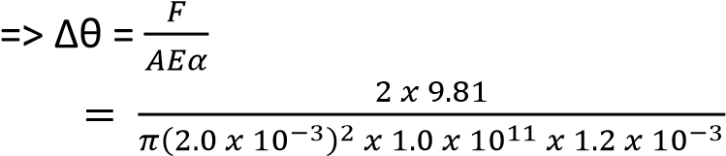
= 1.4K
(d) Why does an iron roof make cracking sound at night? (02marks) During the day, the roof is heated, it expands and buckles since it is fixed. At night, the roof contracts due to fall in temperature. As it straightens again sound is produced.
9. (a) (i) Describe the terms tensile stress and tensile strain as applied to a stretched wire.
(02marks)
- Tensile stress is the ratio of the stressing force applied on the wire to the cross sectional area of the wire.
- Tensile strain is the ratio of extension in a wire to original length of the wire.
(ii) Distinguish between elastic limit and proportional limit. (02marks)
  - Elastic limit s the point beyond which a material does not regain its original length and shape when the load is removed.
  - Proportional limit is a point beyond which the extension of a material is not proportional to the applied force or load.
(b) With the aid of a labeled diagram, describe an experiment to investigate the relationship
between tensile stress and tensile strains of a steel wire. (07marks)
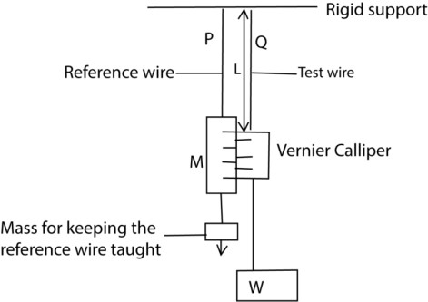

- Two thin, long wires of the same material and length P and Q are suspended from a rigid support.
- P carries a scale M in mm and it’s straightened by attaching a weight at its end.
- Q carries a Vernier scale which is alongside scale M
- Various loads are added to the test wire and corresponding extensions caused are read off from a vernier scale.
- The diameter (2r) of the wire is obtained by a micrometre screw gauge, and the cross section area of the wire A = 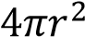
- The strain, 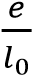 and stress, are obtained
- The procedure is repeated for different values of F and e
- A graph of stress against strain is plotted. From the graph it is found that in the first part stress is proportional to strains up to a certain point beyond which it not proportional.

(c)(i) A load of 60N is applied to a steel wire of length 2.5m and cross sectional area of 0.22mm². If Young’s Modulus for steel is 210GPa, find the expansion produced. (03marks)
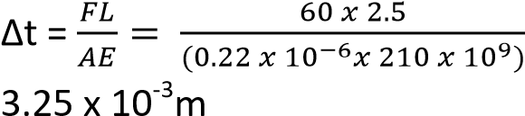=
(ii) If the temperature rise of 1K causes a fractional increase of 0.001%, find the change in length of a steel wire of length 2.5 when the temperature increases by 4K.
(03marks)
1K causes an extension of 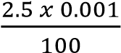
4K causes an extension of
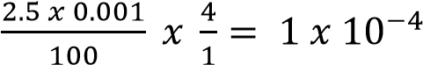m

(d) The velocity, V, of a wave in a material of Young’s Modulus, E and density, ρ, is given by
V = 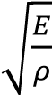. Show that the relationship is dimensionally correct. (03marks)
LHS, [V] = LT⁻¹ ………………….……… (i) Since [E] = ML⁻¹T⁻² and [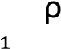 ] = ML⁻³
⇨ RHS = 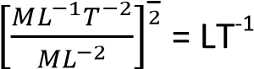 …….. (ii)
From eqn. (i) and eqn. (ii) the relation is dimensionally consistent.
10. (a) (i) Define stress and strain (02marks) Stress is force per unit area.
Strain is force per unit length
(ii) Determine the dimensions of Young’s modulus. (03marks)
Y = 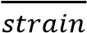
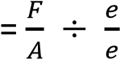
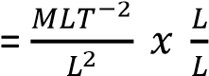
= ML⁻¹T⁻²
- Sketch a graph of stress versus strain for a ductile material and explain its features. (06marks)

    - OA – stress is proportional to strain and the material regains
its length
    - AB - stress is not proportional to strain but the material
regains its length
    - Beyond B the material becomes permanently stretched
    - CD the material undergoes plastic deformation
    - Beyond D the material breaks

- A steel wire of cross section area 1mm² is cooled from a temperature of 60⁰C to 15⁰C. Find the:
  - strain (02marks)
Strain = αΔθ
= 1.1x 10-5 x (60 – 15)
= 4.95 x 10 ⁻⁴

  - force needed to prevent it from contracting. (03marks)
*Young’s Modulus= 2.0 x 10¹¹Pa, Coefficient of linear expansion of
steel = 1.1 x 10⁻⁵K⁻¹]
Force = AYstrain
= 10⁻⁶ x 2 x 10¹¹ x 4.95 x 10⁻⁴
= 99N

- Explain the energy changes which occur during plastic deformation (04marks)

During plastic deformation, molecular separation increase leading to a gain in elastic potential energy and heat is evolved. This heat is not recoverable when stress is reduced to zero. 11. (a) Explain the term
    - Ductility (01mark) Ductility is the ability of a material to be transformed into different
shapes without crumbling

    - Stiffness (01mark) Stiffness is the ability of a material to oppose change in shape
(b) A copper wire and steel wire each of length 1.0m and diameter 1.0mm are joined end to end to form a composite wire 2.0m long. Find the strain in each when the composite stretches by 2.0 x 10⁻³m.
*Young’s Modulus for copper and steel are 1.2 x 10¹¹Pa and 2.0 x
10¹¹Parespectively] (07marks)
F₁ = k₁e₁; F₂ = k₂e₂ But F₁ = F₂ k₁e₁ = k₂e₂
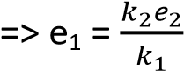
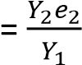
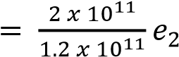
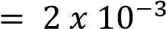
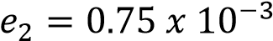 m

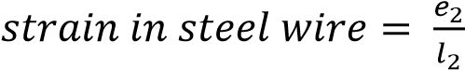
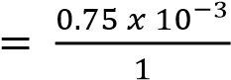
= 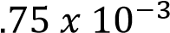

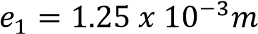
Strain in copper wire = 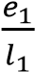
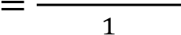
= 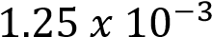

TOPIC 3/7: THERMOMETRY
Competency: The learner investigates the mode of operation of different types of thermometers and their applications in the real world.
Thermometry
This involves the study of thermometers as instruments used to measure temperature on the basis of certain physical thermometric properties which change with temperature and remains constant at constant temperature.
A thermometric property is a physical quantity which varies continuously, uniformly and linearly with temperature and remains constant at constant temperature.

Scales of temperature
These are scales in which the measure of hotness or coldness of a body can be expressed .i.e. the measure of hotness or coldness of a particular body can be expressed in;
- Degrees centigrade (⁰C) forming a Celsius scale of temperature.
- Kelvin (K) forming a thermodynamic scale of temperature.
- Degrees Fahrenheit (⁰F) forming a Fahrenheit scale of temperature.
Convrsion os scales
If t⁰C is temperature reading
  - The thermodynamic scale is given by T= (t +273)K
  - Fahrenheit scale temperature = 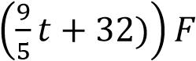

Types of thermometers and thermometric property
Type of thermometers | Thermometric property
Liquid in glass | Length of liquid column
Electrical resistance thermometer e.g. platinum resistance | Resistance of the platinum wire
Gas thermometer e.g. constant volume gas thermometer | Changes in pressure with temperature
Thermocouple | Induced e.m.f
Radiation pyrometer | radiation

Qualities of a good thermometric property
- Considerably vary for small changes in temperature.
- Vary over a wide range of temperature (both high and low)
- Vary linearly, uniformly and continuously with temperature
- Be accurately measurable over a wide range of temperature with a simple apparatus

Related concepts
- Fixed point is defined as constant temperature at which a physical state of pure water is expected to change at 760mmHg. Fixed points are basically two i.e. 0⁰C and 100⁰C.
- Lower fixed point (T₀) is the temperature of pure melting ice at 760 mmHg. It is 0⁰C.
- Upper fixed point (T₁₀₀) is the temperature of pure steam at 760mmHg. It is 100⁰ C.
- Triple point (T_{tr}) is the temperature at which pure water pure steam and pure ice co – exist in equilibrium at 760mmHg. It is 0.16⁰ C or 273.16K.
- Fundamental interval is the range of the thermometer readings at the two fixed points e.g. for thermometers which give direct readings of temperature = 100⁰ C.

Establishing scales of temperature
- Chose a physical property of substance (X)
- Determine the value of the property at the upper fixed point of the thermometer (X₁₀₀). This is done by placing the bulb of the thermometer in steam at 760mmHG until a constant reading is obtained.
- Determine the value of the property at the upper fixed point of the thermometer (X₀). This is done by placing the bulb of the thermometer in melting ice at 760mmHG until a constant reading is obtained.
- If the value of the thermometric property at temperature, θ, is X_{θ}.
Then θ = 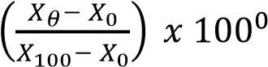C

Thermal dynamic scale of temperature
On this scale of temperature is measured in “Kelvin” or K and makes use of triple point only.
If X_{tr} is the value of a thermometric property at the triple point and X_{T} is the value of thermometric
property at temperature, T = 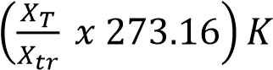
Using a platinum resistance thermometer
T = 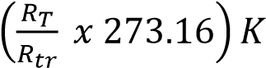
Where
- R_{T} is the resistance of the wire at unknown temperature, T.
- R_{tr} is the resistance of the wire at the triple point of water.

Example 1
The pressure recorded by a constant volume gas thermometer at temperature T is 4.8 x 10⁴Nm⁻². Find T if the pressure at the triple point of water is 4.2 x 10⁴Nm⁻².
Solution
T = 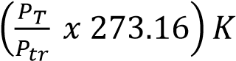
T = 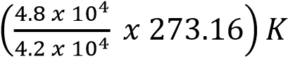 312.2K

Absolute zero temperature
This is the temperature of an ideal gas which corresponds to its zero volume or zero pressure it exerts on the walls of the container in which it is trapped. This value approximates to the triple point of pure water i.e. - 273⁰C or 0K.

Molecular explanation for existence of absolute zero temperature
When a gas is cooled, its molecules loose kinetic energy continuously since it depends directly on temperature. As molecules lose kinetic energy they move closer into close proximity until when they cease to have kinetic energy. At this point the gas is said to occupy a negligible volume and its temperature at this point is called the absolute zero temperature and the pressure the gas exerts on the walls of the container occupied is negligible.

Estimating absolute zero temperature
- Volumes a fixed mass of a gas at various temperatures are determined.
- The volumes of the gas are plotted against corresponding temperature.
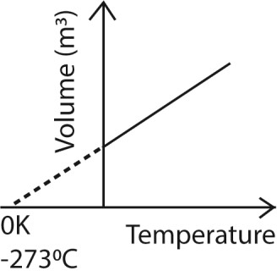

Absolute zero temperature is determined by extrapolating the graph until when it touches the temperature axis and is found to be -273⁰C or 0K.

Types of thermometers
1. Liquid in glass thermometer Depends on expansion of the liquid

Advantages of liquid-in-glass thermometer.
- The thermometer is simple, cheap and portable.
- The thermometer can be calibrated to give direct readings e.g. clinical thermometer

Liquids used in thermometers Mercury
Advantages
- withstands high temperature without change of state
- does not wet glass - expands uniformly
Disadvantage
- it is expensive
- it is poisonous

Alcohol
Advantage
- Measures low temperatures because of its low freezing point
- Cheap
Disadvantages
- does not measure high temperature above 78⁰C.
- wets glass
- Water is not used because it has irregular expansion
- Cannot measure temperatures below 0⁰Cor above 100⁰C

2. Constant volume gas thermometer
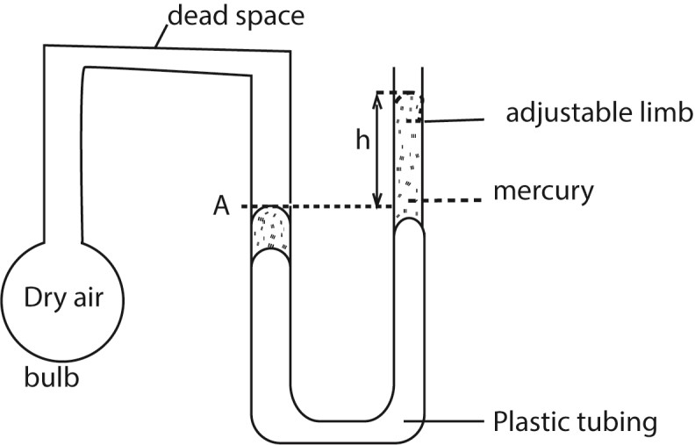
- Place the bulb inside an enclosure whose temperature is to be measured.
- Allow some time for the gas to acquire the temperature of the enclosure. The gas in the bulb may expand and forces mercury up the adjustable tube.
- Adjust the adjustable limb to bring back mercury to constant volume at A and record the height of mercury, h_{θ}.
- The Celsius scale is given by θ = 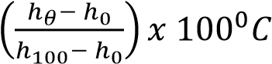 where h₁₀₀ and h₀ are the heights at steam and ice points

Limitations
- The temperature of the gas in the dead space is different from that of the gas in the bulb - Thermal expansion of the bulb may lead to change in volume - Capillary effect on the mercury surface.
Correction
- The dead space should be made small
- The bulb should be made of material with low thermal expansivity - The manometer tubes should be widened and with the same diameters.
Advantages of constant volume gas thermometers.
- It is very sensitive since a small change in temperature; i.e. small changes in temperature leads to a great expansion of a gas
- Gas thermometers give accurate results since pressure vary linearly with temperature - Can measure wide range of temperature.
Disadvantages of constant volume gas thermometers
- it is bulky and delicate
- does not give direct readings
- it cannot measure temperature at a point
- it does not measure rapidly changing temperature

Example 2
Value of property
Pressure in mmHg | Ice point | Steam point | Room temperature
Pressure in mmHg | 760 | 1040 | 795
- Using the above data, calculate the room temperature on the scale of the constant volume gas thermometer.
θ = C
- Explain why a gas thermometer is seldom used for temperature measurements in a laboratory.
Requires the disadvantages of the thermometer

3. Resistance thermometer

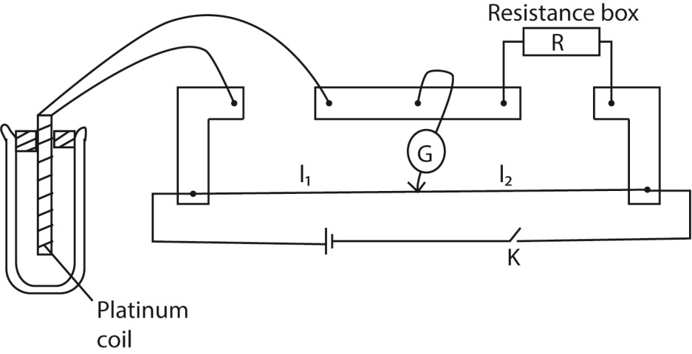
- Place the resistance thermometer in a funnel with crushed ice and leave it for some time. - Close the switch and obtain a balance point by adjusting the resistance box,
- Determine the resistance R₀ at 0⁰C from 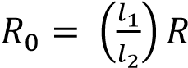
- Transfer the resistance thermometer into a beaker containing boiling water and after some time, determine resistance R₁₀₀.
- Place the resistance thermometer in water at room temperature and determine resistance R_{θ}.
- Temperature of the room temperature, θ = 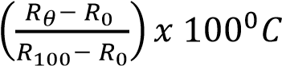

Advantages
- It is accurate
- Has fairly wide range of temperature

Disadvantages
- Cannot measure temperature at a point
- It cannot be used to follow rapidly changing temperatures

Example 3
The resistance of a certain platinum resistance thermometer is found to be 2.56Ω at 0⁰C, 3.56Ω at 100⁰C and 6.78Ω at 444.5⁰C, the boiling point of sulphur on the gas scale
- Calculate boiling point of sulphur on the platinum resistance scale. θ = 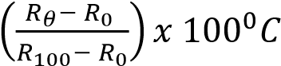
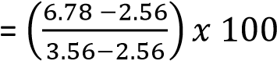
= 422⁰C
- Why are the two values of boiling point of sulphur differ
Different thermometric properties in different thermometers vary differently with temperatures

4. Thermocouples
It consists of different metals such as copper and iron joined in a circuit and their junctions kept at different temperatures. This causes a small current to be produced
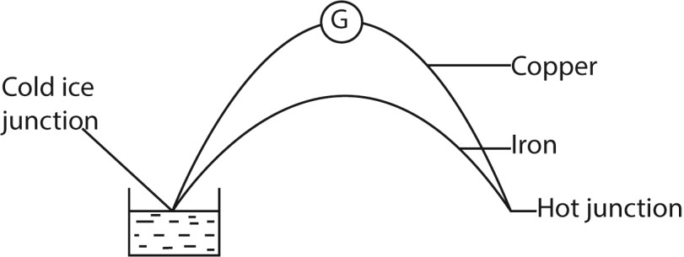

Mode of action
- The cold junction is put in water at 0⁰C and e.m.f, E₀ is determined.
- The other junction is put at a point whose temperature is required
- As a result of difference in temperature, a thermal e.m.f is induced and causes a deflection of the galvanometer, E_{θ}.
- The hot junction is placed at steam point and e.m.f, E₁₀₀ is determined
Then θ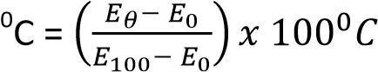

Advantages of a thermocouple
- Can be used to measure temperature at a point
- Can measure rapidly changing temperature
- Can give direct readings
- Has wide range

Disadvantages of a thermocouple
- Not accurate
- Two values of temperature θ1 and θ2 may correspond to one e.m.f
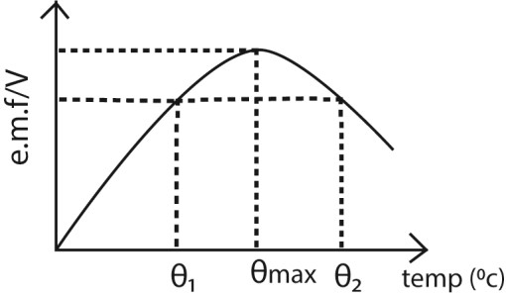

5. Pyrometers
A pyrometer is a thermometer used to measure very high temperatures by using the radiation that the body emits and wavelength of the radiation as the thermometric property. Optical pyrometer
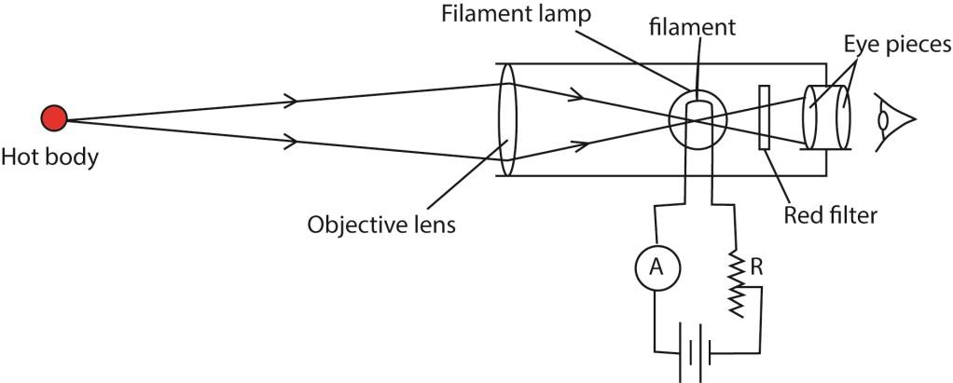
- the filament is focused on the eye piece and the objective focuses the object so that the image of the object lies in the same plane as the filament
- Light from the hot object and the filament is passed through the red filter and viewed by the eyepiece.
- Current is adjusted by the rheostat R until the filament and the object are equally bright.
- The temperature of the hot body is then read from the calibrated ammeter, A.

Revision Exercise (qns. for different global examination bodies)
- (a) Define the following:
    - Triple point of water (01 marks)
It the temperature and pressure at which a vapour, liquid and solid of a substance coexist at equilibrium.
    - Absolute zero temperature (01mark)
It is the minimum temperature on thermodynamic scale i.e. 0K.
  - Explain why triple point of water is taken as a standard in modern thermometry instead of ice and steam points. (04 marks)
It is constant, reproducible and not affected by pressure variations and impurities in water.
  - (i) What is a thermometric property? (01 marks)
Thermometric property is a physical measurable property that varies linearly and continuously with temperature and is constant at constant temperature.
(ii) State three qualities of a good thermometric property? (03mark)
      - should vary linearly with change in in temperature
      - Should vary continuously with temperature
      - Should be sensitive to temperature changes
      - Should be measurable
      - Should vary over a wide range of temperature.
(d)(i) A constant volume thermometer was used to measure temperature when the atmospheric pressure was 760mmHg.
The following values were obtained.
 | Length of Mercury in closed limb (mmHg) | Length of Mercury in open limb (mmHg)
Bulb in ice | 140 | 130
Bulb in steam | 140 | 330
Bulb at room temperature | 140 | 170
Calculate the room temperature. (05marks)
Room temperature = 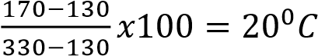
    - List two advantages of the constant volume gas thermometer over the mercury in glass thermometer. (02 marks)
      - it has a wide range
      - very accurate
      - very sensitive
(e) Explain what happens when the temperature of a fixed mass of ice is raised from 0⁰C to 10⁰C. (03marks)
      - Temperature remains constant until all the ice has melted and then temperature of water increases to from 0⁰C to 10⁰C.
      - The volume decreases up to 4⁰C and then increase as temperature increases to 10⁰C.

- (a) (i) Explain how a thermocouple is used to measure temperature on a Celsius scale.
(05marks)
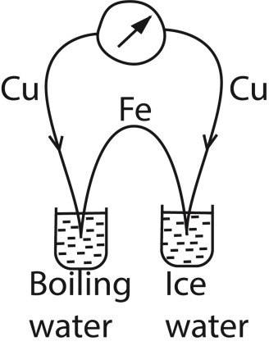
The e.m.f, E_{Tr} is obtained when a hot junction is placed in water at triple point. E.m.f, E_{T} is obtained at unknown temperature T.
T= 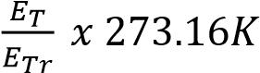
(ii) State two advantages of a thermocouple. (01mark)
        - Used to measure rapidly changing temperature
        - It can give direct readings
        - It is not bulky
        - It can measure temperature at a point

(b)(i) Define thermometric property (01mark)
Thermometric property is a physical measurable property that varies linearly and continuously with temperature and is constant at constant temperature.
(ii) Define how a liquid-in-glass thermometer can be used to measure temperature in degrees
Celsius. (04marks)
        - A bulb is inserted in pure ice-water mixture.
        - After some time, the length l₀ of mercury thread is recorded.
        - The bulb is inserted in steam and constant length l₁₀₀ of mercury thread is recorded.
        - When l_{θ} is the length of mercury thread inserted in an unknown enclosure of temperature, θ⁰, then;
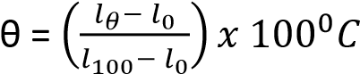
(iii) A thermometer is constructed with a liquid which expands according to relation. V_{t} =V₀(1 + αt + βt²). Where V_{t} is the volume at t⁰C and V₀ is the volume at 0⁰C on the scale of the gas thermometer and α and β are constants.
Given that α = 1000β, what will the liquid thermometer read when the gas thermometer reads 50⁰C.
Using 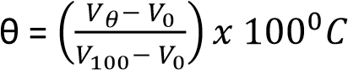
V₅₀ =V₀(1 + α(50) + β(50)²).
V₁₀₀ =V₀(1 + α(100) + β(100)²).
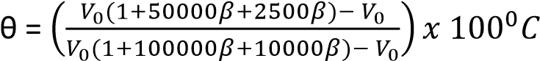
= 47.73⁰C
- (a) Define the following quantities:
    - Thermometric property (01mark)
Thermometric property is a physical measurable property that varies linearly and continuously with temperature and is constant at constant temperature.

    - Specific heat capacity (01mark)
Specific heat capacity is the amount of heat requires to raise the temperature of 1kg mass of a substance by 1K or 1⁰C
  - (i) state two examples of commonly used thermometric properties. (01mark)
        - Volume of constant mass of a gas at constant pressure
        - Pressure of a gas at constant volume
        - Electrical resistance of a platinum wire
        - e.m.f of a thermocouple
    - Describe briefly how to determine the lower and upper fixed points for an uncalibrated liquid-in-glass thermometer (04marks)
        - the bulb of the thermometer is immersed in pure ice-water mixture; the level of liquid column falls to a constant length. The level of the liquid column is marked and is the lower fixed point.
        - the bulb of the thermometer is then immersed in steam from pure water; the level of liquid column rises to a constant length. The level of the liquid column is marked and is the upper fixed point.
- (a) (i) State the thermometric property used in a constant-volume gas thermometer (01mark) pressure
(ii) Give two characteristic of a good thermometric property, (02marks)
      - should vary linearly with change in in temperature
      - Should vary continuously with temperature
      - Should be sensitive to temperature changes
      - Should be measurable
      - Should vary over a wide range of temperature.
  - (i) Describe the steps taken to set up a Celsius scale of temperature for a mercury-in glass thermometer. (04marks)
      - A bulb is inserted in pure ice-water mixture.
      - After some time, the length l0 of mercury thread is recorded.
      - The bulb is inserted in steam and constant length l100 of mercury thread is recorded.
      - When lθ is the length of mercury thread inserted in an unknown enclosure of temperature, θ⁰, then 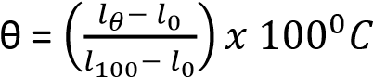

(ii) State four disadvantages of mercury in glass thermometer. (04marks)
          - it is not very sensitive
          - it cannot measure rapidly changing temperature
          - it is delicate, i.e. it breaks easily
  - Describe with the aid of a diagram the operation of an optical pyrometer (06marks)
        - the filament is focused on the eye piece and the objective focuses the object so that the image of the object lies in the same plane as the filament
        - Light from the hot object and the filament is passed through the red filter and viewed by the eyepiece.
        - Current is adjusted by the rheostat R until the filament and the object are equally bright.
        - The temperature of the hot body is then read from the calibrated ammeter, A.

- (a)(i) Define the term thermometric property and give four examples (03marks)
Thermometric property is a physical property whose value varies uniformly and continuously with change in temperature.
Examples
        - Volume of constant mass of a gas at constant pressure
        - Pressure of a gas at constant volume
        - Electrical resistance of a platinum wire
        - e.m.f of a thermocouple
-
(ii) State two qualities of a good thermometric property. (01mark)
- Should vary linearly and continuously with temperature - Should be sensitive to temperature change - Should vary over a wide range of temperature.

  - (i) With reference to a liquid in glass thermometer, describe the step involved in setting up a Kelvin scale of temperature (03marks)

Length l_{tr} of a liquid column is measured at the triple point of water
Length l_{T} of liquid column is measured at unknown temperature, T
T = 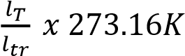

    - State one advantage and one disadvantage of the resistance thermometer. (01mark)
Advantage
          - measures a wide range of temperatures
          - very accurate
Disadvantage
          - unsuitable for rapidly changing temperatures
          - Cannot measure temperature at a point
          - Does not give direct readings
(d) A resistance thermometer has resistance of 21.42Ω at the ice point, 29.10Ω at steam point and 28.11Ω at some unknown temperature θ. Calculate θ on the scale of this thermometer. (03marks)
C
- (a) (i) Define the term thermometric property. (01mark)
Thermometric property is a physical property that vary uniformly and continuously with temperature.
(i) State two thermometric properties. (01mark)
        - Volume of constant mass of a gas at constant pressure
        - Pressure of a gas at constant volume
        - Electrical resistance of a platinum wire
        - e.m.f of a thermocouple
(ii) With the aid of a labeled diagram, describe how the room temperature can be measured using uncalibrated resistance thermometer. (06marks)
      - Place the resistance thermometer in a funnel with crushed ice and leave it for some time.
      - Close the switch and obtain a balance point by adjusting the resistance box,
      - Determine the resistance R₀ at 0⁰C from 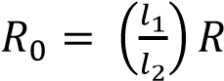
      - Transfer the resistance thermometer a beaker containing boiling water and after some time, determine resistance R₁₀₀.
      - Place the resistance thermometer in water at room temperature and determine resistance R_{θ}.
      - Temperature of the room temperature, 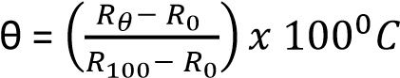
- (a) (i) Define a thermometric property and give two examples (02marks)
Thermometric property is a physical measurable property that varies linearly and continuously with temperature and is constant at constant temperature.
Examples
        - Volume of constant mass of a gas at constant pressure
        - Pressure of a gas at constant volume
        - Electrical resistance of a platinum wire
        - e.m.f of a thermocouple

(ii) When is the temperature of 0K attained? (02marks)
Ok is when molecules of a substance slow down and attain their minimum total energy
(b)(i) With reference to constant-volume gas thermometer, define temperature on the Celsius scale (02marks)
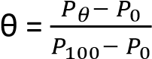 where θ is unknown temperature, P_{θ} is the pressure at unknown temperature,
P₀ is the pressure at ice point and P₁₀₀ is the pressure at steam point.
(ii) State two advantages and two disadvantages of the constant-volume gas thermometer. (02marks)
Advantages
            - it has a wide range
            - very accurate
Disadvantages
            - it does not give direct reading
            - cannot measure rapidly changing temperatures.
(c) (i) Define triple point of water (01mark)
Triple point of water is the temperature and pressure at which saturated water vapour, pure water and ice coexist in equilibrium.
(ii) Describe how you would measure the temperature of a body on the thermodynamic scale using a thermocouple. (03marks)
The e.m.f, E_{Tr} is obtained when a hot junction is placed in water at triple point. E.m.f, E_{T} is obtained at unknown temperature T.
T= 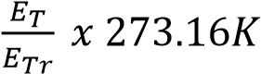

(d) The resistance, R_{θ} of platinum varies with the temperature 0⁰C as measured by the constantvolume gas thermometer according to the equation
R_{θ} = 50.0 + 0.17θ + 3.0 x 10⁻⁴θ²
      - Calculate the temperature on the platinum scale corresponding to 60⁰C on the gas scale. (06marks)
R₀ = 50Ω
R₆₀ = 50 +0.17 x 60 + 3.0 x 10⁻⁴x60² = 61.28Ω
R₁₀₀ = 50 +0.17 x 100 + 3.0 x 10⁻⁴x 100² = 70.00Ω
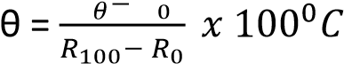
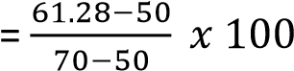
= 56.4⁰C

      - Account for the difference between the two values and state the temperatures at which they agree. (02marks)
Difference thermometric properties vary differently with temperature.
- (a) What is meant by:
      - Thermometric property (01mark)
Thermometric property is a physical property that vary uniformly and continuously with temperature.
      - Triple point (01mark)
It the temperature and pressure at which a vapour, liquid and solid of a substance coexist at equilibrium.
(b) (i) Describe the steps taken to establish a temperature scale. (05marks)
        - Choose a thermometric property
        - Find its value, x₁₀₀ at steam point and value x₀ at ice point.
        - If the value of thermometric property is x_{θ} at temperature θ
        - Then θ = 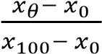
(ii) Explain why two thermometers may give different values for the same unknown temperature. (02marks)
Two thermometers based on different thermometric property may show different temperatures because thermometric properties vary differently with change in temperature.
(c) (i) Describe, with the aid of a diagram, how a constant-volume gas thermometer may be used to measure temperature. (06mrks)
      - Place the bulb inside whose temperature is to be measured.
      - Allow some time for the gas to acquire the temperature of the enclosure. The gas in the bulb may expand and forces mercury up the adjustable tube.
      - Adjust the adjustable limb to bring back mercury to constant volume at A and record the height of mercury, h_{θ}.
      - The Celsius scale is given by 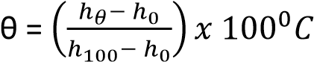 where h₁₀₀ and h₀ are the heights at steam and ice points
(ii) State three corrections that need to be made when using the thermometer in (c)(i) above. (03marks)
        - The bulb should be made of glass with low thermal expansivity
        - Dead space should be narrowed
        - The bulb should be thin to allow easy penetration of heat
(iii) State and explain the sources of inaccuracies in using mercury in glass thermometer, (02marks)
        - Non uniformity the mercury tube
        - Temperature of air in dead space being different from that in the bulb

TOPIC 4/7: HEAT QUANTITIES
Competency: The learner explores the behaviour of substances when heat is applied to them in order to sustainably apply them in heat systems.

Heat capacity
This is the quantity of heat required to raise the temperature of the body by 1⁰C or 1K.
It follows that if the temperature of a body whose heat capacity C rises by Δθ when the amount of heat ΔQ is added to it
ΔQ = CΔθ ………………………. (i)

Specific heat capacity (s.h.c), c
This is the amount of heat required to raise the temperature of 1kg mass of a substance through 1⁰C or 1K.
It follows that if the temperature of a body of mass m and s.h.c, c rises by Δθ when an amount of heat ΔQ is added it, then
ΔQ =mcΔθ …………………… (ii)
From (i) and (ii)
C = cm

Molar heat capacity
This is the heat required to raise the temperature of 1 mole of a substance by 1Kor 1⁰C.
Units: Jmol⁻1K⁻¹

Measurement of specific heat capacity

(a) Measurement of specific heat capacity of solid/metal (copper, and aluminium ) that are good conductors using electrical method
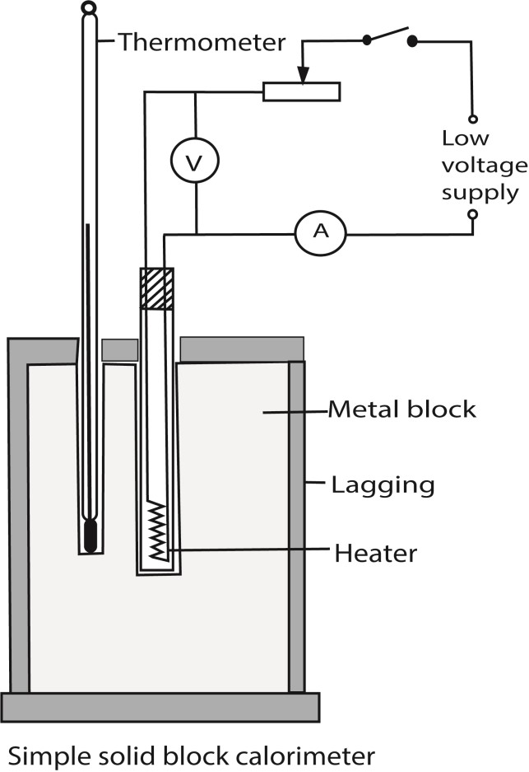
- Two holes are drilled into the specimen solid of mass m.
- A thermometer is inserted in one of the holes and an electric heater into the other hole. The holes are then filled with a good conducting fluid, e.g. oil to ensure thermal contact.
- The apparatus is insulated and initial temperature θ₀ is recorded.
- The heater is switched on at the same time a stop clock is started.
- The steady values of ammeter reading, I and voltmeter reading, V are recorded.
- After considerable temperature rise, the heater is switched off and stop clock stopped.
- The highest temperature θ₁ recorded and time t taken noted.
- Assuming negligible heat loss, the specific heat capacity, c, of the conducting solid is calculated from
c = 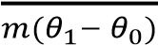
Precautions
- The block of metal should be highly polished and heavily lagged.
- The two holes should be filled with either mercury or light oil to improve thermal contact with the heater and thermometer.

(b) Measurement of specific heat capacity of a liquid by electrical method
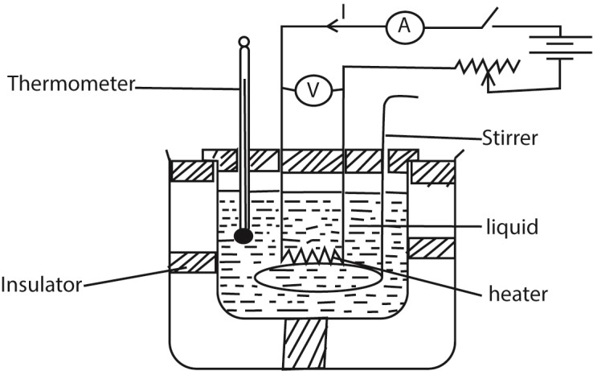
- A liquid of known mass, m is poured in a double walled calorimeter of a known heat capacity, C
- The setup is as shown above
- The initial temperature θ₁ of the liquid and calorimeter is recorded.
- Switch K is closed and simultaneously a top clock is started.
- The ammeter and voltmeter readings I and V are respectively recorded.
- The liquid is stirred as it is heated, and after sometime, t of heating, the current is switched off and final temperature θ₂ noted.
- Assuming no heat loss; heat supplied by the heater = heat received by water and calorimeter
i.e. IVt = (mc + C)(θ₂ – θ₁), where c is the specific heat capacity of a liquid.

(c) Measurement of specific heat capacity of a liquid by continuous flow method
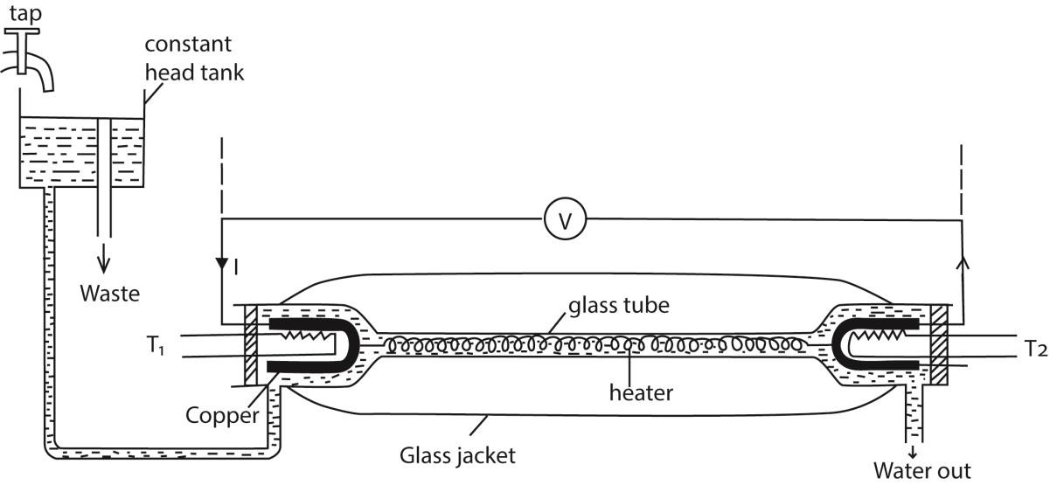
- A liquid is allowed to flow at constant rate
- Power is switched on and the liquid is heated until temperatures registered by T₁ and T₂ are steady and the values θ₁ and θ₂ respectively are recorded.
- The p.d V and current I are recorded from the voltmeter and ammeter respectively
- The mass, m of a liquid collected in time t is recorded
- At steady state; VIt = mc(θ₂ – θ₁) + h ………….. (i) where h is heat lost to the surrounding
- The rate of flow is changed and the voltage and current are adjusted until the steady readings of T₁ and T₂ are θ₁ and θ₂ respectively
- If m₁, V₁ and I₁ are the values mass of liquid collected in time t, voltmeter and ammeter readings respectively, then
V₁I₁t = m₁c(θ₂ – θ₁) + h ………………………... (ii)
Subtracting (ii) from (i)
c = 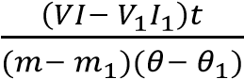

Example 1
In a continuous flow experiment, a steady difference of temperature of 1.5⁰C is maintained when the rate of liquid flow is 4.5gs⁻¹ and the rate of electrical heating is 60.5W. On reducing the liquid flow rate to 1.5gs⁻¹, 36.5W is required to maintain the same temperature difference.
Calculate the
- Specific heat capacity of the liquid. (04marks)
P = 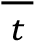cθ + h
60.5 = 4.5 x 10⁻³ x c x 1.5 + h ………… (i)
36.5 = 1.5 x 10⁻³ x c x 1.5 + h ………… (ii)
Subtracting (ii) from (i) 24 = 3 x x 10⁻³ x c x 1.5
c = 5,333Jkg
- Rate of heat loss to the surroundings (03marks)
Substituting c in (i)
60.5 = 4.5 x 10⁻³ x 5333 x 1.5 + h
h = 24.5W

(d) Measurement of specific heat capacity of a solid by the method of mixtures
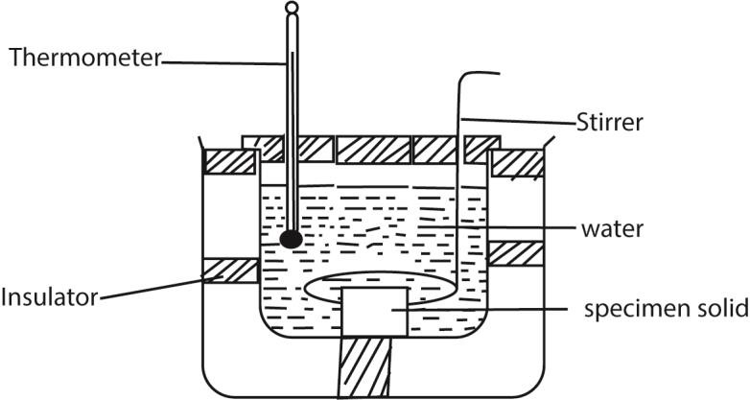
- A solid on mass m_{s} kg and specific heat capacity, c_{s}, is heated in boiling water at temperature at temperature θ₁⁰C and quickly transferred to a calorimeter of heat capacity, C, containing water of mass, m₁ and , at the temperature θ₂.
- The final constant temperature θ₃ of the mixture is determined.
Assuming there is no heat loss
Heat lost by the solid = heat gained by calorimeter + heat gained by water m_{s} x c_{s} x (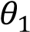– θ₃) = (C + 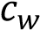m₁)(θ₃ – θ₂)

c_{s} 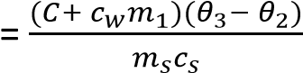 where c_{w} is specific heat capacity of water

Precautions
- The calorimeter must be heavily lagged.

(e) Measurement of specific heat capacity of a liquid by the method of mixtures
- A solid on mass m_{s} kg and specific heat capacity, c_{s}, is heated in boiling water at temperature at temperature θ₁⁰C and quickly transferred to a calorimeter of heat capacity, C, containing a liquid of mass, m₁ and , at the temperature θ₂.
- The final constant temperature θ₃ of the mixture is determined.
Assuming there is no heat loss
Heat lost by the solid = heat gained by calorimeter + heat gained by water

m_{s} x c_{s} x (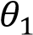– θ₃) = C(θ₃ – θ₂) + m_{l}(θ₃ – θ₂)

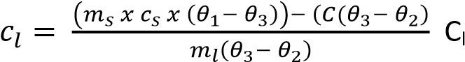= specific heat capacity of the liquid.

Precautions
- The calorimeter must be heavily lagged.

Example 2
Apiece of copper of mass 100g is heated to 100⁰C and then transferred to a well-lagged copper can of mass 50g containing 200g of water at 10⁰C. Neglecting heat loss, calculate the final steady temperature of the mixture.
[Specific heat capacity of copper and water are 400Jkg⁻¹K⁻¹ and 4200Jkg⁻¹K⁻¹)

Solution
Let the final temperature be θ.
Heat lost by the copper mass = heat gained by the copper can + heat gained by water
0.1 x 400 x (100 – θ) = 0.05 x 400 x (θ – 10) + 0.2 x 4200 x (θ – 10) θ = 14.0⁰C

Example 3
- State two advantages of the continuous flow method over the method of mixtures. (01mark)
  - No cooling correction is required
  - Heat capacity of the apparatus is not requires
  - Temperature measured at leisure when steady
  - Resistance of the heater not required

- State two disadvantages of the method in (c)(i) (01mark) - larger volumes of liquid required - not suitable for volatile liquids.

Newton’s law of cooling
Newton’s law of cooling states that under forced convection, the rate of loss of heat of a body is directly proportional to its excess temperature over that of the surrounding.
i.e.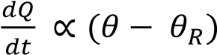
where 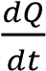 is the rate of heat loss, θ = body’s temperature, θ_{R} = temperature of the surroundings.
The rate of heat loss also depends on
- Surface area of the body and,
- Nature of the surface, i.e. whether dull or shiny
Hence for a body of a uniform temperature, θ and surface area A
Rate of heat loss, 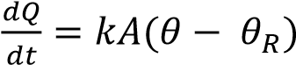 where k is a constant.
NB. A small body cools faster than a big body because a small body has a larger surface area to volume ration.

An experiment to verify Newton’s law of cooling
- Hot water is placed in a calorimeter that is standing on an insulating surface and is put in a draught.
- The temperature, θ, of the water is recorded at suitable intervals.
- The room temperature θ_{R} is recorded.
- Plot a graph of temperature against time to get a graph similar to the one below.
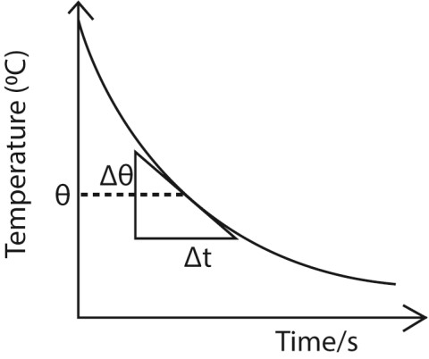
- Draw tangent at various temperatures, θ and obtain their slopes. These slopes give the rate of temperature fall.
- Plot these slopes with corresponding excess temperatures (θ – θ_{R})
- A straight line graph is obtained implying that the rate of heat loss is proportional to excess temperature.

Example 4
Describe an experiment to verify Newton’s law of cooling. (05marks)

Cooling correction
Despite all precautions to prevent heat losses in experiments of the mixtures, still there will be some significant heat loss that will prevent the mixture to attain maximum temperature rise. An estimate has to be made of the temperature that would have been attained if these heat losses were not there. The small temperature added to the observed maximum temperature to make up for the heat lost to the surrounding during the experiment is called cooling correction.

Definition of cooling correction
This is the extra temperature difference to be added to the observed maximum temperature of the mixture to make up for the heat lost to the surrounding during the experiment.

Experiment to determined cooling correction
- Pour a liquid in a calorimeter and place it on a table
- Place a thermometer into the liquid and after sometime, record the temperature of the surroundings, θ₀.
- Gently place a hot solid into the liquid and stir.
- Record the temperature of the mixture at suitable interval until the temperature of the mixture has fallen by about 1⁰C below the observed maximum temperature, θ₁. - Plot a graph of temperature against time
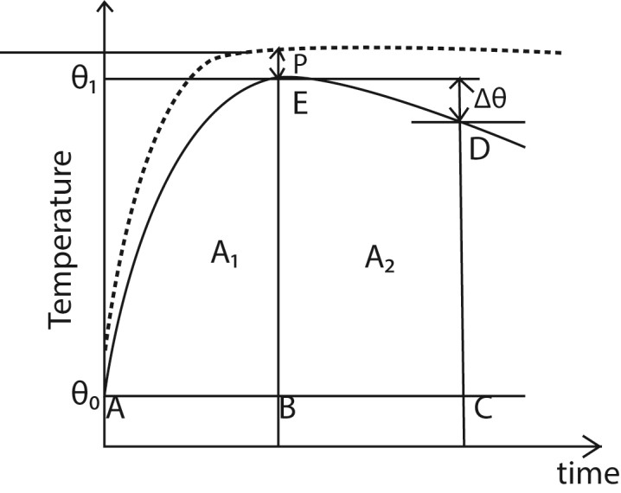
- The broken line shows how we would expect the temperature to rise if no heat were lost and the difference, P, between the plateau of this imaginary curve, and the crest of the experimental curve, E. is known as the 'cooling correction’
- Draw a line AC through θ0 parallel to the time axis.
- Draw a line BE through θ1 parallel to the temperature axis.
- Draw a line CD beyond BE parallel to the temperature axis and note Δθ
- Estimate the area A1 and A2 under the graph by counting the square on the graph paper
- Cooling correction, P s given by the graph
- Cooling correction, P = 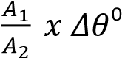C

Example 5
i) What is meant by cooling correction? (01marks)

This is the extra temperature difference to be added to the observed maximum temperature of the mixture to make up for the heat lost to the surrounding during the experiment.

(ii) Explain how the cooling correction may be estimated in the determination of the heat capacity of poor by the method of mixtures (05marks)

Latent heat

Definition
This is the quantity of heat absorbed or released when a substance changes physical state at constant temperature. E.g. during melting, evaporation, sublimation, condensing, solidification

Example 6
Explain why there is no change in temperature when a substance is melting (04marks)

Supply of heat to a melting solid reduces the forces of attraction between the molecules and increases the separation between them. This increases the potential energy (P.E) between the molecules while keeping kinetic energy (K.E) of the molecules the same. Further increase in separation between the molecules causes the regular pattern to collapse as the solid changes to liquid. Until this process is complete, the temperature does not change.

Example 7
Explain the changes that take place in the molecular structure of substances during fusion and evaporation (04marks)
Heat supplied during fusion breaks down the forces that keep ordered pattern of molecules is solid crystalline structure to form a liquid. The potential energy of the molecules increase but the average kinetic energy and temperature of the molecules remain unchanged.
Heat supplied during evaporation breaks molecular bonds in liquids and allows gas molecules to expand against atmospheric pressure which allows then to move independently.

Example 8
Explain why the specific latent heat of evaporation is always greater than specific latent heat of fusion of a substance at the same pressure are different. (04marks)
Change from solid to liquid, intermolecular bonds are weakened and there is a small increase in volume. This implies there negligible change in volume and thus little work done against atmospheric pressure.
During vaporization, a lot of heat is required to break molecular bonds in a liquid and to enable expansion to larger volume of a gas against atmospheric pressure.

Specific latent heat of fusion
Specific latent het of fusion is the amount of heat required to change 1kg mass of a substance from solid to liquid without change of temperature. Units are Jkg⁻¹

Experiment to determine the specific latent heat of fusion by the method of mixtures
- A known mass m₁ kg of water at temperature θ₁ (a few degrees above room temperature) is placed in a calorimeter of mass m_{c} kg and heat capacity. C.
- A small piece of dry ice (dried by blotting paper) is added to the water and stirred to a constant temperature θ₂.
- The total mass, m, of the calorimeter and water and ice is determined.
Calculation
Mass of ice = (m – (m₁ + m_{c}) = m₃kg

Heat lost by water and calorimeter = heat gained by ice to melt and again temperature to θ₂.
Suppose c and l_{f} are the specific heat capacity and latent heat of fusion of water, then
(m₁c + )(θ₁ – θ₂) = m₃l_{f} + m₃c(θ₂ – 0)

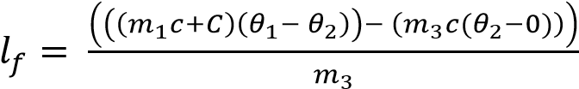

Experiment to determine the specific latent heat of fusion by electrical method
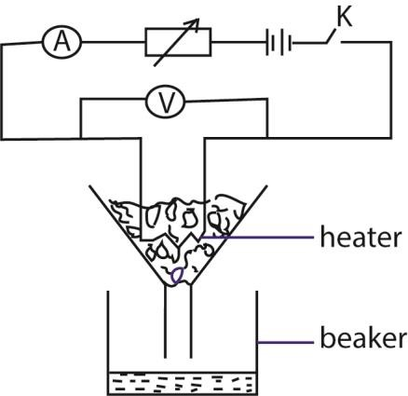
- Place pure ice in a funnel such that it submerge the heater - With R set, close K and simultaneously start a stop clock.
- Collect a known mass m of water in a specified time, t.
- Record the readings I and V of the ammeter and voltmeter spectively. Assuming no heat gain from the surrounding Heat supplied by the heater = heat gained by ice.
IVt -= ml_{f}b where l_{f} is the specific latent heat of fusion
NB: if heat lost gained from the surrounding is h
Then IVt + h = mlf ………………….. (i)
The experiment is repeated for different values of V’, I’ and m’ in the same time
I’V’t + h = m’lf ………………….. (ii)
Combining (i) and (ii)
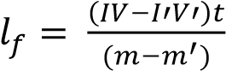

Specific latent heat of vaporization
Specific latent het of vaporization is the amount of heat required to change 1kg mass of a substance from liquid to vapor without change of temperature. Units are Jkg⁻¹.

Experiment to determine the specific latent heat of vaporization of water by electrical method
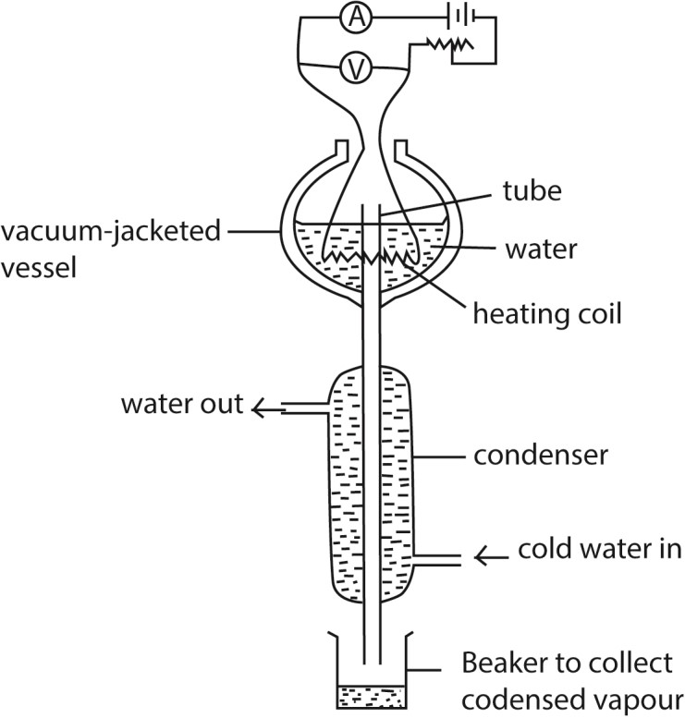
- Put the liquid whose specific latent heat of vaporization is required in a vacuum jacketed vessel as shown above.
- The liquid is heated to boiling point.
- The current, I, and voltage, V are recorded.
- The mass of condensed water, m, condensed in time, t, is determined.
- Then IV = 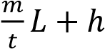,
where h is the rate of heat loss to the surroundings
- To eliminate, h, the experiment is repeated for different values of I’ and V’ and the mass of the condensed water, m’ condensed in tie t is determined.
- Again I’V’ = 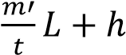
- Latent heat of vaporization, L =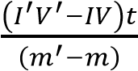

Example 9
An appliance rated 240V, 200W evaporates 20g of water in 5 minutes. Find the heat loss if specific latent heat of vaporization is 2.26 x 10⁶Jkg⁻¹. (03marks)
Electrical energy supplied = mlv + h
Power x time = mlv + h
200 x 5 x 60 = 20 x 10⁻³ x 2.26 x 10⁶ + h
h = 14800J

An experiment to determine the specific latent heat of vaporization of water by the method of the mixtures
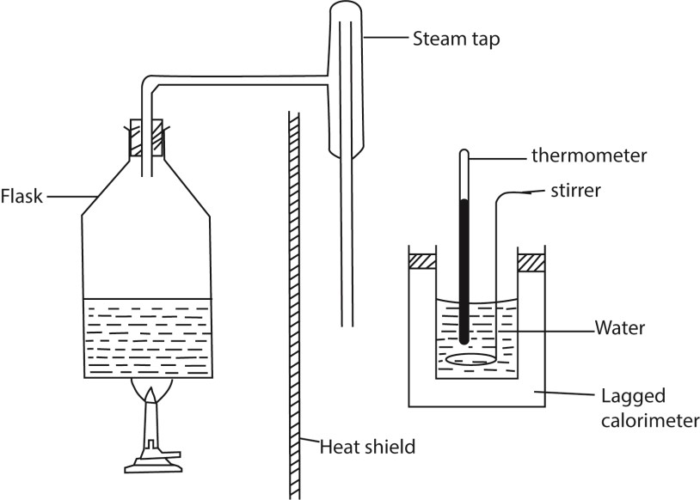
- The initial temperature θ₀ and mass, m of water in the calorimeter are measured
- Steam from boiling water is passed into water in a calorimeter and after a reasonable temperature rise, flow of steam is stopped and final temperature, θ_{f} is recorded.
- Mass m₂ of water in the calorimeter is then taken - The mass of steam condensed, m_{s} = (m₂- m)
Given that the heat capacity of the calorimeter= C
Heat gained by steam = heat gained by water and calorimeter
m_{s}c_{v} + m_{s}c(100- θ_{f}) = (m₂ – m)c(θ_{f} – θ₀) + C(θ_{f} – θ₀) c_{v} = specific latent heat of vaporization c= specific heat capacity of water

Example 10
Explain why evaporation causes cooling? (03marks)
When a liquid evaporate molecules with high kinetic energy escape leaving molecules with low kinetic energy. Since temperature of the liquid depends on the average kinetic energy of its molecules, the temperature drops.

Example 11
Explain the effect of pressure on the boiling point of a liquid. (02marks)
- Since a liquid boils when its saturated vapour pressure is equal to external pressure.
- Increasing the external pressure increases the boiling point of a liquid because the liquid has to be heated to a higher temperature to make its saturated vapour pressure equal to external pressure

Revision exercise (Question as previous examinations of global examination bodies)
- (a) Define the following:
    - Specific heat capacity (01mark)
Specific heat capacity is the amount of heat required to rise the temperature of 1kg mass of a substance by 1K or 1⁰C
    - Latent heat. (01marks)
Latent heat is energy absorbed or released by a substance during a change in its physical state (phase) without changing its temperature.
(b) (i) Describe an experiment to determine the specific heat capacity of a solid using the method of mixtures. (06marks)
Measurement of specific heat capacity of a solid by the method of mixtures
      - A solid on mass m_{s} kg and specific heat capacity, c_{s}, is heated in boiling water at temperature at temperature θ₁⁰C and is quickly transferred to a calorimeter of heat capacity, C, containing water of mass, m₁ and , at the temperature θ₂.
      - The final constant temperature θ₃ of the mixture is determined. Assuming there is no heat loss
Heat lost by the solid = heat gained by calorimeter + heat gained by water m_{s} x c_{s} x (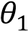– θ₃) = (C + 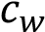m₁)(θ₃ – θ₂)

c_{s} 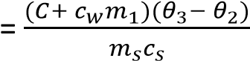 where c_{w} is specific heat capacity of water
(iii) State two precautions taken in (b)(i). (02marks)
        - The calorimeter must be heavily lagged to minimize heat loss from the mixture.
        - Transfer the solid is fast to minimize heat loss from it during the transfer.
        - Stir the mixture gently to ensure uniform temperature distribution without causing splashing or heat loss.
        - Carry out the experiment several times to minimize errors - Make correction for heat loss.
(c) An electric heater of 2.2kW was used to heat 2kg of water, initially at 25⁰C, in a kettle of heat capacity 400JK⁻¹ until the water boiled at 100⁰C. The heating was continued for 3 more minutes and it was found that the mass of water in the kettle was 1.802kg.
Calculate;
(i) how long it took the water to boil
Heat given out by the heater = heat gained by the kettle and water
VIt = Cθ + mcθ
2.2 x 10³t = 400(100 – 25) + 2 x 4200 (100 – 25) t = 300s = 5minutes
(ii) the specific latent heat of vaporization (05mark)
Mass of water vaporized = 2 – 1.802 =0.198
Let specific latent heat be L
VIt = mL
2.2 x 10³ x 3 x 60 = 0.198L
L = 2 x 10⁶Jkg⁻¹

(d) Explain why the specific latent heat of vaporization in much higher than the specific lantent heat of fusion for the same substance. (05marks)
Latent heat of fusion only supply energy to breaks down the forces that keep ordered pattern of molecules is solid crystalline structure to form a liquid. The potential energy of the molecules increase but the average kinetic energy and temperature of the molecules remain unchanged.
While,
Latent heat of vaporization is always greater that latent heat of fusion because energy is supplied to break down stronger molecular bonds in liquids and to provide energy to liquid molecules in order to expand into gas molecules against atmospheric pressure.
- (a) Define the following:
    - specific heat capacity (01 mark)
Specific heat capacity is the amount of heat requires to raise the temperature of 1kg mass of a substance by 1K or 1⁰C
    - specific latent heat of vaporization. (01mark)
Specific latent heat of vaporization is the amount of heat energy required to change 1kg of a liquid to vapour at constant temperature.
(b) With the aid of a labelled diagram, describe an experiment to determine the specific latent heat of vaporization of a liquid. (07 marks)

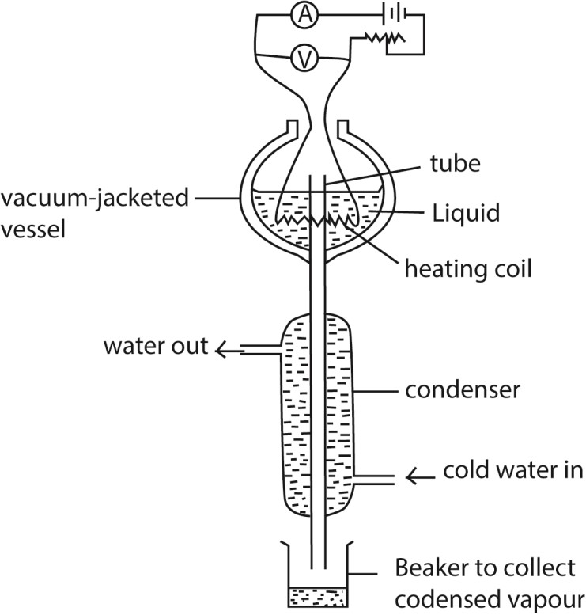
      - Put the liquid whose specific latent heat of vaporization is required in a vacuum jacketed vessel as shown above.
      - The liquid is heated to boiling point.
      - The current, I, and voltage, V are recorded.
      - The mass of liquid, m, condensed in time, t, is determined.
      - Then IV = 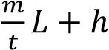, where h is the rate of heat loss to the surroundings
      - To eliminate, h, the experiment is repeated for different values of I’ and V’ and the mass of the liquid, m’ condensed in tie t is determined.
      - Again I’V’ = 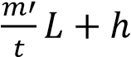
Latent heat of vaporization, L =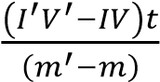
- (a) The inlet and outlet temperatures of water flowing in a continuous flow method are
15.2⁰C and 17.4⁰C respectively. A flow rate of 20 g min⁻¹ is obtained when a current of 2.3A flows and a p.d of 3.3V is applied. When oil, which flows in and out at the same temperatures as water is used, the flow rate obtained is 70.0 g min⁻¹. Calculate the specific heat capacity of the oil, if a p.d 3.9V is applied and a current of 2.7A flows. (05 marks)
VIt = mcθ+ h where h is the rate of heat loss
1.3 x 2.3 = 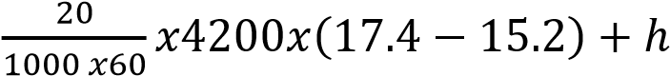 ……………….. (i)
3.9 x 2.7 = 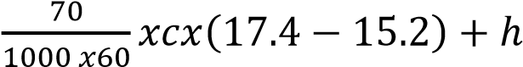………………………..(ii)
Subtracting (i) from (ii) 2.94 = 2.5667x 10⁻³c – 3.08 c = 2345Jkg⁻¹K⁻¹
hence specific heat capacity of the liquid = 2,345 Jkg⁻¹K⁻¹
- Explain the effect of pressure on:
  - boiling point of a liquid. (03marks)
When the liquid boils its saturated vapour pressure = external pressure and saturated vapour pressure increases with increasing temperature. When external pressure is raised, a liquid will boil at higher saturated pressure which occurs at high temperature.
  - Melting point of ice. (03 marks)
Increase in pressure lowers the melting point of ice because melting of ice is followed by a decrease in volume.
- (i) Describe with the aid of a diagram, an experiment to determine the specific heat capacity of a liquid using the continuous flow method. (07marks)
    - A liquid is allowed to flow at constant rate
    - Power is switched on and the liquid is heated until temperatures registered by T₁ and T₂ are steady and the values θ₁ and θ₂ respectively are recorded.
    - The p.d V and current I are recorded from the voltmeter and ammeter respectively
    - The mass, m of a liquid collected in time t is recorded
    - At steady state; VIt = mc(θ₂ – θ₁) + h ………….. (i) where h is heat lost to the surrounding
    - The rate of flow is changed and the voltage and current are adjusted until the steady readings of T₁ and T₂ are θ₁ and θ₂ respectively
    - If m₁, V₁ and I₁ are the values mass of liquid collected in time t, voltmeter and ammeter readings respectively, then V₁I₁t = m₁c(θ₂ – θ₁) + h ………….. (ii)
Subtracting (ii) from (i)
c = 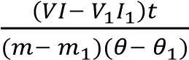
(ii) State two advantages of the continuous flow method over the method of mixtures. (01mark)
      - No cooling correction is required
      - Heat capacity of the apparatus is not requires
      - Temperature measured at leisure when steady
      - Resistance of the heater not required

(i) State two disadvantages of the method in (c)(i) (01mark) - larger volumes of liquid required - not suitable for volatile liquids.
(c) The brake lining of the wheel of a car of mass 800kg have total mass of 4.8kg and are made of a material of specific heat capacity 1200Jkg⁻¹K⁻¹. If the car is at 15ms⁻¹ and is brought to rest by applying the brakes, calculate the maximum possible temperature rise of the brake lining. (04marks)
Mechanical energy = heat absorbed by the lining
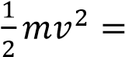mcθ where θ is temperature change
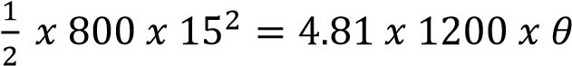
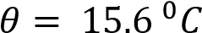
4. (a) (i) Define specific latent het of fusion (01mark)
Specific latent het of fusion is the amount of heat required to change 1kg mass of a substance from solid to liquid without change of temperature.
(ii) State effect of impurities on melting point (01mark) Impurities lower the melting point.
- Explain why there is no change in temperature when a substance is melting (04marks) Supply of heat to a melting solid reduces the forces of attraction between the molecules and increases the separation between them. This increases the potential energy (P.E) between the molecules while keeping kinetic energy (K.E) of the molecules the same. Further increase in separation between the molecules causes the regular pattern to collapse as the solid changes to liquid. Until this process is complete, the temperature does not change.
- With the aid of a labelled diagram, describe the continuous flow method of measuring the specific heat capacity of a liquid. (06marks)
- A liquid is allowed to flow at constant rate
- Power is switched on and the liquid is heated until temperatures registered by T₁ and T₂ are steady and the values θ₁ and θ₂ respectively are recorded.
- The p.d V and current I are recorded from the voltmeter and ammeter respectively
- The mass, m of a liquid collected in time t is recorded
- At steady state; VIt = mc(θ₂ – θ₁) + h ………….. (i) where h is heat lost to the surrounding
- The rate of flow is changed and the voltage and current are adjusted until the steady readings of T₁ and T₂ are θ₁ and θ₂ respectively
- If m₁, V₁ and I₁ are the values mass of liquid collected in time t, voltmeter and ammeter readings respectively, then V₁I₁t = m₁c(θ₂ – θ₁) + h ………….. (ii)
Subtracting (ii) from (i)
c = 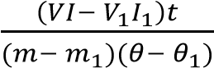

- In an experiment to determine the specific latent heat of fusion of ice, heating coil is placed in a filter funnel and surrounded by lumps of ice. The following sets of reading were obtained.

V(V) | 4.0 | 6.0
I(A) | 2.0 | 3.0
Mass of water m (g) collected in 500s | 14.9 | 29.8
Calculate
  - Specific latent heat of fusion of ice (04marks)
Specific latent heat c_{l} 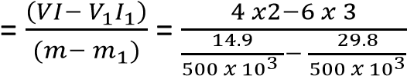 = 3.36 x 10⁵Jkg
  - Energy gained in the course of obtaining the first set of readings (03marks)
I₁V₁ = m₁c_{l} + h
4 x 2 = 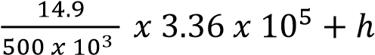
h = -2W
Energy gained from surrounding = h x t = 2 x 500 = 1000J
- Why are two sets of reading necessary n (d) above? (01mark)
To account for heat gained from surrounding
- (a) Define specific latent heat of vaporization. (01mark)
Specific latent heat of vaporization is the amount of heat required to change 1kg mass of a liquid into vapour at constant temperature.
  - With the aid of labelled diagram, describe an experiment to measure the specific latent heat of vaporization of a liquid using an electrical method. (07marks)
      - Put the liquid whose specific latent heat of vaporization is required in a vacuum jacketed vessel as shown above.
      - The liquid is heated to boiling point.
      - The current, I, and voltage, V are recorded.
      - The mass of liquid, m, condensed in time, t, is determined.
      - Then IV = 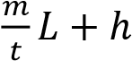, where h is the rate of heat loss to the surroundings
      - To eliminate, h, the experiment is repeated for different values of I’ and V’ and the mass of the liquid, m’ condensed in tie t is determined.
      - Again I’V’ = 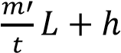
Latent heat of vaporization, L =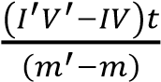

    - Explain the effect of pressure on the boiling point of a liquid. (02marks)
      - Since a liquid boils when its saturated vapour pressure is equal to external pressure.
      - Increasing the external pressure increases the boiling point of a liquid because the liquid has to be heated to a higher temperature to make its saturated vapour pressure equal to external pressure

    - A liquid of specific heat capacity 2.8 x 10³Jkg⁻¹K⁻¹ and specific latent heat of vaporization 9.00 x 10⁵Jkg is contained in a flask of heat capacity 800JK⁻¹ at a temperature of 32⁰C. An electric heater rated 1kW is immersed in 2.5kg of the liquid and switched on for 12 minutes, calculate the amount of liquid that boiled off, given that the boiling point of the liquid is 80⁰C. (06marks)
Heat supplied by the heater = mcθ + Cθ + m₁L
1000 x 12 x 60 = 2.5 x 2.8 x 10³(80-32) + 800 x (80- 32) + 9.00 x 10⁵m₁
Mass of the liquid evaporates, m₁ = 0.384kg
    - (i) Two thermometers are used to measure the temperature of a body. Explain why the temperatures may be different. (02marks)
Because thermometric properties vary differently with temperature and only agree at fixed points.
(ii) A platinum resistance thermometer has a resistance of 5.42Ω at the triple point of water. Calculate the resistance at a temperature of 50.0⁰C. (02marks)
T = 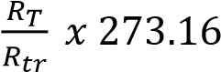
(273 + 50) = 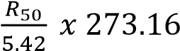
R₅₀ = 6.41Ω
- (a)(i) Define the terms specific heat capacity and specific latent heat of fusion (02marks)
Specific heat capacity is the amount of heat required to raise the temperature of 1kg mass of a substance by 1K of 1⁰C.
Specific latent heat of fusion is the amount of heat required to change 1kg of solid substance to a liquid at constant temperature.
(ii) Explain the changes that take place in the molecular structure of substances during fusion and evaporation (04marks)
Heat supplied during fusion breaks down the forces that keep ordered pattern of molecules is solid crystalline structure to form a liquid. The potential energy of the molecules increase but the average kinetic energy and temperature of the molecules remain unchanged.
Heat supplied during evaporation breaks molecular bonds in liquids and allows gas molecules to expand against atmospheric pressure which allows then to move independently.
  - With the aid of a labelled diagram describe an experiment to determine the specific heat capacity of a liquid using the continuous flow method. (08marks)
    - A liquid is allowed to flow at constant rate
    - Power is switched on and the liquid is heated until temperatures registered by T₁ and T₂ are steady and the values θ₁ and θ₂ respectively are recorded.
    - The p.d V and current I are recorded from the voltmeter and ammeter respectively
    - The mass, m of a liquid collected in time t is recorded
    - At steady state; VIt = mc(θ₂ – θ₁) + h ………….. (i) where h is heat lost to the surrounding
    - The rate of flow is changed and the voltage and current are adjusted until the steady readings of T₁ and T₂ are θ₁ and θ₂ respectively
    - If m₁, V₁ and I₁ are the values mass of liquid collected in time t, voltmeter and ammeter readings respectively, then V₁I₁t = m₁c(θ₂ – θ₁) + h ………….. (ii)
Subtracting (ii) from (i)
c = 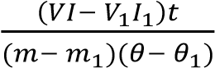
- (a) Steam at 100⁰C is passed into a copper calorimeter of mass 150g containing 340g of water at 15⁰C. This is done until the temperature of the calorimeter and its content is 71⁰C. If the mass of the calorimeter and its content is found to be 525g, calculate the specific latent heat of vaporization of water. (06marks)
Mass of condensed steam = 525 - (340+ 150) = 35g
Heat lost by steam = heat gained water and calorimeter
Ml_{v} + mcΔθ = m₁cΔθ + CΔθ
0.035l = 0.340(100 – 71) + 0.150 (100 – 71)
Specific latent heat capacity, lv = 2.259 x 10⁶Jkg⁻¹.

  - An appliance rated 240V, 200W evaporates 20g of water in 5 minutes. Find the heat loss if specific latent heat of vaporization is 2.26 x 10⁶Jkg⁻¹. (03marks)
Electrical energy supplied = mlv + h
Power x time = mlv + h
200 x 5 x 60 = 20 x 10⁻³ x 2.26 x 10⁶ + h h = 14800J

- (a) (i) Define latent heat (01mark)
Latent heat is the amount of heat required to change a unit mass of a substance from one state to another at constant temperature.
(ii) Explain the significance of latent heat in regulation of body temperature (03marks)
On a hot day, the body sweats. Evaporation occurs at the surface of the body leading to the cooling of the body since the evaporating water draws heat from the body.
(b) (i) using kinetic theory, explain boiling of a liquid (03mark)
Molecules of a liquid through moving randomly have attractive forces between them. When a liquid is heated, the molecules move faster and forces of attraction weakened until they are overcome at the boiling temperature. At this point, saturated vapour pressure (SVP) of liquids is equal to external pressure. Liquid molecules with enough energy escape from the bulk to the atmosphere.

(ii) Describe how you would determine the specific latent heat of vaporization of water by the method of the mixtures (05marks)
    - The initial temperature θ₀ and mass, m of water in the calorimeter are measured
    - Steam from boiling water is passed into water in a calorimeter and after a reasonable temperature rise, flow of steam is stopped and final temperature, θ_{f} is recorded.
    - Mass m₂ of water in the calorimeter is then taken - The mass of steam condensed, m_{s} = (m₂- m)
Given that the heat capacity of the calorimeter= C
Heat gained by steam = heat gained by water and calorimeter
m_{s}c_{v} + m_{s}c(100- θ_{f}) = (m₂ – m)c(θ_{f} – θ₀) + C(θ_{f} – θ₀) c_{v} = specific latent heat of vaporization c= specific heat capacity of water
(iii) Explain why latent heat of vaporization is always greater than that of fusion. (02marks) In evaporation energy is needed to break intermolecular forces of attraction ad to expand against atmospheric pressure while in fusion, energy is needed to weaken molecular attraction only.
(c) In an experiment to determine the specific latent heat of vaporization of a liquid using the continuous flow calorimeter, the following results were obtained.
Voltage, V/V | Current, I/A | Mass collected in 300s/g
7.4 | 2.6 | 5.8
10.0 | 3.6 | 11.3
Calculate the power of the heater required to evaporate 3.0g of water in 2 minutes (06marks)
I₁V₁ = m₁l + h …………………………………(i)
I₂V₂ = m₂l + h …………………………………(ii)
From (i) and (ii)
l = 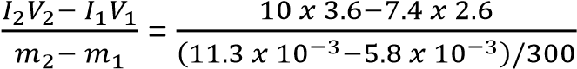= 9.14 x 10⁵Jkg⁻¹
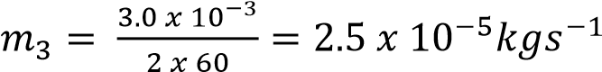
l = 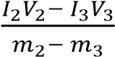
9.14 x 10⁵n = (10 x 3.6 –I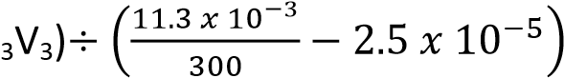
11.59 = 36 – I₃V₃
Power = I₃V₃ = 36 – 11.59 = 24.41W

- (a) (i) Define specific heat capacity of a substance. (01mark)
Specific heat capacity is the energy required to raise the temperature of 1kg mass of a substance by 1K.
(ii) State three advantages of the continuous flow method over the method of mixtures in determination of the specific heat capacity of a liquid. (03marks) - The heat capacity of the apparatus is not required. - Heat loss is eliminated in the calculation - Resistance thermometer can be used.
- Temperatures are read at leisure

(b) In a continuous flow experiment, a steady difference of temperature of 1.5⁰C is maintained when the rate of liquid flow is 4.5gs⁻¹ and the rate of electrical heating is 60.5W. On reducing the liquid flow rate to 1.5gs⁻¹, 36.5W is required to maintain the same temperature difference.
Calculate the
(i) Specific heat capacity of the liquid. (04marks)
P = 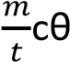 + h
60.5 = 4.5 x 10⁻³ x c x 1.5 + h ………… (i)
36.5 = 1.5 x 10⁻³ x c x 1.5 + h ………… (ii)
Subtracting (ii) from (i) 24 = 3 x x 10⁻³ x c x 1.5
c = 5,333Jkg
(ii) Rate of heat loss to the surroundings (03marks)
Substituting c in (i)
60.5 = 4.5 x 10⁻³ x 5333 x 1.5 + h h = 24.5W
(c) (i) Describe an electrical method for determination of the specific heat capacity of a metal. (06marks)
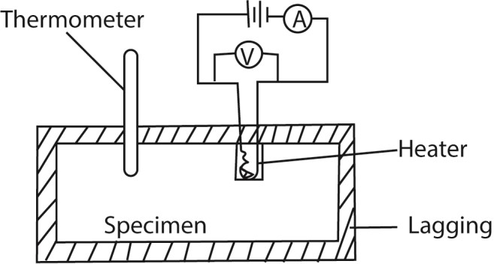
        - Two holes are drilled into the specimen solid of mass m.
        - A thermometer is inserted in one of the holes and an electric heater into the other hole.
The holes are then filled with a good conducting fluid, e.g. oil to ensure thermal contact.
        - The apparatus is insulated and initial temperature θ₀ is recorded.
        - The heater is switched on at the same time a stop clock is started.
        - The steady values of ammeter reading, I and voltmeter reading, V are recorded.
        - After considerable temperature rise, the heater is switched off and stop clock stopped.
        - The highest temperature θ₁ recorded and time t taken noted.
        - The specific heat capacity, c, of the conducting solid is calculated from c = 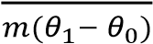
(ii) State the assumptions made in the above experiment. (02marks)
- All heat supplied by the heater is gained by the metal block - The volume of the metal does not change.
(iii) Comment about the accuracy of the results of the experiment in (c)(i) above. (01marks) The value of specific heat capacity is accurate as long as there is not heat loss to the surrounding.

- (a) (i) Define specific heat capacity of a substance (01mark)
Specific heat capacity is the quantity of heat required to raise the temperature of 1kg mass of a substanceby1K without change of state
(ii) State how heat losses are minimized in calorimetry (02mark)
        - Surrounding the calorimeter vacuum
        - Using a highly polished surface
        - By lagging the calorimeter using insulating material - Surrounding the calorimeter with a layer of still air.
(b) (i) What is meant by cooling correction? (01marks)

This is the extra temperature difference to be added to the observed maximum temperature of the mixture to make up for the heat lost to the surrounding during the experiment.

- Explain how the cooling correction may be estimated in the determination of the heat capacity of poor by the method of mixtures (05marks)
  - The broken line shows how we would expect the temperature to rise if no heat were lost and the difference, P, between the plateau of this imaginary curve, and the crest of the experimental curve, E. is known as the 'cooling correction’ - Draw a line AC through θ₀ parallel to the time axis.
  - Draw a line BE through θ₁ parallel to the temperature axis.
  - Draw a line CD beyond BE parallel to the temperature axis and note Δθ
  - Estimate the area A₁ and A₂ under the graph by counting the square on the graph paper
  - Cooling correction, P s given by the graph Cooling correction, P = 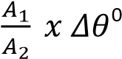C

- Explain why a small body cools faster than a larger one of the same material. (04marks) Small body has a large surface area to volume ratio and small quantity of heat compare to the big body. And the rate of heat is proportional to the surface area while the rate of temperature fall is inversely proportional to the quantity of heat held by the body

(c) Describe how you would determine the specific heat capacity of a liquid by the continuous flow method. (07marks)
- A liquid is allowed to flow at constant rate
- Power is switched on and the liquid is heated until temperatures registered by T₁ and T₂ are steady and the values θ₁ and θ₂ respectively are recorded.
- The p.d V and current I are recorded from the voltmeter and ammeter respectively
- The mass, m of a liquid collected in time t is recorded
- At steady state; VIt = mc(θ₂ – θ₁) + h ………….. (i) where h is heat lost to the surrounding
- The rate of flow is changed and the voltage and current are adjusted until the steady readings of T₁ and T₂ are θ₁ and θ₂ respectively
- If m₁, V₁ and I₁ are the values mass of liquid collected in time t, voltmeter and ammeter readings respectively, then V₁I₁t = m₁c(θ₂ – θ₁) + h ………….. (ii)
Subtracting (ii) from (i) c =

TOPIC 5/7: TRANSFER OF HEAT
Competency: The learner investigates modes of heat transfer in nature and their application in industry and society.
Conduction
Conduction is the transfer of heat from a region of high temperature to that of low temperature without a resultant movement of the molecules of conducting material.

Mechanisms of heat conduction
- Metals
  - The atoms of metals consist of free mobile electrons; when one end of a metal is heated, these free electrons travel at high speed and collide with other electrons and atoms. In this way heat is transferred quickly from a hot end to a cold end.
  - Secondly when one end of a metal is heated atoms vibrate with high frequency and amplitude; collide with other atoms to which they give heat. Those atoms that receive heat also vibrate with high frequency and amplitude, collide and transfer their heat. In this way heat energy is transferred from one part of the metal to another.
- Non-metals
  - In non-metal heat is transferred by interatomic vibrations.
  - When one end of a metal is heated atoms vibrate with high frequency and amplitude; collide with other atoms to which they give heat. Those atoms that receive heat also vibrate with high frequency and amplitude, collide and transfer their heat. In this way heat energy is transferred from one part of the metal to another
- Heat transfer in gases
Heat energy in gases is transferred by molecular collisions between hot and cold molecules. When a gas is heated, the fast moving molecules collide and pass on their kinetic energy to cold slower molecules.

Temperature distribution along a conductor

(i) Lagged metal
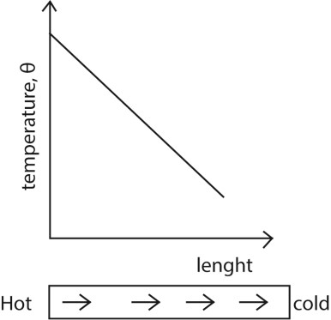
The rate of heat flow along the bar is constant since heat loss is negligible. (ii) Unlagged or exposed to the surrounding
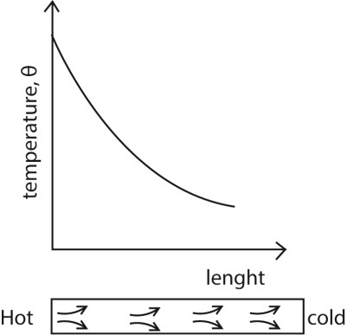
The rate of heat flow decrease with length due to heat losses

Example 1
The two ends of a metal bar of length 1.0m are perfectly lagged up to 20cm from either end. The ends of the bar maintained at 100⁰C and 0⁰C respectively.
- Sketch a graph of temperature versus distance of a bar. (02marks)
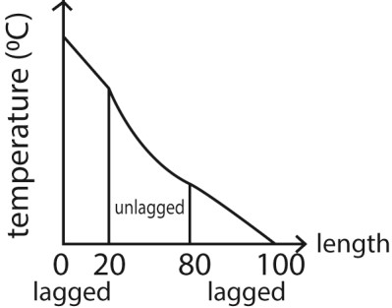
- Explain the features of the graph in (b)(i)(03marks)
- In lagged portions there is constant heat flow because there is no heat loss to the surroundings - In unlagged portion heat flow is not uniform due to heat loss to the environment.

Thermal conductivity
Thermal conductivity is the rate of heat transfer per unit cross section area per unit temperature gradient

Factors affecting the rate of heat flow
- Temperature gradient - Cross-section area
i.e. 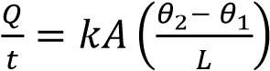

Measurement of thermal conductivity of a good conductor (e.g. metal)

Conditions
- Heat must flow through the specimen at measurable rate
- The temperature gradient along the specimen must be measurably steep. i.e. the specimen bar must be longer than it diameter.
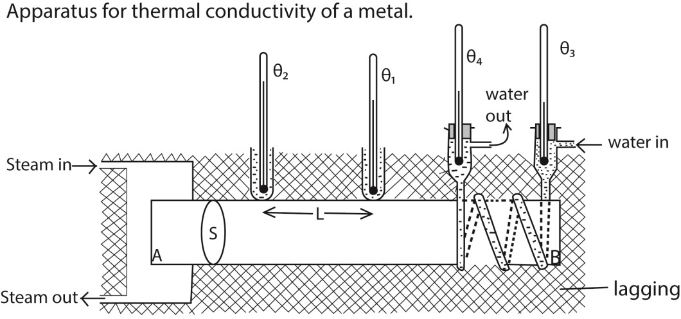
- Specimen bar AB of mean diameter, d, is heated by steam at end A and cooled by water at end B as shown above
- The lagging ensure a constant rate of heat flow
- The setup is left to run for some time until steady temperatures θ₁, θ₂, θ₃ and θ₄ are obtained.
- The rate water flow m kgs⁻¹ is measured using a cylinder and stop clock.
- Cross section area A =
- The rate of heat flow is given by
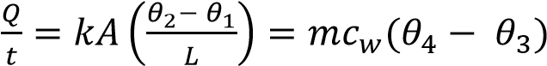
where k = thermal conductivity of the metal and c_{w} is specific heat capacity of water

Measurement of thermal conductivity of a bad conductor (e.g. glass, cork
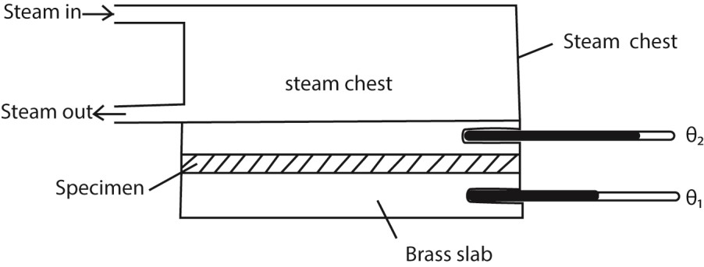
- Glass s cut in form of a thin disc of cross section area, A and thickness, x.
- The disc is sandwiched between a steam chest and brass slab of mass, m and specific heat capacity, c.
- Steam is passed through the chest until the thermometers register steady temperatures, θ₁ and θ₂.
- Then, 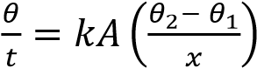
- The glass disc is removed and brass slab is heated directly by steam chest, until its temperature is about 10⁰C above θ₁.
- Steam chest is removes and the top of the glass slab is covered by the glass disc.
- The temperature of the slab is recorded at suitable time interval until its temperature is about 10⁰C below θ₁.
- A graph of temperature against time is plotted and its slope s determined at θ₁
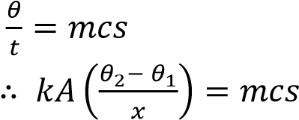
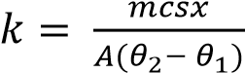 but A = 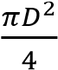
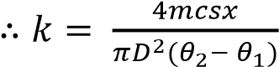

Precautions
- Sample in a thin disc
- Faces of the disc highly polished to ensure tight uniform contacts - A thin layer of grease is smeared on faces for good thermal contact.

Example 2
A cylindrical iron vessel with a base of diameter 15cm and thickness 0.30cm has its base coated with a thin film of soot of thickness 0.10cm. It is then filled with water at 100⁰C and placed on a large block of ice at 0⁰C. Calculate the initial rate at which the ice will melt (06marks) (thermal conductivity of soot=0.12Wm⁻¹K⁻¹, Thermal conductivity of iron, k = 75Wm⁻¹K⁻¹)
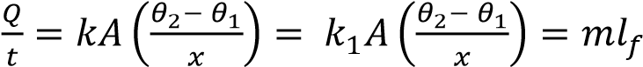
where m is mass that melt per second and = latent heat of fusion
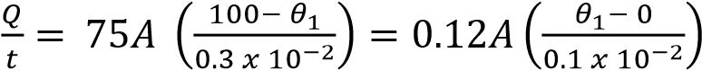
θ₁ = 99.52⁰C
Also, 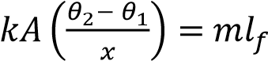
m = 6.42 x 10⁻⁴kgs⁻¹

Example 3
A window of height 1.0m and width 1.5m contains a double grazed unit consisting of two single glass panes, each of thickness 4.0mm separated by an air gap of 2.0mm. Calculate the rate at which heat is conducted through the window if the temperatures of external surfaces of glass are 20⁰C and 30⁰Crespectively.
[Thermal conductivities of glass and air are 0.72Wm⁻¹K⁻¹ and 0.025 Wm⁻¹K⁻¹ respectively] (07marks)
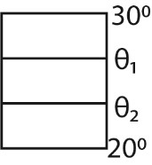
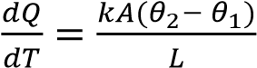= mc x slope
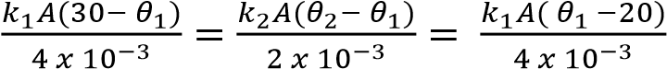
=> θ₁ + θ₂ = 50
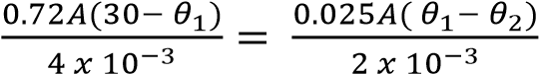
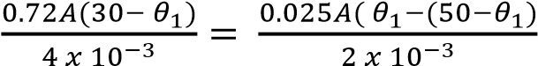
θ₁ = 29.4⁰C
Hence 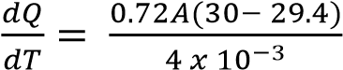 =162W

Example 4
Explain why heating systems based on the circulation of steam are more efficient than those based on circulation of boiling water. (02marks)
A given mass of steam gives out more energy that an equal amount of water at the same temperature because steam possesses very high specific latent heat vaporization

Convections
Convection is a process of heat transfer in fluids from a region of high temperature to a region of low temperature, due to movement of the medium.

Mechanism of heat transfer by convection
When a fluid is heated from underneath, it expands and becomes less dense than fluid above. The warm less dense fluid molecules rise to the top and the cool more dense fluid molecules from above moves downwards to take place. This process continues and circulating current of the fluid is established until the whole fluid is heated up.

Example 5
- What is convection?
- Explain how convectionoccurs.

Radiation
Thermal radiation is the transfer of heat through vacuum i.e. no material medium is required for this transmission.
A black body radiation is an electromagnetic radiation emitted by a body solely due its temperature i.e.
energy emitted depends on body’s temperature.

Electromagnetic spectrum
Electromagnetic spectrum is the distribution of electoral magnetic radiations ranging from those of short wave length to those of longer wave length as shown below.
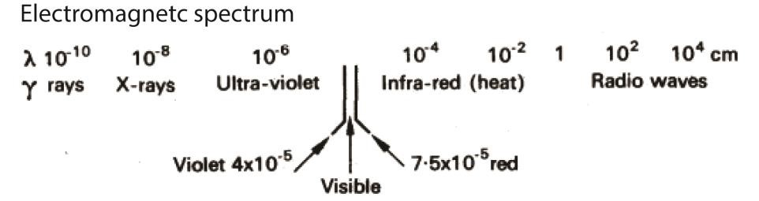

Infrared radiations
Infrared radiations are electromagnetic radiations which are converted into heat when they strike a surface.

Properties of infrared radiations
- They travel at the speed of light.
- They are reflected and refracted like light.
- When absorbed by a body the body’s temperature is raised.
- Causes photo-electric emission from surfaces like Cesium.
- Affects special types of photographic plates which enable pictures to be taken in the dark. - They are absorbed by glass but transmitted by rock salt and quartz.

Comparison of radiation ability for different surfaces
A cubical metal tank whose sides is painted; dull black, dull white and highly polished is filled with hot water and radiations from each surface are detected by a thermopile as shown below.
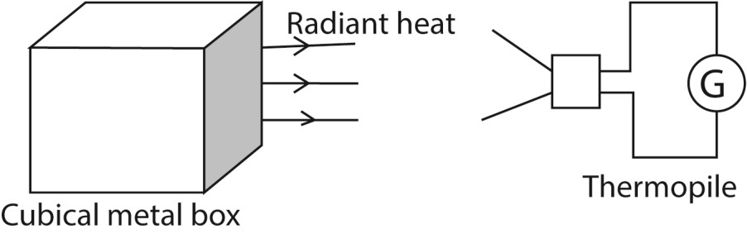
The galvanometer deflection is greatest when the thermopile is facing the dull black surface and least when facing a highly polished silver surface. Therefore, a polished surface is the least radiator and a black surface is the best radiator.

Detectors of infrared radiation

(a) Detection of infrared radiation using Barometer
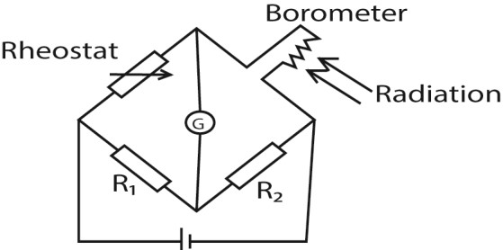
The bolometer strip is connected to Wheatstone bridge circuit above. The rheostat is adjusted until the galvanometer shows no deflection. When the radiations fall on the strip, they are absorbed and its temperature raises leading to an increase in resistance. The galvanometer deflects showing the presence of radiations.

(b) Detection of infrared radiation using Thermopile
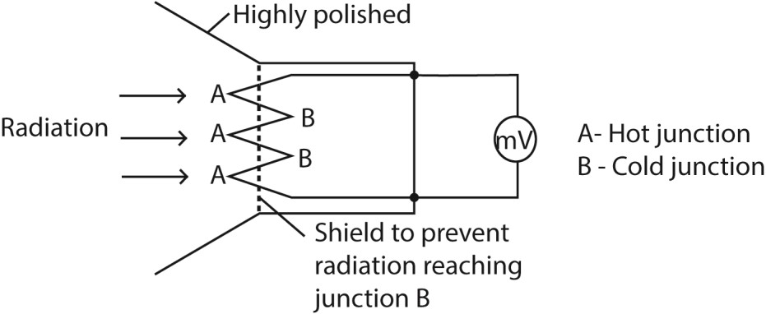
Radiation falling on junction A is absorbed and temperature rises above that of junction B. An e.m.f is generated and is measured by millivolt meter which deflects as a result.

(c) Detection of infrared radiation using the ether-thermo scope.
A blackened and clear bulbs are connected to a tube partly filled with ether i.e. each bulb contains mixture of air and ether vapour. When the arrangement is exposed to infrared radiations, more radiations are absorbed by the blackened bulb than those absorbed by the clear bulb. This raises the pressure inside the blackened bulb causing the ether liquid to be raised in the unblackened bulb as shown below.
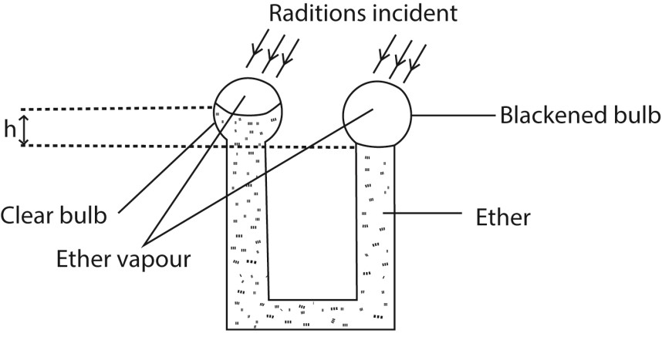
The rise h is proportional to incident radiation

Black body
- A black body is one which absorbs all radiations incident on it and reflects or transmits none.
- The radiations emitted by a black body are called temperature radiations or black body radiations.

Approximation of black body
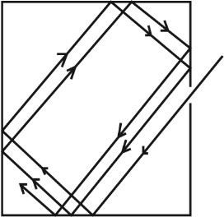
When radiation enters a black container through a hole, it undergoes multiple reflections. At each reflection, part of the radiation is absorbed. After several reflections, all the radiation is retained inside the container. Hence it approximates to a black body.

Distribution of black body radiation
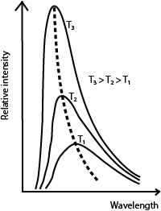
- For every wave length, relative intensity increases as temperature is increased.
- The wavelength at which maximum intensity occur shifts to the shorter wavelength as temperature is increased.
-  _{max} is the wavelength of radiation emitted at maximum intensity/emission of a black body at a particular temperature.

Laws of black body radiation
- Wien’s displacement law
If λ_{max} is the wavelength of the peak of the curve for a given temperature, T then λ_{max}T = constant; the constant is Wien’s constant = 2.9 x 10⁻³mK
- If E λ_{max} is the height of the peak of the curve for temperature, T, then E λ_{max} T⁵.
- The curve showing the variation of E_{λ} with λ at a constant temperature obeys the Plank formula; E 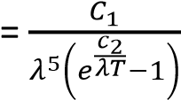 where c₁and c₂ are constant

Example 6
State Stefan’s law. (01mark)
Stefan’s law states that the total power radiated by a black body per unit surface area is proportional to the fourth power of its absolute temperature. i.e. 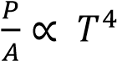
If E is the total energy radiated per second per m² area of a black body at temperature T, then E = σT⁴.
Where σ is called Stefan’s constant = 5.67 x 10⁻⁸Wm⁻²K⁻⁴.

Example 7
The earth receives energy from the sun at the rate of 1.4 x 10³Wm⁻². If the ratio of the sun’s orbit radius to the Earth’s orbit radius is 216, calculate the surface temperature of the sun. (05marks)
Power radiated by the sun = 4πr²σT⁴
Energy intensity = 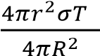
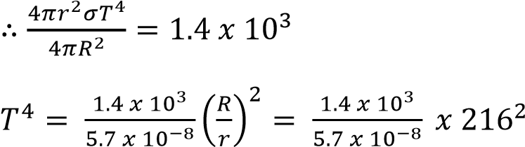
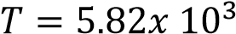 K

Example 8
A spherical black body of radius 2.0cm at -73⁰C is suspended in an evacuated enclosure whose walls are maintained at 27⁰C. If the rate of exchange of thermal energy is equal to 1.85Js⁻¹,
(i) find the value of Stefan’s constant, (05marks)
T₁ = 27 + 273 = 300K
T₂ = -73 + 273 = 200K
P = Aσ(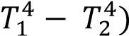
1.85 = 4π(0.02)²σ(300⁴ – 200⁴)
σ = 5.66 x 10⁻⁸Wm⁻¹K⁻⁴
(ii) Calculate the wavelength at which the radiation emitted by the enclosure has maximum intensity (03mark)
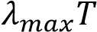 = 2.9 x 10⁻³
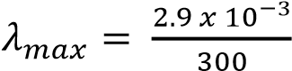= 9.7x 10⁻⁶m

Prevost’s theory of heat exchange
When a body is in thermal equilibrium with its surrounding, its rate of emission of radiation to surrounding is equal to the rate of absorption of the radiation from the surrounding.

Example 9
A small blackened solid copper sphere of radius 2cm is placed in an evacuated enclosure whose wall are kept at 100⁰C. Find the rate at which energy must be supplied to the sphere to keep its temperature at 127⁰C. (03marks)

P =σA(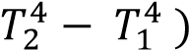
= σ4πr²(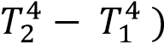
= 5.67 x 10⁻⁸ x 4π (2 x 10⁻²)²(400⁴ – 372⁴)
= 1.78W

Example 10
The energy intensity received by a spherical planet from a star is 1.4 x 10³Wm⁻². The star is of radius 7.0 x 10⁵km and is 14.0 x 10⁷km from the planet.
(i) Calculate the surface temperature of the star. (04marks)
Incident energy per second (power) on a unit of planet = 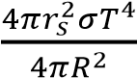
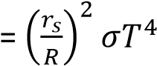 where r_{s} and R are the radii of the star and the distance of the star from the planet respectively.
1.4 x 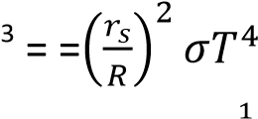10

T =
(ii) State any assumptions you have made in (c)(i) above (01marks)
- The star is spherical
- The star radiates as a black body
- There is no heat loss to the sphere

Greenhouse effect and global warming
- When short wavelength infrared radiation from the sun pass through the water vapour and carbon dioxide in lower layers of the atmosphere, the radiation is absorbed by the earth warming it up.
- The earth re-emits this radiation (infrared) as black body radiation of long wavelength (because of low temperature) and therefore it is trapped by the water vapour and carbon dioxide in the earth’s atmosphere.
- Since the radiation is prevented from escaping from the earth’s atmosphere, it causes global warming.
The quality of radiation refers to the characteristics or properties of radiation that determine its effects and interactions with matter. Here are some key aspects of radiation quality:
- Wavelength and Frequency:
  - Wavelength: The distance between two consecutive peaks of a wave, determining its energy and type (e.g., infrared, ultraviolet, visible light).
  - Frequency: The number of wave cycles per second, which is inversely related to wavelength.
- Energy:
  - Photon Energy: The energy of individual photons in the radiation, typically measured in electron volts (eV). Higher energy photons can cause more significant interactions with matter.
- Intensity:
  - Radiation Intensity: The power per unit area of the radiation, measured in watts per square meter (W/m²). It indicates the amount of energy delivered to a surface.
- Ionizing vs. Non-Ionizing Radiation:
  - Ionizing Radiation: High-energy radiation that can ionize atoms and molecules, causing chemical changes (e.g., X-rays, gamma rays).
  - Non-Ionizing Radiation: Lower-energy radiation that does not ionize atoms but can cause other effects (e.g., radio waves, microwaves).
- Penetrating Ability:
  - Penetration Depth: The ability of radiation to penetrate materials, depending on its energy and the type of material. For example, gamma rays have high penetration power, while alpha particles have low penetration.
- Biological Effects:
  - Radiation Dose: The amount of radiation absorbed by an organism, measured in grays (Gy) or sieverts (Sv). It helps assess the potential biological impact.
  - Radiation Quality Factor: A factor used to account for the different biological effects of various types of radiation, influencing the calculation of the dose equivalent.
Understanding the quality of radiation is crucial in fields such as medical imaging, radiation therapy, and environmental protection, as it helps assess and manage the effects of radiation on health andmaterials.

Application of black body radiation

(i) Astrophysics & Astronomy
- Stars are modeled as approximate black bodies, allowing scientists to determine their temperature, size, and age from emitted radiation.
- The cosmic microwave background (CMB) is a near-perfect black body spectrum, providing evidence for the Big Bang theory.

(ii) Temperature Measurement
- Infrared thermometers and pyrometers use black body radiation principles to measure high temperatures without direct contact.
- Thermal imaging cameras detect emitted radiation to create heat maps, useful in medicine, engineering, and surveillance.

(iii) Quantum Physics
• Planck’s study of black body radiation solved the ultraviolet catastrophe and led to the birth of quantum mechanics, revolutionizing modern physics.

(iv) Industrial Applications
- Used in furnace design and material testing to understand heat transfer.
- Calibration of instruments like spectrometers relies on black body radiation standards.

(v) Environmental & Climate Science
• Helps model Earth’s radiation balance, crucial for studying climate change and greenhouse effects.

Revision exercise as set by global examination bodies
1. (a) State
- Stefan’s law of thermal radiation (01mark)
Stefan’s law states that the total power radiated by a black body per unit surface area is proportional to the fourth power of its absolute temperature. i.e. 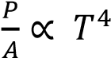
- Wien’s displacement law. (01 ark)
The wavelength λ_{m} at which maximum energy is radiated for temperature, T is such that λ_{m}T = constant.
- Describe an experiment to show the rate of heat loss from a body depends on the nature of the surface. (04marks)
A cubical metal tank whose sides are painted; dull black, dull white and highly polished is filled with hot water and radiations from each surface are detected by a thermopile as shown below.
The galvanometer deflection is greatest when the thermopile is facing the dull black surface and least when facing a highly polished silver surface. Therefore, a polished surface is the least radiator and a black surface is the best radiator. Hence, rate of heat loss from a body depends on the nature of the surface.
- (i) Describe an experiment to detect thermal radiation. (03 marks)

Using Borometer
The bolometer strip is connected to Wheatstone bridge circuit above. The rheostat is adjusted until the galvanometer shows no deflection. When the radiations fall on the strip, they are absorbed and its temperature rises leading to an increase in resistance. The galvanometer deflects showing the presence of radiations.

Or Using a thermopile
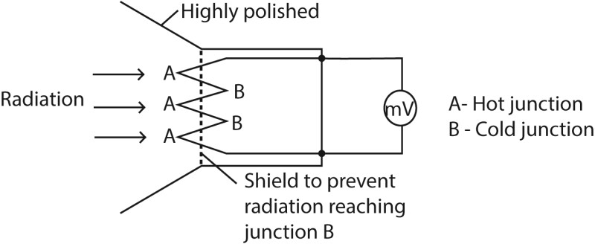
Radiation falling on junction A is absorbed and temperature rises above that of junction B. An e.m.f is generated and is measured by millivolt meter which deflects as a result.
Or
Using the ether-thermo scope.
A blackened and clear bulbs are connected to a tube partly filled with ether i.e. each bulb contains mixture of air and ether vapour. When the arrangement is exposed to infrared radiations, more radiations are absorbed by the blackened bulb than those absorbed by the clear bulb. This raises the pressure inside the blackened bulb causing the ether liquid to be raised in the unblackened bulb as shown below.
The rise h is proportional to incident radiation

(iii) Explain the mechanisn of heat transfer in fluids. (03 marks)
When a fluid is heated from underneath, it expands and becomes less dense than fluid above. The warm less dense fluid rises to the top and the cool more dense fluid from above moves downwards to take place. This process continues and circulating current of the fluid is established until the whole fluid is heated up.

- Explain;
  - what is meant by a perfect black body. (01 mark)
A perfect black body is one that absorbs all the radiation incident on it, but reflects and transmits none.
  - what is meant by quality of radiation. (01 mark)
The quality of radiation refers to the characteristics (such as frequency, intensity) or properties of radiation that determine its effects and interactions with matter.
  - Why a black body at 1000K is red hot whereas it is white hot at 2000K. (02 mark) Red hot: 1000K, the peak wavelength emitted by a black body falls in visible red range making the black body appear red hot.
White Hot: At 2000K, the black body produces a mixture of peak wavelengths with colors in the visible spectrum including red, yellow, green, and blue, which combine to produce white light. Thus, the black body appears white hot.
- The element of an electric fire with an output of 0.5kW, is a cylinder 20cm long.The element behaves as a black body and when in use its temperature is
693.5⁰C. Calculate the diameter of the element. (04marks)
From P = σAT⁴
= σ(πdL)T⁴
⇨ 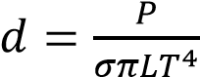
Substitution

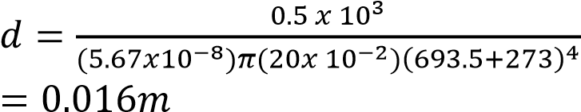
- (a) (i) State any three properties of ultraviolet radiation.(03marks)
      - Produces ionization
      - Produces fluorescence
      - Affects photographic films
      - Produces photoelectric effect
      - Absorbed by glass
      - Can be polarized
      - Promotes chemical reactions
(ii) What is a black body? (01mark)
A black body is one that absorbs all radiations incident on it without reflecting or transmitting any.
  - A cylindrical metal rod with a well- insulated curved surface has one end blackened and then exposed to thermal radiation from a body at a temperature 500K. If the equilibrium temperature of the blackened end is 400K and the length of the rod is 10cm, calculate the temperature of the other end. [Thermal conductivity of the metal = 500Wm⁻¹K⁻¹] (04marks)

Power absorbed = σA(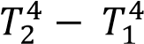)
= 5.67 x 10⁻⁸A(500⁴ – 400⁴) = 2092.13A
Power conducted = 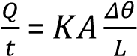
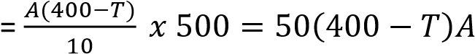
Power absorbed = power conducted 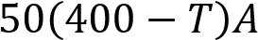 =2092.13A
T = 358.16K
- (a) (i) What is meant by a black body? (02marks)
A black body is a body that absorbs all radiations incident on it and transmits and reflects none
(ii) Give two examples of a black body. (01mark)
      - The sun
      - Star
      - Black hole (remnants of a star after it has used up all its energy]
      - An almost enclosed blackened surface with hole/furnace with small hole
  - With aid of graphs describe how radiation emitted by a black body varies with wavelength for two temperatures.
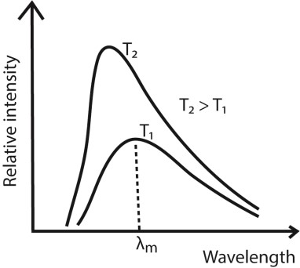
    - For every wave length, relative intensity increases as temperature is increased.
    - The wavelength at which maximum intensity occur shifts to the shorter wavelength as temperature is increased.
    -  _{max} is the wavelength of radiation emitted at maximum intensity/emission of a black body at a particular temperature.
- (a)(i) Define a black body. (01mark)
A black body is a body which absorbs all the radiations incident on it and does not reflect or transmit any.
(ii) Sketch and explain graphs of intensity versus wavelength for three different temperatures of a black body. (03marks)
  - For every wave length, relative intensity increases as temperature is increased.
  - The wavelength at which maximum intensity occur shifts to the shorter wavelength as temperature is increased.
  -  _{max} is the wavelength of radiation emitted at maximum intensity/emission of a black body at a particular temperature.
- (a) (i) What is a black body?(01marks)
A black body is one which absorbs all the radiation that falls upon it, and reflects or transmits none.
    - Explain with the aid of a diagram how black body can be approximated. (03marks)
When radiation enters a black container through a hole, it undergoes multiple reflections. At each reflection, part of the radiation is absorbed. After several reflections, all the radiation is retained inside the container. Hence it approximates to a black body.
    - With the aid of sketch graphs explain the silent features of the spectral distribution of black body radiation (04 marks)
  - For every wave length, relative intensity increases as temperature is increased.
  - The wavelength at which maximum intensity occur shifts to the shorter wavelength as temperature is increased.
  -  _{max} is the wavelength of radiation emitted at maximum intensity/emission of a black body at a particular temperature.
- Give four properties of ultraviolet radiation. (02marks)
  - produce ionization and florescence
  - affect photographic plates
  - produces photoelectric effect - promotes chemical reaction - can be reflected and refracted.
- Describe an experiment to compare the energy radiated by two surfaces at different temperatures (04marks)
  - A metal cube whose sides have a variety of finishes; dull black, white, highly polished is filled with water and this water is kept boiling by a constant heat supply.
  - A thermopile is made to face the various finishes of the cube at equal distances and each time the deflection on the galvanometer is noted.
  - The deflection of the galvanometer is greatest when the thermopile is facing the dullblack surface and least when facing the highly polishes surface.
  - This implies that the dull-black surface is a better radiator.
- (i) State Stefan’s law. (01mark)
Stefan’s law states that the total power radiated by a black body per unit surface area is proportional to the fourth power of its absolute temperature. i.e. 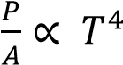
(ii) The earth receives energy from the earth from the sun at the rate of 1.4 x 10³Wm⁻². If the ratio of the earth’s orbit to the sun’s radius is 216, calculate the surface temperature of the sum.
(05marks)
Power radiated by the sun = 4πr²σT⁴
Energy intensity =

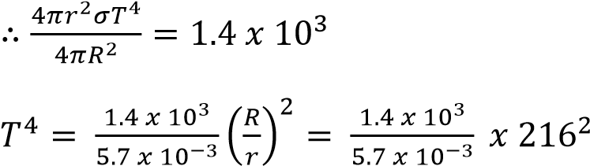
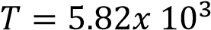 K
- (a) State Stefan’s law of black body radiation. (01marks)
Stefan’s law states that the energy radiated per second per unit area of black body is proportional to the fourth power of the temperature of the body in Kelvin.

  - Briefly describe how a thermopile can be used to detect thermal radiation. (05marks)

Radiation falling on junction A is absorbed and temperature rises above that of junction B. An e.m.f is generated and is measured by millivolt meter which deflects as a result.

  - Explain the temperature distribution along
    - a perfectly lagged metal bar (02marks)
When a metal is fully lagged, no heat is lost to the surroundings. The rate of heat flow along the metal bar is the same making the fall in temperature along the bar is uniform, (ii) an unlagged metal bar. (02marks)

For a fully unlagged metal, heat lost to the surroundings. The rate of heat flow along the bar is not the same. Hence temperature gradient along the bar decreases with distance from the hot end to the cold end.

  - The wall of a furnace is constructed with two layers. The inner layer is made of bricks of thickness 10.0cm and thermal conductivity 0.8 Wm⁻¹K⁻¹ and the outer layer is made of material of thickness 10.0 cm and thermal conductivity 1.6 Wm⁻¹K⁻¹.
The temperatures of the inner and outer surfaces ate 600⁰C and 460⁰C respectively.
      - Explain why in steady state, the rate of thermal energy transfer must be the same in both layers. (01mark)
Rate of the thermal energy transfer is the same because no heat is lost transverse to the direction of heat flow.

      - Calculate the rate of heat flow per square meter through the wall. (05marks)
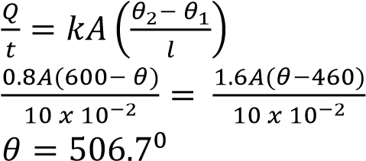
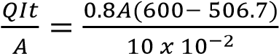= 746.4Wm⁻²
  - Explain the greenhouse effect and how it is related to global warming. (04marks)
Short wavelength radiation from the sun passes through glass of green house. This is absorbed by plants and soil leading to increase in temperature. Plants and soil reradiate long wavelength radiations which cannot penetrate the glass and trapped in the greenhouse leading to higher temperature inside the greenhouse.
Water vapour, carbon dioxide, CFC and other greenhouse gases exhibit the same selective absorption effect in the temperature, making the earth to high temperature by absorbing short wavelength radiation.
The earth reradiates long wavelength radiation which is absorbed by the layers of greenhouse gases. This leads to increased temperature over the earth and after a long time may lead to global warming.
- (a)(i) What is meant by a black body? (01mark)
A black body is one that absorbs all the radiations incident on it, reflects none and transmits none.
(ii) Describe how a black body can be approximated in practice. (04marks)
When radiation enters a black container through a hole, it undergoes multiple reflections. At each reflection, part of the radiation is absorbed. After several reflections, all the radiation is retained inside the container. Hence it approximates to a black body.
  - (i) State Prevost’s theory of heat exchange. (01mark)
A body at constant temperature is in of dynamic equilibrium with its surroundings. The rate of radiation being equal to the rate of absorption.
    - Sketch the variation with wavelength of the intensity of radiation emitted by a black body at two different temperatures. (01mark)
      - For every wave length, relative intensity increases as temperature is increased.
      - The wavelength at which maximum intensity occur shifts to the shorter wavelength as temperature is increased.
      -  _{max} is the wavelength of radiation emitted at maximum intensity/emission of a black body at a particular temperature.
  - A cube of side 1.0cm has a grey surface that emits 50% of the radiation emitted by a black body at the same temperature. If the cube’s temperature is 700⁰C, calculate the power radiated by the cube. (03marks)
P =σAT⁴
T = 700 + 273 = 973K
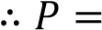0.5 x 5.67 x 10⁻⁸ x (6 x 10⁻⁴) x 973⁴ = 15.25W
- (i) What is meant by a black body? (01mark)
A black body is one that absorbs all incident radiations on it, transmits and reflects none.

  - Sketch curves showing the spectral distribution of energy radiated by a black body at three different temperatures. (02marks)
  - Describe the main features of the curves you have drawn in (d)(ii) (02marks)
      - For every wave length, relative intensity increases as temperature is increased.
      - The wavelength at which maximum intensity occur shifts to the shorter wavelength as temperature is increased.
      -  _{max} is the wavelength of radiation emitted at maximum intensity/emission of a black body at a particular temperature.
(iv) A small blackened solid copper sphere of radius 2cm is placed in an evacuated enclosure whose wall are kept at 100⁰C. Find the rate at which energy must be supplied to the sphere to keep its temperature at 127⁰C. (03marks)
P =σA(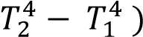
= σ4πr²(
= 5.67 x 10⁻⁸ x 4π (2 x 10⁻²)²(400⁴ – 372⁴)
= 1.78W
- (a) (i) State the laws of black body radiation (02marks)
      - The wavelength λ_{m} at which maximum energy is radiated for temperature, T is such that λ_{m}T = constant. (Wien’s displacement law)
      - If E_{λm} is the height of the peak of the curve for a temperature T, then E_{λm} T⁶
      - The total energy radiated per square meter per second by a black body at temperature, T, is proportional to T⁴ (Stefan’s Boltzmann law)

(ii) Sketch the variation of intensity with wavelength in a black for different temperatures. (03marks)
  - For every wave length, relative intensity increases as temperature is increased.
  - The wavelength at which maximum intensity occur shifts to the shorter wavelength as temperature is increased.
  -  _{max} is the wavelength of radiation emitted at maximum intensity/emission of a black body at a particular temperature.

(b) (i) What is a perfectly black body? (01marks)
A perfect black body is one that absorbs all the radiation incident on it, but reflects and transmits none.

(ii) How can a perfectly black body be approximated in reality? (04marks)
When radiation enters a black container through a hole, it undergoes multiple reflections. At each reflection, part of the radiation is absorbed. After several reflections, all the radiation is retained inside the container. Hence it approximates to a black body.

(c)(i) The energy intensity received by a spherical planet from a star is 1.4 x 10³Wm⁻². The star is of radius 7.0 x 10⁵km and is 14.0 x 10⁷km from the planet.
(i) Calculate the surface temperature of the star. (04marks)
Incident energy per second (power) on a unit of planet = 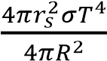
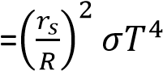
where r_{s} and R are the radii of the star and the distance of the star from the planet respectively.
1.4 x 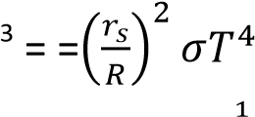10
T =
(ii) State any assumptions you have made in (c)(i) above (01marks)
      - The star is spherical
      - The star radiates as a black body
      - There is no heat loss to the sphere
10. (a) What is meant by black body? (01mark)
A black body is one that absorbs all incident radiation, but reflects and transmits none. (b) Describe how an approximate black body can be realized in practice. (02marks)
When radiation enters a black container through a hole, it undergoes multiple reflections. At each reflection, part of the radiation is absorbed. After several reflections, all the radiation is retained inside the container. Hence it approximates to a black body.

(c)(i) Draw sketch graphs to show how variation of relative intensity of black body radiation with wavelength for three different temperatures. (02marks)

(iii) Describe the features of the sketch in (c)(i) above. (03marks)
As temperature increases, the intensity increases. The intensity of shorter wavelengths increases more rapidly. The wavelength of the most intense radiation decreases as temperature increases.
(d)(i) State Stefan’s law (01mark)
Stefan’s law states that the total power radiated by a black body is directly proportional to the fourth power of its absolute temperature.
(ii) A solid copper sphere of diameter 10 mm and temperature of 150K is placed in an enclosure maintained at a temperature of 290K. Calculate, stating assumptions made, the initial rate of rise of temperature of the sphere.
[Density of copper = 8.93 x 10³kgm⁻³, specific heat capacity of copper = 3.7 x 10²JkgK⁻¹)
(07marks)
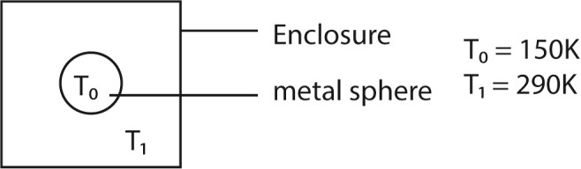

Power radiated by the sphere = 4πr²σT₀⁴
Power absorbed by the sphere =4πr²σT₁⁴ Net power absorbed, P = 4πr²σ(T₁⁴ – T₀⁴)
But also, P = mc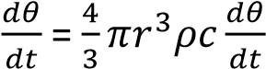
At equilibrium
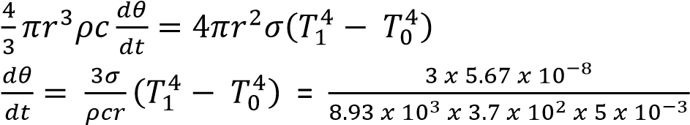= 0.068Ks⁻¹

(e) With the aid of a labelled diagram, describe how a thermopile can be used to determine infrared radiation. (04marks)
Radiation falling on junction A is absorbed and temperature rises above that of junction B. An e.m.f is generated and is measured by millivolt meter which deflects as a result.

TOPIC 6/7: BEHAVIOUR OF GASES
Competency: The learner investigates modes of heat transfer in nature and their application in industry and society.

Definition of Gases
A gas is a term applied to a substance which is in the gaseous phase above its critical temperature.
A critical temperature is a temperature above which a gas cannot be liquefied no matter how great the pressure is.

Gas laws

(a) Boyle’s law
States that the pressure of a fixed mass of a gas is inversely proportional to volume. If P stand for pressure and V for volume; then 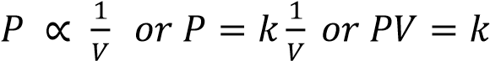 where k is a constant that depend on the mass of a gas and
temperature.
Graphically
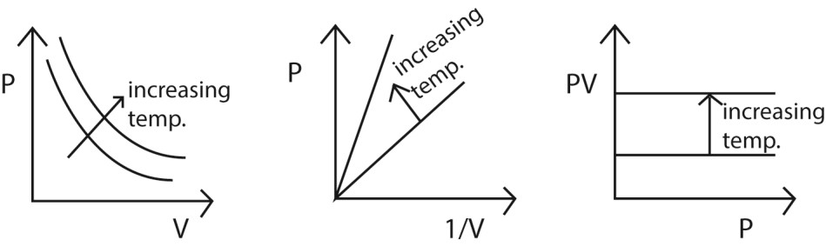
In general, when the pressure and volume of a gas change from P₁ and V₁to P₂ and V₂ respectively at constant temperature, then P₁V₁ =P₂V₂.

An experiment that can be used to verify Boyles’ law.
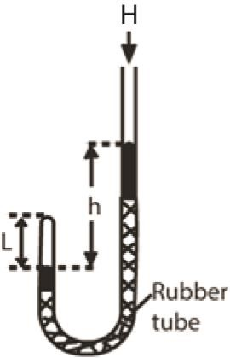
- air in the closed limb of a U-tube barometer as shown above
- Mercury is poured to a height, h, and the length of the air column, L is noted. - the length h is varied to obtain different sets of values of h and L
- Pressure of the gas is calculated from P = (H + h)ρg where H= height of barometer corresponding to atmospheric pressure, ρ = density of mercury, g = acceleration due to gravity. Note that h can be positive or negative.
- If A is the cross section area, V =AL
- Values of h, L, P, V and 1/V are tabulated
- A plot of P against 1/V gives a straight line through the origin which verifies Boyle’s law.

(b) Charles’ law
Charles’s states that the volume of a fixed mass of a gas is directly proportional to its absolute temperature at constant pressure

A graph of volume against temperature is shown below
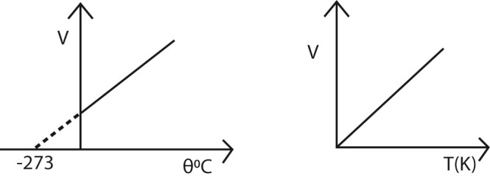
In general when the volume and temperature of a gas change from V₁ and T₁ to V₂ and T₂ respectively at constant pressure, then, 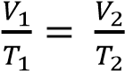

Experiment to verity Charles’ law

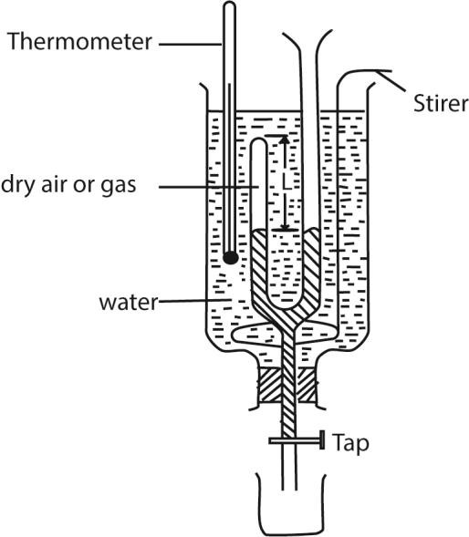
- Dry air is trapped in the closed limb as shown above
- The level of mercury in the two limbs is maintained at the same level by adding or removing mercury at each temperature of the bath to ensure that pressure of the air is equal to atmospheric temperature.
- The length L of the air column and temperature of the water bath θ are recorded.
- Several values of L and θ are obtained by passing steam
- A graph of L against θ gives a straight line showing that the volume of the gas is proportional to temperature.

(c) Pressure law
It states that the pressure of a fixed mass of a gas is proportional to temperature provided the volume is constant. i.e. 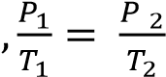

Ideal gas equation or equation of state
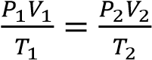
Or
PV = kT

Example 1
A gas cylinder has volume of 0.040m³ and contains air at pressure of 2.0MPa. Assuming that the temperature remain constant, calculate
(a) The equivalent volume of air at atmospheric pressure of 1.0 x 10⁵Pa
From PV = constant
0.04 x 2 x 10⁶ = V x 1.0 x 10⁵
V= 0.8m³

(b) The volume of air, at atmospheric pressure, which escapes from the cylinder when it is opened to atmosphere.
0.8 - 0.04 = 0.76m³
i.e. air escapes from the cylinder until it contains 0.04m³ of air at atmospheric pressure

(d) Dalton’s law of partial pressures
States that the total pressure of a mixture of gases, which do not react chemically, is equal to the sum of the partial pressures of the gases.

Example 2
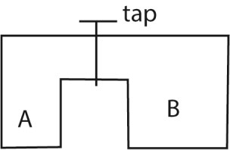
Two cylinders A and B of volumes V and 3V respectively are separately filled with a gas. The cylinders are connected as shown above with the tap closed. The pressures of A and B are P and 4P respectively. When the tap is opened the common pressure becomes 60Pa. Assuming isothermal conditions find the value of P. (04marks)
Solution
From PV = nRT
Moles n₁ of the gas in A before mixing= 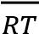
Moles n₂ of the gas in B before mixing = 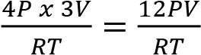
Moles n₃ of the gas when tap is opened = 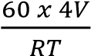
But moles of the gas before mixing = mole of the gas after mixing
⇨ n₁ + n₂ =n₃
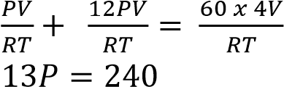
P = 18.46Pa

External work done by expanding gas.
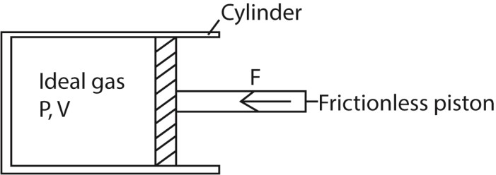
Suppose the gas expands by dv so that the piston moves out through a small distance dx.

Work done by the gas, dW = Fdx = PAdx
= Pdv
Total work done during expansion from v₁ to v₂ is given by
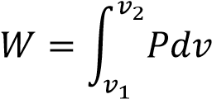

Example 3
When 1.5kg of water is converted to steam at (100⁰C) at standard pressure (1.01 x 10⁵Nm⁻²) 3.39MJ of heat is required. During the transformation from liquid to vapour, the increase in volume of water is 2.5m³.
- Calculate the work done against the external pressure during the process of evaporation. From ΔW = P(V₂ – V₁)
External work done = 1.01 x 10⁵ x 2.5 = 2.53 x 10⁵J

- Explain what happens to the rest of the energy.
The difference in energy is the increase in internal energy of water molecules.
i.e. 3.39 x 10⁶ – 2.53 x 10⁵ = 3.24 x 10⁶J = increase in internal energy of water molecules.

Molar Heat capacities
Molar heat capacity of a substance is the amount of heat required to raise the temperature of one mole of it by 1K. It is expressed in Jmol⁻¹K⁻¹.

Molar heat capacity at constant volume, c_{v}
Molar heat capacity at constant volume of a substance is the amount of heat required to raise the temperature of one mole of it by 1K at constant volume. It is expressed in Jmol⁻¹K⁻¹.

Molar heat capacity at constant pressure, c_{p}
Molar heat capacity at constant pressure of a substance is the amount of heat required to raise the temperature of one mole of it by 1K at constant pressure. It is expressed in Jmol⁻¹K⁻¹.

The relationship between the principal molar heat capacities C_{p} and C_{v} for an deal gas.
From dQ = dU + dW……………. (i)
But dQ = C_{p}dT, dU = C_{v}dT and dW= PdV = RdT
Substituting in (i)

C_{p}dT = C_{v}dT + RdT
C_{p} – C_{v} = R
Where R is the universal gas constant per unit mass.

Example 4
The temperature of 1mole of helium gas at a pressure of 1.0 x 10⁵Pa increases from 20⁰C to 100⁰C when the gas is compressed adiabatically.
Find the final pressure of the gas. (Take 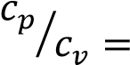γ =1.67) (04 marks)
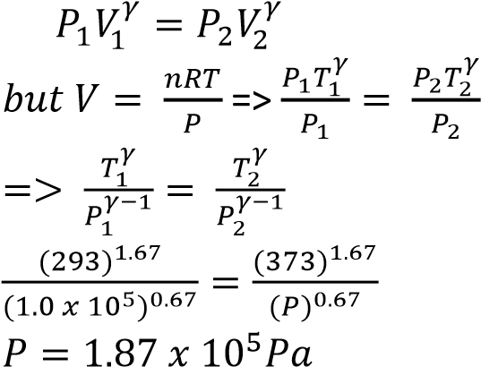

Example 5
Nitrogen gas is trapped in a container by a movable piston. If the temperature of the gas is raised from 0⁰C to 50⁰C at constant pressure of 4.0 x 10⁵Pa and the total heat added is 3.0 x 10⁴J, calculate the work done by the gas. [The molar heat capacity of nitrogen at constant pressure is 29.1Jmol⁻¹K⁻¹, C_{p}/C_{v}= 1.4]

ΔQ = ΔU + Δw ……………………. (i)
Cv = 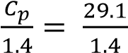 = 20.79Jmol⁻¹ ΔQ = nC_{p}ΔT
n = 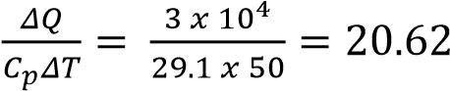
From equation (i)
3 x 10⁴ = 20.62 x 20.79 (50-0) + Δw Δw = 8.57 x 10³J

Example 6
Ten moles of a gas, initially at 27⁰C are heated at constant pressure of 1.01 x 10⁵Pa and volume increased from 0.25m³ to 0.375m³. Calculate the increase in internal energy.
[Assume C_{p} = 28.5Jmol⁻¹K⁻¹] (06marks)
T₁ = 27⁰C = 300K
Using 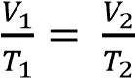
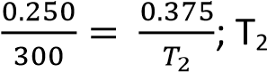= 450K
ΔQ = ΔU + Δw
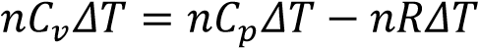
= 10 x 28.5 x 150 – 10 x 8.31 x 150 = 3.03 x 10⁴J

Example 7
An ideal gas at 18⁰C is compressed adiabatically until the volume is halved. Calculate the final
temperature of the gas. [Assume specific heat capacities of the gas at constant pressure and volume are 2100Jkg⁻¹K⁻¹ and 1500Jkg⁻¹K⁻¹] respectively. (04marks)
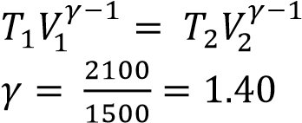
⇨ 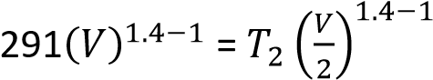
T₂ = 384K

Dalton’s Law
Dalton’s law states that the total pressure of a mixture of gases which do not interact chemically is equal to the sum of partial pressures of the individual gases.

Definition
Partial pressure is the pressure of an individual gas in a mixture or partial pressure of a gas in a mixture is the pressure which it would exert if it were allowed to occupy the volume of the mixture at the same temperature as the mixture

The kinetic theory of matter
- Gases are composed of molecules which are in continuous random motion.
- The molecules collide elastically with one another and also with the walls of the container.
- The pressure of a gas is due to the molecules bombarding the walls of its container. Whenever a molecule bounces off a wall, its momentum at right-angles to the wall is reversed; the force which it exerts on the wall is equal to the rate of change of its momentum. The average force exerted by the gas on the whole of its container is the average rate at which the momentum of its molecules is changed by collision with the walls.

Calculation of pressure
To find the pressure of the gas we must find this force, and then divide it by the area of the walls.

Assumptions
- The attraction between the molecules is negligible.
- The volume of the molecules is negligible compared with the volume occupied by the gas.
- The molecules are like perfectly elastic spheres.
- The duration of a collision is negligible compared with the time between collisions.
Consider a molecule of mass, m, moving in a cube of length, l and velocity, u.
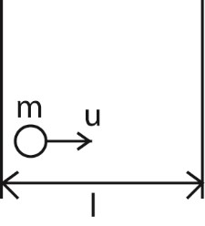
Change in momentum = mu - ⁻mu = 2mu
Rate of change of momentum = 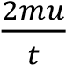
Time, t, between collision = 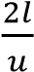
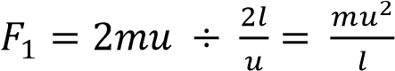
For N molecules, force on the wall,
F = 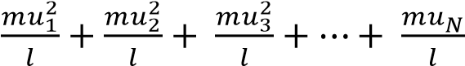
Pressure, P = 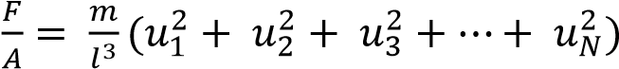 since A = ²
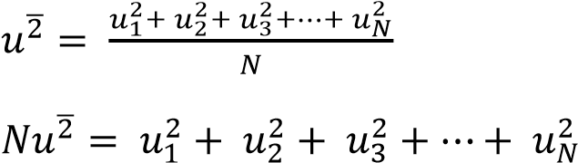
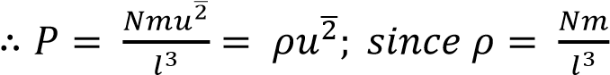
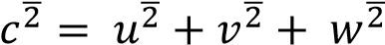 and 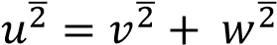
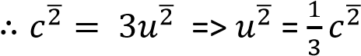
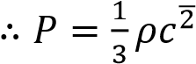

Definition
Mean square speed is the average square speed of the gas molecules at a particular temperature, T
Root-mean-square speed,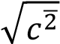 is the square root of mean of square velocities of gas molecules.
Since 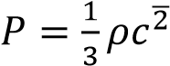
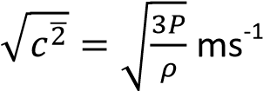
From PV = nRT and ρ =
P = 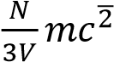
PV = 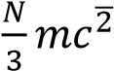
⇨ 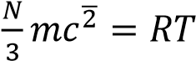
This shows that mean square speed s proportional to temperature.
Also
RT = 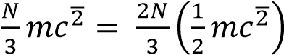
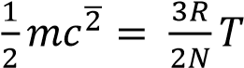
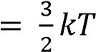
Where k = is Boltzmann's constant numerically equal to 1.38 x 10⁻²JK⁻¹.
Therefore, the average kinetic energy of translation of the random motion of the molecule of a gas is proportion to the kinetic energy.

Example 8
If the mass of 1mole of hydrogen is 2.0g and this occupies a volume of 0.022m³ at 273K and pressure of 10⁵Nm⁻². Calculate the r.m.s speed of hydrogen at 546K.
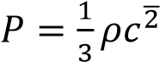
ρ = 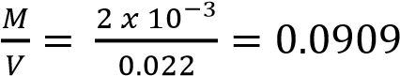kgm⁻³
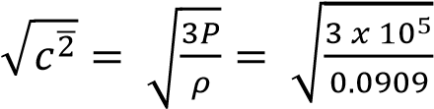= 1.8167 x 10³ms⁻¹

Let r.m.s speed at 546K be 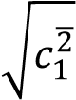
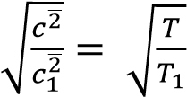
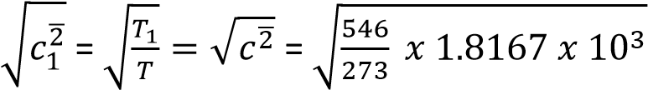= 2569.2ms⁻¹

Example 9
Derive the expression P = 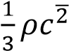 for the pressure, P, of an ideal gas of density ρ and mean square speed,
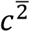. State any assumptions made (07marks)

Example 10
Derivation of Dalton’s law from kinetic theory expression, p = 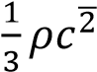, where ρ is the pressure of a gas of density ρ and mean square speed c²

P = 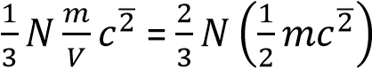
For gas 1, P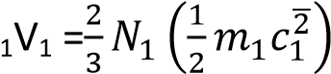
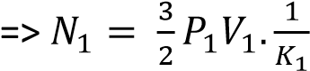
Similarly for gas 2
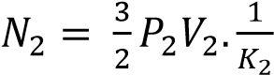
For a mixture of gases, N = 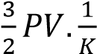; but N = N₁ + N₂
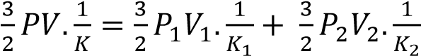
Since temperature is constant, K₁ = K₂ = K
- PV = P₁V₁ + P₂V₂
- But V = V₁ = V₂
- 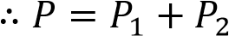

Example 11
Explain why the pressure of a fixed mass of a gas rises if its temperature is increased. (02marks)
When the temperature of a fixed mass of a gas is increased, at constant volume, the velocities and kinetic energy of molecules is increased. They bombard the walls of the container more frequently with increased force. This increases pressure since pressure is proportional to force.

Example 12
Explain the following observations using the kinetic theory.
(i) A gas fills any container in which is it placed and exerts pressure on its walls. (03marks)
A gas contains molecules with negligible intermolecular forces that are free to move in all directions. As they move, they collide with each other and with the walls of the container. The unrestricted movements make them to fill the available space and collisions with the walls contribute to the pressure exerted on the wall.
(ii) The pressure of a fixed mass of a gas rises when temperature is increased at constant volume. (02 marks)
When the temperature of a gas increases, the kinetic energy of the gas molecules increases. This increases the frequency and force of collision against the walls of a container leading to increase in pressure.

Example 13
Explain why the pressure of a fixed mass of a gas in a closed container increases when the temperature of the container is raised. (02marks)
When the temperature of the container increases, the average velocity of the molecules increases. So the number and force of collisions with the walls of the container per second increase. Consequently the momentum change per second increases as they bombard the walls. This leads to increase in the impulsive force exerted on the walls causing increase in pressure

Graham’s law
States that the rate of diffusion of a gas is inversely proportional to the square root of its density.
From 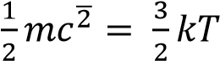 where k is a universal constant
At the same Kelvin temperature T, the mean kinetic energies of the molecules of different gases are equal.
If subscript 1 and 2 denote gases 1 and 2 respectively
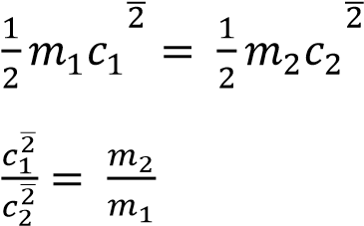
At a given temperature and pressure, the density of a gas, ρ, is proportional to the mass of its molecule, m, since equal volumes contain equal number of molecules
Therefore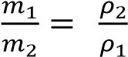
Then 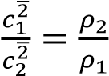
Hence,
√

̅
√

̅

√

√

The equation
- shows that the average molecular speeds are inversely proportional to the square roots of the densities of the gases.
- explains why the rates of diffusion-which depend on the molecular speeds-are also inversely proportional to the square roots of the densities.

Real gases
As opposed to ideal gases, in real gas;
- The volume of the molecules may not be negligible in relation to the volume V occupied by the gas.
- The attractive forces between the molecules may not be negligible.

Real gas equation
To account for molecular volume and intermolecular forces J.H. Vander Waal proposed the following equation
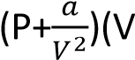-b) =RT
For 1mole of a gas 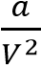 corrects deficit in pressure due to intermolecular attractions of gas molecules and b, called the co-volume accounts for the finite volume of molecules themselves
NB: (i) A real gas obeys ideal gas equation above the critical temperature

Differences between ideal and real gases
- Ideal gases obey Boyle’s law while real gases do not.
- The volumes of the molecules of ideal gases are negligible compared to the container while for the real gases the volume is not negligible.
- Ideal gases have negligible intermolecular forces while the intermolecular forces of real gases are not negligible
- The velocity of ideal gas molecules is constant in between collision while real gases molecules do not have constant velocity due to intermolecular forces.

Vapours
A gas is the gaseous state of a substance above its critical temperature, T_{C}.
A vapour is the gaseous state of a substance below its critical temperature.

A graph of a real gas below and above the critical temperature
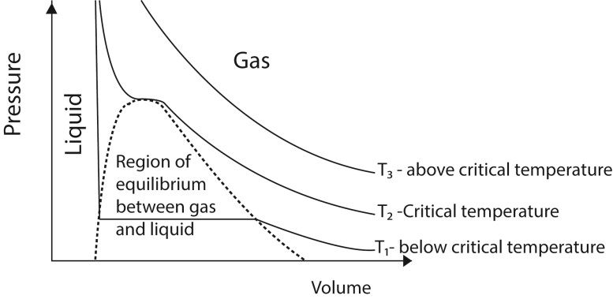
- Above the critical temperature a gas obeys Boyle’s law.
- Below the critical temperature a gas exist as unsaturated vapour at low pressure when the pressure is increase it condenses until all the gas is turned into a liquid.
A critical temperature is a temperature above which a gas cannot be turned into a liquid by compression.

Saturated and unsaturated vapour
Unsaturated vapour is a vapour that is not in dynamic equilibrium with its own liquid while saturated vapour is a vapour that is in dynamic equilibrium with its own liquid

Differences between saturated and unsaturated vapors
- A saturated vapour pressure is one which is in dynamic equilibrium with its own liquid and an unsaturated vapour is one that is not in dynamic equilibrium with its own liquid.
- A saturate vapour pressure does not obey gas laws whereas unsaturated vapour approximately obeys gas laws.

Example 14
Sketch graphs of pressure against temperature for an ideal gas and for saturated water vapour originally at 0⁰C (03marks)

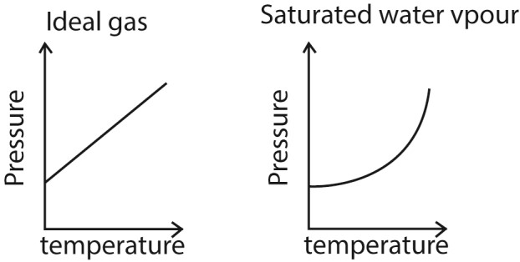

An experiment to determine saturated vapour pressure at a given temperature
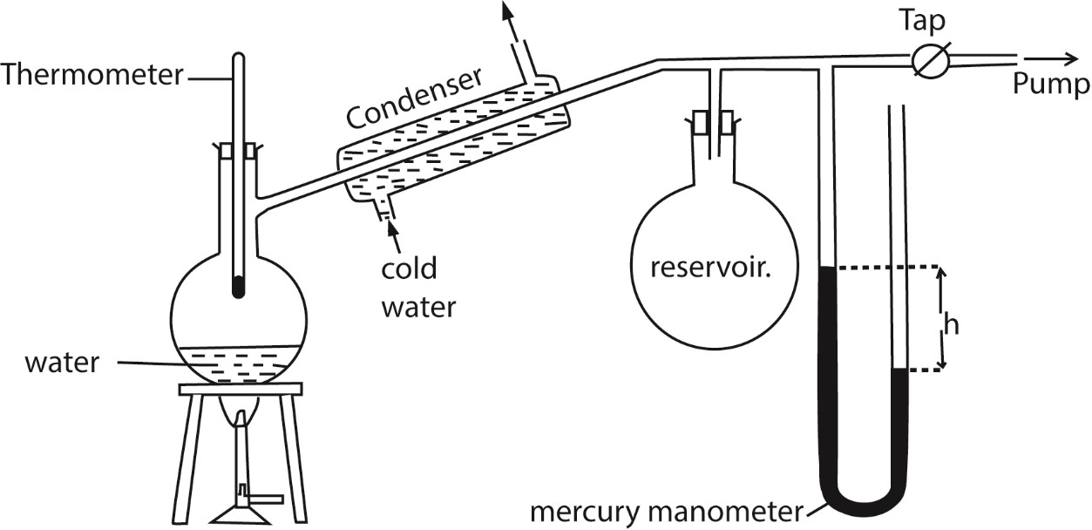
- The pressure of the air in Reservoir is shown by the mercury manometer; if its height is h, the pressure in mm mercury is P = H-h, where H is the barometer height.
- The tap is opened and the pressure above water varied using the pump to a suitable value.
- The tap is closed and water in the flask in heated until it boil.
- The temperature θ and difference in mercury levels, h, are noted and recorded.
- The saturated vapour pressure, P = (H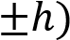 is calculated
- The procedure is repeated other values of θ and h
- A graph of P versus θ is plotted and the saturated vapour pressure at a particular temperature is obtained.

Example 15
With the aid of a labelled diagram, describe an experiment to determine standard saturated vapour pressure of water. (05marks)

Example 16
Use the kinetic theory to explain the following observations
- Saturated vapour pressure of a liquid increases with temperature. (03marks)
If a liquid is in dynamic equilibrium with its vapour, an increase in temperature increases mean kinetic energy of the molecules and hence the rate at which molecules escape from the liquid. The density of the vapour increases implying increase in the rate of condensation until dynamic equilibrium is restored. There are now more molecules in the vapour phase than previously that are moving faster and hence higher pressure.

- Saturated vapour pressure is not affected by decrease in volume at constant pressure. (03marks)
A decrease in volume leads to a momentary increase in vapour density. Consequently, the rate of condensation increases while the rate of evaporation rate is constant. When the vapour density reduces, the condensation rate also reduces. So the dynamic equilibrium is restored to the initial value.

Example 17
Two similar cylinders P and Q contain different gases at the same pressure. When gas is released from P the pressure remains constant for some time before it starts dropping. When gas is released from Q the pressure continuously drops. Explain the observation above. (05marks)
- The gas in P is in form of a saturated vapour; that is, in dynamic equilibrium with a liquid. As the gas is released, more liquid turns into a gas to restore pressure until the gas becomes unsaturated and the pressure begins to drop as the moles of the gas decrease
- The gas in Q is unsaturated, and thus pressure reduces as the moles of the gas reduce up on release.

Experiment to show that a liquid boils off when its saturated vapour pressure equals the external pressure
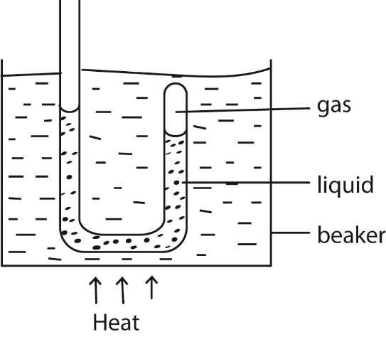
- Air is trapped in the closed limb of the tube by water column.
- The tube is heated in water bath.
- When the water bath begins to boil, the water in the tube comes to the same level in each limb.
- This shows that the vapor pressure in closed limb is equal to external pressure.

Evaporation
During evaporation, a liquid changes to vapour low the boiling point.

Reasons why evaporation causes cooling
During evaporation liquid molecules with high kinetic energy escape from inter molecular attraction in the liquid leaving molecules of low kinetic energy behind. Since temperature s proportional average kinetic energy of molecules, the liquid cools. Factors affecting the rate of evaporation
- Surface area. Evaporation increases with surface area of a liquid due to increase in the number of exposed molecules.
- Temperature: increase in temperature increases the rate of evaporation because it increases the average kinetic energy of the molecules.
- Drought /wind blowing over the surface. Wind removes the saturated air layer from the surface of the liquid thereby increasing the rate of evaporation.

Example 36
Explain the occurrence of land and sea breeze. (04marks)
During day, the land is heated to a high temperature than the sea. Hot air expands and rises from land. A stream of cool air from the sea blows towards the land to replace the uprising air, hence sea breeze occurs.
At night the land cools faster because it is no longer heated by the sun. The sea retains the warmth because it is heated deeply. Warm less dense air rises from the sea surface and air from land blows to replace it leading to land breeze.

Example 18
A horizontal tube of uniform bore, closed at one end, has some air trapped by a small quantity of water. The length of the enclosed air column is 20cm at 12⁰C.
Find stating any assumptions made, the length of air column when the temperature is raised to 38⁰C.
[S.V.P of water at 12⁰C and 38⁰C are 10.5mmHg and 49.5mmHg respectively.
Atmospheric pressure = 75cmHG] (05marks)
T₁ = 273 + 12 = 285K,
T₂ = 273 + 38 = 311K;
P₁ = 750 – 10.5 = 739.5mmHg,
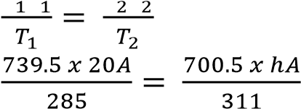
P₂ = 750-49.5 = 700.5mmHg
h = 23.04cm
Assumption: the tube does not expand when the temperature increases.

Example 19
When hydrogen gas is collected over water, the pressure in the tube at 15⁰C and 75⁰C are 65.5cm and 105.6cm of mercury respectively. If the saturated vapour pressure at 15⁰C is 1.42cm of mercury, find its value at 75⁰C (04marks)
P₁= 65.5 – 1.42 = 62.08 and T₁ = 273 + 15 = 288K
P₂ = 105.6 – P, and T₂ = 273 + 75 = 348K
From 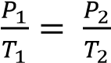
P 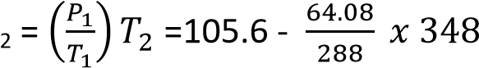= 28.12cmHg

Isothermal and adiabatic changes
Isothermal expansion takes place at constant temperature.
Adiabatic expansion takes place at constant heat.
Sketch graphs of pressure versus volume for fixed mass of a gas undergoing isothermal and adiabatic changes.
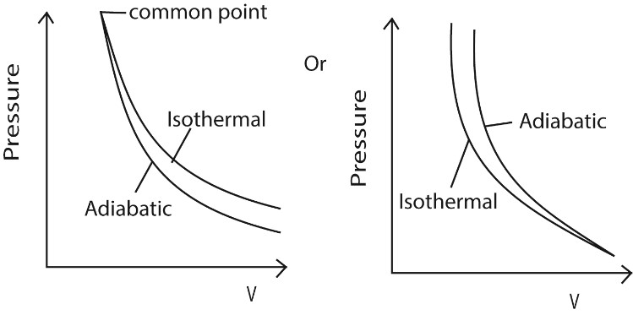

Condition necessary for realization of an isothermal change
- The gas must be held in thin-walled and highly conducting vessel
- The process must take place slowly so that heat passes into the gas to maintain constant temperature.
- The gas vessel must be surrounded by a constant temperature bath.

Conditions for adiabatic change
- The gas must be held in a thick walled and poorly conducting vessel
- The process must be carried out rapidly to minimize heat linkage through the walls.

Relationship between volume, pressure and temperature
  - For reversible isothermal change
PV = nRT where n is the number of mole of gas, R = gas constant
  - For reversible adiabatic change
Pv^{γ} = constant
TV^{γ-1} = constant

Example 20
Ten moles of a gas, initially at 27⁰C are heated at constant pressure of 1.01 x 10⁵Pa and volume increased from 0.25m³ to 0.375m³. Calculate the increase in internal energy. [Assume C_{p} = 28.5Jmol⁻¹K⁻¹] (06marks)
T₁ = 27⁰C = 300K
Using 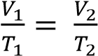
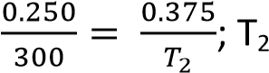= 450K
ΔQ = ΔU + Δw
= 10 x 28.5 x 150 – 10 x 8.31 x 150
= 3.03 x 10⁴J

Example 21
An ideal gas at 18⁰C is compressed adiabatically until the volume is halved. Calculate the final
temperature of the gas. [Assume specific heat capacities of the gas at constant pressure and volume are 2100Jkg⁻¹K⁻¹ and 1500Jkg⁻¹K⁻¹] respectively. (04marks)

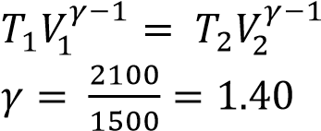
⇨ 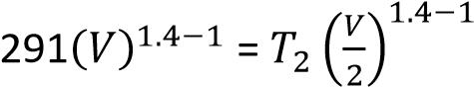
T₂ = 384K

Example 22
State the first law of thermodynamics and use it to distinguish between Isothermal and adiabatic changes in a gas. (05marks)
ΔQ = ΔU + ΔW = nC_{v}ΔT + ΔW
During isothermal expansion, ΔT = 0. Therefore all the energy supplied is equal to the work done by the gas during expansion.
In adiabatic expansion, no heat enters or leaves the gas. Therefore ΔQ = 0 and ΔU = -ΔW.
In adiabatic expansion, work s done at the expense of its internal energy. Therefore the gas cools.

Example 23
- (i) What is meant by isothermal process and adiabatic process? (02marks)
Isothermal process is the expansion or compression of a gas at constant temperature.
Adiabatic process is the expansion or compression of a gas where there is no heat loss or gain into the gas.
  - Explain why adiabatic expansion of a gas causes cooling (03marks)
During an adiabatic expansion of a gas, no heat is supplied to the gas. Molecules strike the receding piston and bounce off with reduced velocities and hence lower kinetic energy. Since kinetic energy is proportional to temperature, the gas cools during the expansion

- A gas at a temperature of 17⁰C and pressure 1.0 x 10⁵Pa compressed isothermally to half its original volume. It is then allowed to expand adiabatically to its original volume (i) Sketch a P-V curve the above process (02marks)
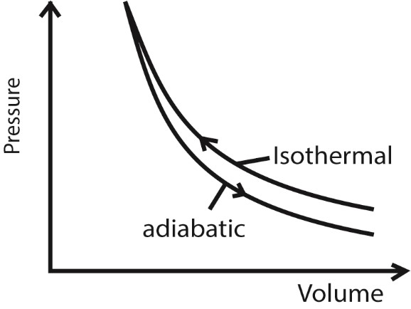
  - If the specific heat capacity at constant pressure is 2100Jmol⁻¹K⁻¹ and at constant volume is
1500Jmol⁻¹K⁻¹, find the final temperature of the gas (04marks) γ = 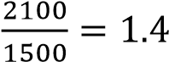
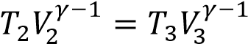
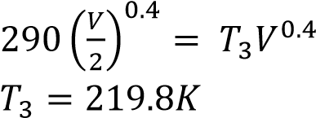
Revision exercise (Qns. as set by Global examinations’ bodies)
1. (a) Define the following;
(i) Saturted vapour. (01mark)
A saturated vapour is one that is a dynamic equilibrium with its own liquid
(ii) Partial pressure of a gas. (01 marks)
Partial pressure is the pressure that would be exerted by a gas if it alone occupied the volume of the mixture.
(b) (i) Explain the effect of increase in temperature on the saturated vapour pressure of a liquid. (04marks)
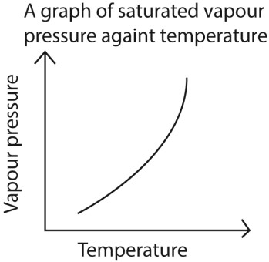
The saturated vapor pressure of any substance depends on its temperature. At higher temperatures, more molecules have sufficient kinetic energy to break from the liquid surface into the vapor phase. Under these conditions, equilibrium is reached at a higher pressure.
(ii) Describe an experiment to determine the saturated vapour pressure and boiling point of water
The setup is shown below
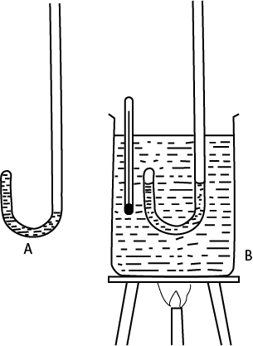
- Atmospheric pressure, H, is deterined using a mercury barometer
- Water is trapped in a J tube as shown in A
- The J-tube in and its content is transferred into a beaker of water B and a thermometer is inserted as shown in B.
- Water in the beaker is heated until it boils and the boiling point is obtained from the constant reading of the thermometer.
- It also noted that water in the closed and open tube of the J-tube are at the same level indicating that water boils when its saturated vapor pressure is equal to the atmospheric pressure H.

- (i) Define an idea gas (01ark)
An Ideal gas s one that obeys Boyle’s law under all conditions
(ii) What assumptions of the kinetic theory of an ideal gas need to be modified to account for the behaviour of a real gas.
  - Negligible is Volume of Gas Molecules: The kinetic theory assumes that the volume of individual gas molecules is negligible compared to the volume of the container. In reality, gas molecules do occupy space, and their finite size becomes significant at high pressures, where the volume of the container is reduced.
  - No Intermolecular Forces: The theory assumes that there are no attractive or repulsive forces between gas molecules. However, real gases experience intermolecular forces (Van der Waals forces), which affect their behavior. Attractive forces become significant at low temperatures and high pressure, leading to deviations from ideal gas behavior.
  - Perfectly Elastic Collisions: The theory assumes that collisions between gas molecules and with the walls of the container are perfectly elastic, meaning there is no loss of kinetic energy. In reality, some energy is lost in collisions, although it is often small enough to be negligible in many situations.
  - Random Motion: While gas molecules do move randomly, the theory assumes complete randomness without considering the influence of intermolecular forces. In real gases, these forces can lead to non-random behavior, particularly under certain conditions.
To account for these deviations, the Van der Waals equation is often used as an improvement over the ideal gas law:
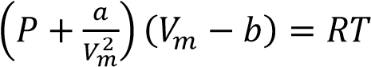
Where
  - P is the pressure of the gas.
  - V_{m} is the molar volume of the gas.
  - T is the temperature of the gas. • R is the universal gas constant.
  - a and b are empirical constants specific to each gas, accounting for intermolecular forces and the finite volume of gas molecules, respectively.

- A sealed flask of volue 80cm³ contains argon at a pressure of 10kPa and a temperature of 27⁰C. Calculate;
(i) number of molecules of argon in the flask (03marks)
From PV = nRT
n = 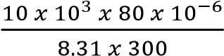 = 3.2 x 10⁻⁴ moles
Number of molecules = 3.2 x 10⁻⁴ x 6.02 x 10²³ = 1.9264 x 10²⁰.

(ii) root mean square speed of the molecules in the flask (Molar mass of argon is 0.018kg) (03 mark)
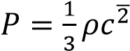
Mass of Argon = 3.2 x 10⁻⁴ x 0.018 =5.76 x10⁻⁶kg
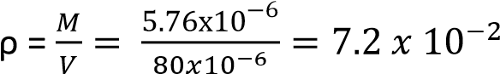kgm⁻³
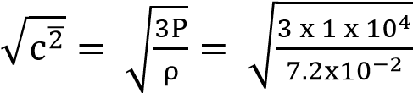= 645.5 ms⁻¹
- (a) What is meant by the following:
    - Super-heated water? (01 mark)
Superheated water is liquid water under pressure at temperatures between the usual boiling point, 100 °C and the critical temperature, 374 °C.
    - Super cooled vapour? (01 mark)
Supercooled vapor refers to a gaseous state that remains at a temperature below its usual condensation point but doesn't condense into a liquid.
(b) Explain how:
(i) a gas in a vessel exerts pressure. (03marks)

A gas in a vessel exerts pressure due to the constant motion and collisions of its molecules with the walls of the container. Each molecule that collides with of vessel exerts a small force on the wall; and the cumulative effect of numerous collisions over a given area generates a continuous force on the wall of the vessel. This force per unit area constitutes pressure of a gas.

(ii) the atmosphere surrounding the earth prevents it from becoming unbearably cold. (03marks)

        - atmosphere contain greenhouse gases and clouds that trap heat from the sun keeping the earth warm
        - atmospheric gases act as insulators reducing temperature fluctuations
        - circulation of atmospheric gases redistributes heat from the equator to cold paces

(c) A container of volume 0.2m³ contains hydrogen gas of molar mass 2gmol⁻¹ at a pressure of 1.5 x 10⁴ Pa and a temperature of 27⁰C.
Calculate the:
(i) number of hydrogen molecules in the container. (03 marks)
From 
1.5 x 10⁴ x 0.2 = n x 8.31 x (273 + 17)
The number of moles of hydrogen gas, n = 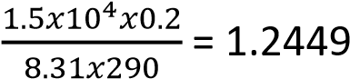
Number of hydrogen molecules = 1.2449 x 6.02 x 10²³
= 7.4943 x 10²³ molecules
      - mean square speed of the molecules. (03 marks)

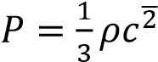
Mass of hydrogen = 1.2449 x2 =2.4898 x 10⁻³kg
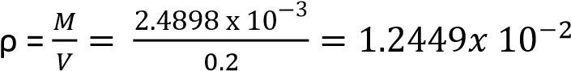kgm⁻³
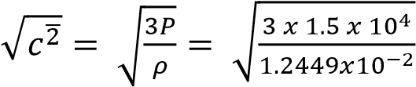= 1,901 ms⁻¹

      - root mean square speed of oxygen molecules at the same temperature. (Molar mass of oxygen – 32mol⁻¹) (02 marks)
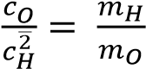
Hence root mean square speed of oxygen =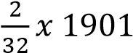 = 119ms⁻¹

(d) Sketch a graph of saturated vapour pressure of a liquid against temperature and explain the shape of the curve. (04 marks)
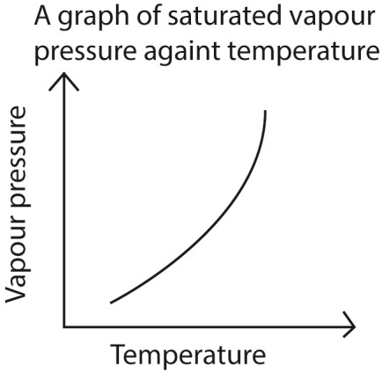
Saturated vapour pressure increases with temperature due to the increase in kinetic energy and the probability of molecules overcoming the intermolecular forces holding them in the liquid phase, allowing them to escape into the vapour phase
- (a) (i) What is meant by isothermal and adiabatic processes in a gas.
(03marks)
Isothermal expansion is an expansion of gas that takes place at constant temperature.
Adiabatic expansion is an expansion of gas that takes place at constant heat.
    - State the conditions necessary to achieve the processes in (a)(i) (04 marks)
Isothermal process occurs at constant temperature and therefore the gas must be enclosed in thin walled container of good thermal conductivity placed in a large heat reservoir and occurs slowly enough to allow heat exchange with the surrounding.

Adiabatic process requires no heat input or out and therefore should occur rapidly in well insulated container like a thermos flask and gas should be ideal.

    - Explain why air coming out of a valve of a ball feels cold. (02marks)
This is due rapid (adiabatic) expansion accompanied with a decrease in temperature which causes a cold sensation.

- A mass of air initially occupying a volume of 2000cm³ at a pressure of 76mmHG and a temperature of 20⁰C expands adiabatically and reversibly to twice its volume. It is then compressed isothermally and reversibly to a volume of 3000cm³.
  - Find the final temperature and pressure of the gas. (06marks)

Under adiabatic expansion
Initial temperature = 273 +20 = 293
Finial temperature under adiabatic condition
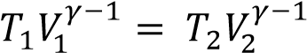
⇨ 293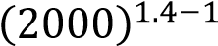 = 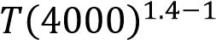
T = 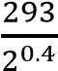 = 222.1K
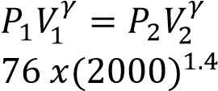
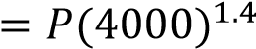
Final pressures under adiabatic condition
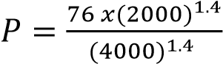= 28.8mmHG

Under isothermal conditions
 = constant
⇨ 28.8 x 4000 = P x 3000
P = 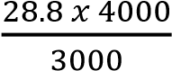 = 38.4mmHg
Hence final temperature and pressure are 222.1K and 38.4mmHg respectively

  - Indicate the two processes on a P-V diagram. (02 Marks)
(The ration of the specific heat capacities of air = 1.4)
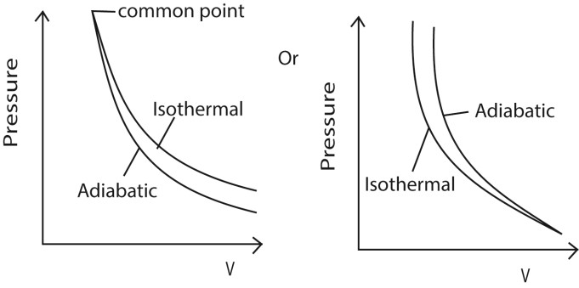
- Show that the work done, W, by a gas in expanding from volume V₁ to V₂ at constant pressure, P, is W = P(V₂ – V₁). (04 marks)

If the piston is moved through a small distance dx, so that the pressure P is constant then
dw = Fdx but F = PA;
=> dw = PAdx; also, Adx = dv

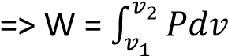
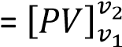
= P(v₂ – v₁)
4. (a) Define the following:
  - Molar heat capacity of a gas at constant pressure. (01mark)
The specific heat capacity of a gas at constant pressure is the heat required to warm unit mass of it by one degree, when its pressure is kept constant.
  - Molar heat capacity of a gas at constant volume. (01mark)
Molar heat capacity of a gas at constant volume is the amount of heat required to raise 1 mole of the gas through1K at constant volume.
- Derive the expression Cp –Cv = R, where Cp is the molar heat capacity of a gas at constant pressure and Cv is the molar heat capacity of a gas at constant volume and R is the gas constant. (05marks)
From dQ = dU + dW……………. (i)
But dQ = C_{p}dT, dU = C_{v}dT and dW= PdV = RdT
Substituting in (i)
C_{p}dT = C_{v}dT + RdT
C_{p} – C_{v} = R
- (i) Differentiate between adiabatic and isothermal expansions. (02marks)
Isothermal expansion occurs at constant temperature.

Adiabatic expansion occurs at no heat input or output in the system.
(ii) State two examples of adiabatic changes. (01marks)
Expansion of a gas in an insulated cylinder. release of air from a pneumatic tire. rapidly pumping air into a bicycle tire.
(d) A fixed mass of an ideal gas of volume 400cm³ at 15⁰C expands adiabatically and its temperature falls to 0⁰C. It is then compressed isothermally until the pressure returns to its original value. If the molar heat capacity at constant pressure is 28.6 J mol⁻¹K⁻¹, calculate the final volume after isothermal compression. (05marks)
Solution

Under adiabatic expansion
Initial temperature = 273 +15 = 288K
Final temperature = 273 + 0 = 273K
Cp = Cv + R = 28.6 + 8.31 = 36.91J
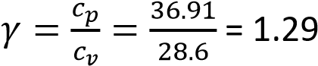
Finial volume (V) under adiabatic condition
⇨ 288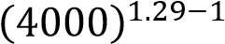 =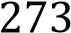 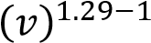
V = 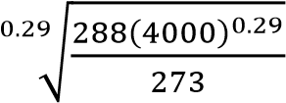 = 4810.2 cm³
Final pressures(P₂) under adiabatic condition
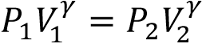
P x (4000)^{1.29} = P₂ x (4810.2)^{1.29}
P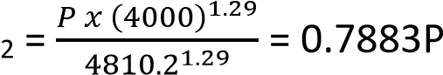
Final volume under isothermal conditions
 = constant
⇨ 0.7883P x 4810.2 = P x v
V = 3,792cm³
Hence final volume = 3.792cm³

(e) (i) What is saturated vapour pressure of a liquid? (01mark)
A saturated vapour is one that is a dynamic equilibrium with its own liquid
(ii) Describe an experiment to show that a liquid boils when its saturated vapour pressure equals to the atmospheric pressure. (04marks)
The setup is shown below

Experiment to show that a liquid boils off when its saturated vapour pressure equals the external pressure
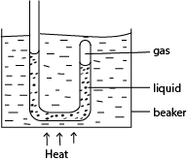
R

- Air is trapped in the closed limb of the tube by water column.
- The tube is heated in water bath.
- When the water bath begins to boil, the water in the tube comes to the same level in each limb.
- This shows that the vapor pressure in closed limb is equal to external pressure
Hence water boils when its saturated vapour pressure is equal to atmospheric pressure.
- (a)(i) What is meant by a reversible process? (02marks)
A reversible process is a process that can proceed in a reverse direction by very small change in conditions making it take place through exactly same steps.
(ii) Distinguish between a saturated vapour and unsaturated vapour. (02marks)
A saturated vapour is one that is a dynamic equilibrium with its own liquid while unsaturated vapour is not in

(iii) Explain why evaporation causes cooling (03marks)
When a liquid vaporizes, it absorbs latent heat of vaporization from the body from which evaporation occurs. Hence the body cools.
  - Describe an experiment to determine the temperature dependence of saturated vapour pressure of water. (07marks)
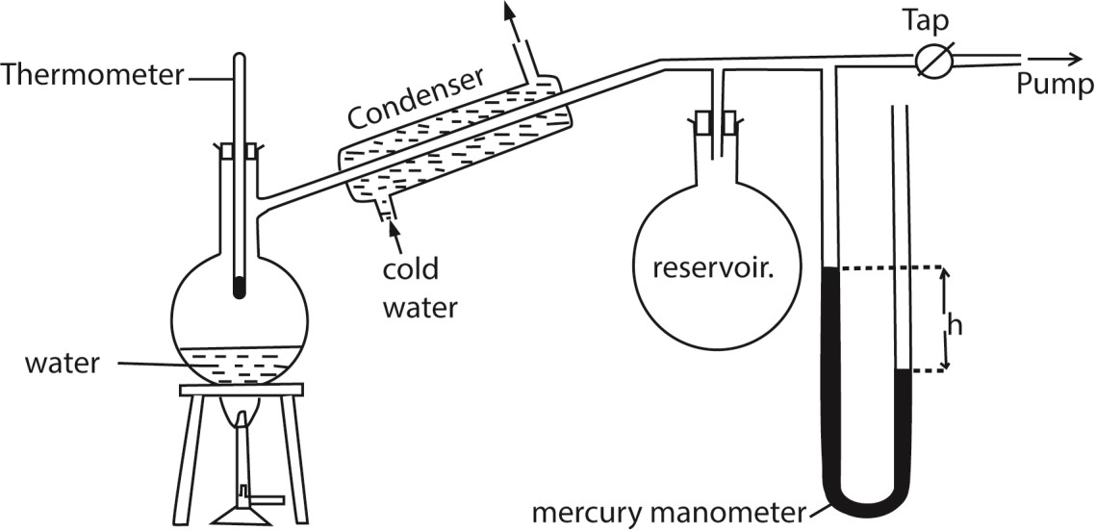
    - The pressure of the air in R is shown by the mercury manometer; if its height is h, the pressure in mm mercury is P = H-h, where H is the barometer height.
    - The tap is opened and the pressure above water varied using the pump to a suitable value.
    - The tap is closed and water in the flask in heated until it boil.
    - The temperature θ and difference in mercury levels, h, are noted and recorded.
    - The saturated vapour pressure, P = (H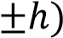 is calculated
    - The procedure is repeated other values of θ and h
    - A graph of P versus θ is plotted and it shows that saturated vapour pressure, P, increases with temperature, θ.

  - (i) State Dalton’s law of partial pressures. (07marks)
Dalton’s law states that the total pressure of a mixture of gases that to not react chemically is equal to the sum of the partial pressure of the components of a gas.

(ii) A sealed container has liquid water, water vapour and air all at 27⁰C. The total pressure inside the container is 69cmHg. When the temperature is raised to 85⁰C, the total pressure changes to 96cmHg. If the saturated vapour pressure of water at 27⁰C is 5cmHg and water vapour remains saturated, calculate the saturated vapour pressure of water at 85⁰C. (05marks)
T₁ = 27 + 273 = 300K
T₂ = 85 + 273 = 358K
Partial pressure at T₁; P₁ = 69-45 = 64cmHg Partial pressure at T₂, P₂ = (96 –P) cmHg
Using 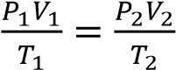 but V₁ = V₂ = V
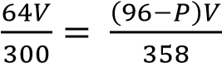
P = 19.63cmHg
- (a)(i) What is meant by boiling point? (01marks)
The boiling point of a liquid is the temperature at which its saturated vapour pressure equals the external pressure.
(ii) Explain why boiling point of a liquid increases with increase in the external pressure.
(05marks)
When the liquid boils its saturated vapour pressure = external pressure and saturated vapour pressure increases with increasing temperature. When external pressure is raised, a liquid will boil at higher saturated pressure which occurs at high temperature.
- Explain how the pressure of a fixed mass of a gas can be increased at
  - Constant temperature (03marks)
By reducing the volume occupied by a gas, the molecules take less time to move between the walls of the container as the distance is reduced. The number of collisions per unit area increases hence pressure increases at constant temperature.
  - Constant volume (03marks)
By heating the gas, the molecules gain more kinetic energy. The molecules will bombard the walls many times per unit time per unit area. The total rate of change of momentum will increase hence pressure will increase
- Sketch a pressure versus volume curve for a real gas undergoing compression (03 marks)
    - Above the critical temperature a gas obeys Boyle’s law.
    - Below the critical temperature a gas exist as unsaturated vapour at low pressure when the pressure is increase it condenses until all the gas is turned into a liquid.
- The cylinder of an exhaust pump has a volume of 5cm³. If it is connected through a valve to a flask of volume 225 cm³ containing air at a pressure of 75cmHg, calculate the pressure of air in the flask after two strokes of the pump, assuming that the temperature of the air remain constant.
First stroke
P₁V₁ = P₂V₂ but V₂ = 225 + 25 = 250cm²
75 x 225 = P₂ x 250
P₂ = 674cmHg
Second stroke
P₂V₂ = P₃V₃
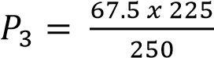= 60.8cmHG
Alternatively
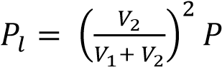 , n = number of strokes
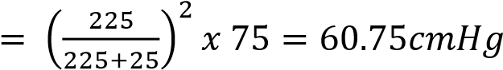
- (a) (i) State Dalton’s law of partial pressures. (01marks)
Dalton’s law of partial pressures states that the total pressure of a mixture of gases that do not react chemically is equal to the sum of partial pressures
(ii) Using the expression p = 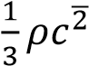, where ρ is the pressure of a gas of density ρ and mean square speed c², derive Daltons law of partial pressures for two gases. (05marks)
P = 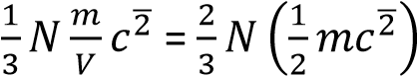
For gas 1, P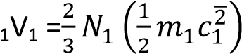
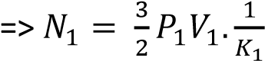
Similarly for gas 2
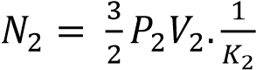
For a mixture of gases, N = 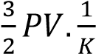; but N = N₁ + N₂
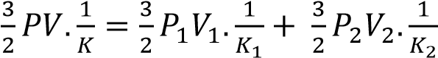
Since temperature is constant, K₁ = K₂ = K
      - PV = P₁V₁ + P₂V₂
      - But V = V₁ = V₂
  - (i) What is meant by isothermal process and adiabatic process. (02marks)
Isothermal process is the expansion or compression of a gas at constant temperature.
Adiabatic process is the expansion or compression of a gas where there is no heat loss or gain into the gas.
    - Explain why adiabatic expansion of a gas causes cooling (03marks)
During an adiabatic expansion of a gas, no heat is supplied to the gas. Molecules strike the receding piston and bounce off with reduced velocities and hence lower kinetic energy. Since kinetic energy is proportional to temperature, the gas cools during the expansion

  - A gas at a temperature of 17⁰C and pressure 1.0 x 10⁵Pa compressed isothermally to half its original volume. It is then allowed to expand adiabatically to its original volume (i) Sketch a P-V curve the above process (02marks)
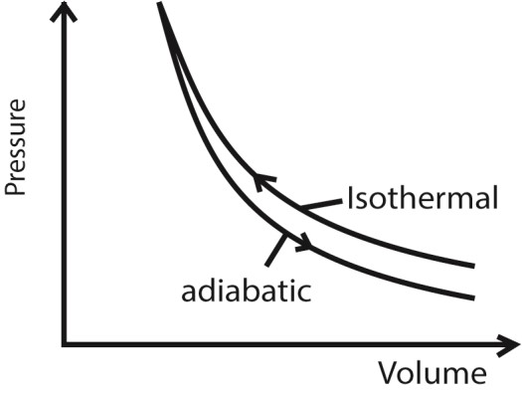
(ii) If the specific heat capacity at constant pressure is 2100Jmol⁻¹K⁻¹ and at constant volume is 1500Jmol⁻¹K⁻¹, find the final temperature of the gas (04marks)
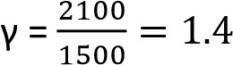
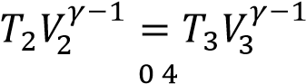
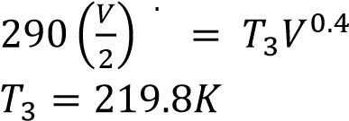
  - (i) What is meant by saturated vapour? (01mark)
A saturated vapour is a vapour in dynamic equilibrium with its own liquid.
    - Explain briefly the effect of altitude on the boiling point of a liquid (02marks)
A liquid boils when its saturated vapour pressure is equal to the external vapour pressure. Atmospheric pressure decreases with increasing altitude, hence the boiling point of a liquid reduces as the altitude increases.
- (a) (i) State two differences between saturated and unsaturated vapours. (02marks)
      - A saturated vapour pressure is one which is in dynamic equilibrium with its own liquid and an unsaturated vapour is one that is not in dynamic equilibrium with its own liquid.
      - A saturate vapour pressure does not obey gas laws whereas unsaturated vapour approximately obey gas laws.
(ii) Sketch graphs of pressure against temperature for an ideal gas and for saturated water vapour originally at 0⁰C (03marks)
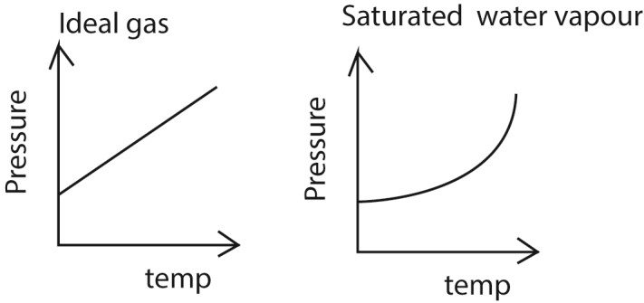
  - The specific heat capacity of oxygen at constant volume is 719Jkg⁻¹K⁻¹ and its density at standard temperature and pressure is 1.429kgm⁻³. Calculate the specific heat capacity of oxygen at constant pressure (04marks)
PV =mrT
r = 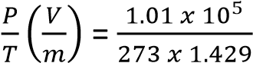 = 258.9Jkg⁻¹K⁻¹
c_{p} – c_{v} = r c_{p} = 719 + 258.9 =977.9Jkg⁻¹K⁻¹
(c) (i) With the aid of a labelled diagram, describe an experiment to determine standard saturated vapour pressure of water. (05marks)

  - The pressure of the air in R is shown by the mercury manometer; if its height is h, the pressure in mm mercury is P = H-h, where H is the barometer height.
  - The tap is opened and the pressure above water varied using the pump to a suitable value.
  - The tap is closed and water in the flask in heated until it boil.
  - The temperature θ and difference in mercury levels, h, are noted and recorded.
  - The saturated vapour pressure, P = (H is calculated
  - The procedure is repeated other values of θ and h
  - A graph of P versus θ is plotted and the saturated vapour pressure at a particular temperature is obtained.
(ii) State how the experiment set up in (c) (i) may be modified to determine a saturated vapour pressure of above atmospheric pressure (01marks)
By replacing the vacuum pump with a bicycle pump
(d)(i) Define ideal gas (01mark)
An Ideal gas s one that obeys Boyle’s law under all conditions
(ii) State and explain the conditions under which real gases behave as ideal gases. (04marks)
  - At higher temperature, the intermolecular spacing increases and intermolecular forces become negligible
  - At very low pressure, the gas occupies negligible volume of the container.
- (a) The pressure, P, of an ideal gas is given by P= 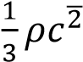, where ρ is the density of the gas and 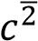 its mean square speed.
  - Show clearly the steps taken to derive this expression (06marks)
Consider a molecule of mass, m, moving in a cube of length, l and velocity, u.
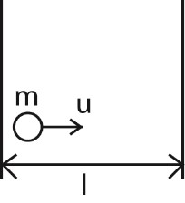
Change in momentum = mu - ⁻mu = 2mu
Rate of change of momentum =
Time, t, between collision = 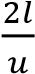
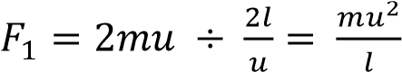
For N molecules, force on the wall,
F = 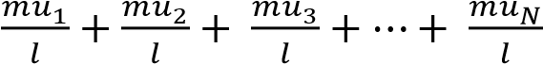
Pressure, P = 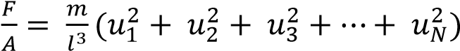 since A = l²
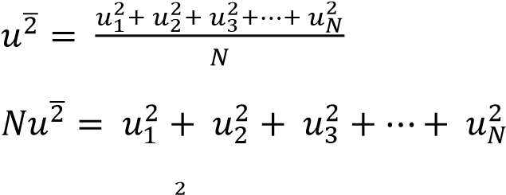
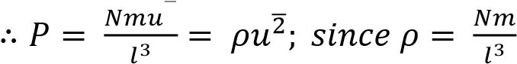
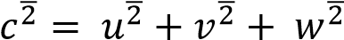 and 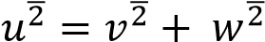
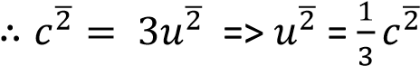
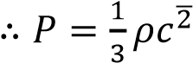
  - State the assumptions made in deriving this expression (02marks)
    - Intermolecular forces of attraction are negligible
    - The volume of the gas molecules are negligible compared to that of the container
    - Molecules make perfectly elastic collision
    - The duration of collision is negligible compared to the time between collisions
    - Sketch the pressure versus volume curve for a real gas for temperatures above and below the critical temperature. (03marks)
      - Above the critical temperature a gas obeys Boyle’s law.
      - Below the critical temperature a gas exist as unsaturated vapour at low pressure when the pressure is increase it condenses until all the gas is turned into a liquid.
    - For 1 mole of a real gas, the equation of state is 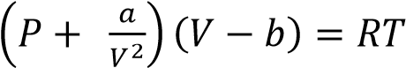
Explain the significance of the terms 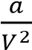 and b. (02marks)
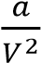- corrects deficit in pressure due to intermolecular attractions of gas molecules b – accounts for the finite volume of molecules themselves.
    - A balloon of volume 5.5 x 10⁻²m³ is filled with helium to a pressure of 1.10 x 10⁵Nm⁻² at a temperature of 20⁰C. Calculate the
(i) the number of helium atoms in the balloon (03marks) From PV =nRT
n = 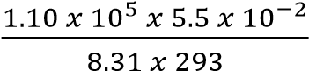 = 2.48 moles
Number of atoms = 2.48 x 6.02 x 10²³ = 1.49 x 10²⁴.
(ii) net force acting on the square meter of material of the balloon if the atmospheric temperature is 1.01 x 10⁵Nm⁻² (04marks)
F = PA
Net force = internal force in the bulb – external force on the bulb
= (1.10 x 10⁵ – 1.01 x 10⁵) x 1.0 = 9.0 x 10³N
- (a) (i) Define saturated vapour pressure. (01mark)
Saturated vapour pressure of a liquid is the pressure exerted by vapour in dynamic equilibrium with its liquid
(ii) Describe with the aid of a diagram, how saturated vapour pressure of a liquid can be determined at a given temperature. (06marks)

    - The pressure of the air in R is shown by the mercury manometer; if its height is h, the pressure in mm mercury is P = H-h, where H is the barometer height.
    - The tap is opened and the pressure above water varied using the pump to a suitable value.
    - The tap is closed and water in the flask in heated until it boil.
    - The temperature θ and difference in mercury levels, h, are noted and recorded.
    - The saturated vapour pressure, P = (H is calculated
    - The procedure is repeated other values of θ and h
    - A graph of P versus θ is plotted and the saturated vapour pressure at a particular temperature is obtained.

- Use the kinetic theory to explain the following observations
  - Saturated vapour pressure of a liquid increases with temperature. (03marks)
If a liquid is in dynamic equilibrium with its vapour, an increase in temperature increases mean kinetic energy of the molecules and hence the rate at which molecules escape from the liquid.
The density of the vapour increases implying increase in the rate of condensation until dynamic equilibrium is restored. There are now more molecules in the vapour phase than previously that are moving faster and hence higher pressure.

  - Saturated vapour pressure is not affected by decrease in volume at constant pressure. (03marks)
A decrease in volume leads to a momentary increase in vapour density. Consequently, the rate of condensation increases while the rate of evaporation rate is constant. When the vapour density reduces, the condensation rate also reduces. So the dynamic equilibrium is restored to the initial value.

- When hydrogen gas is collected over water, the pressure in the tube at 15⁰C and 75⁰C are
65.5cm and 105.6cm of mercury respectively. If the saturated vapour pressure at 15⁰C is
1.42cm of mercury, find its value at 75⁰C (04marks)
P₁= 65.5 – 1.42 = 62.08 and T₁ = 273 + 15 = 288K
P₂ = 105.6 – P, and T₂ = 273 + 75 = 348K
From 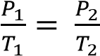
P 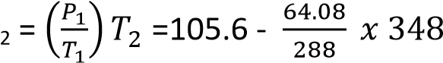= 28.12cmHg

- Explain why the molar heat capacity of an ideal gas at constant pressure differs from the molar heat capacity at constant volume (03marks)
At constant volume, all the heat supplied goes to raising temperature (increasing internal energy of the gas) while at constant pressure, heat is used to raise the temperature of the gas (internal energy) and do external work in expansion to keep the pressure constant. Therefore the molar heat capacity at constant pressure is more than the molar heat capacity at constant volume.
- (a) (i) Define the term specific heat capacity and internal energy and state their units. (03marks)

Specific heat capacity is the amount of heat required to raise the temperature of 1kg mass of a substance by 1K of 1⁰C.
Internal energy is the total of the kinetic energy of atoms and molecules and the parallel potential energy due to mutual interactions of these atoms. Units: joules.

(ii) Why is the distinction between specific heat capacity at constant pressure and that at constant volume important for gases, but less important for solids and liquids? (04marks)
The volume of solids and liquids change very little when heated at constant pressure compared with volume changes for gas for the same temperature changes. Thus solid and liquids do very little work against atmospheric pressure. This implies that there is very little difference in energy when they expand and when they are allowed to expand.

      - Explain why the temperature of a liquid does not change when the liquid is boiling?
(02marks)
When the liquid boils, there is change in a state to vapour and all the heat supplied is used to do work by breaking the molecular bonds of the liquid and overcoming external pressure during the change into a gas. The temperature will not change until all the bonds broken.
      - One kilogram of water is converted to steam at a temperature of 100⁰C and a pressure of
1.0 x 10⁵Pa. If the density of steam is 0.58kgm⁻³ and specific heat of vaporization of water is
2.3 x 10⁶Jkg⁻¹, calculate the
        - external work done (04marks)
Volume of 1kgof steam = 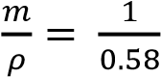 = 1.724m³
Volume of 1kgof steam = 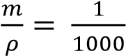 = 0.001m³
Change in volume = 1.724 – 0.001 = 1.723m³
Work = pdV = 1.0 x 10⁵ x 1.723 = 1.723 x 10⁵J
        - internal energy (03marks)
Δu = ΔQ – Δw
= 2.3 x 10⁶ – 1.723 x 10⁵
= 2.13 x 10⁶J
(d) Explain why the specific latent heat of fusion and specific latent heat of vaporization of a substance at the same pressure are different. (04marks)
Change from solid to liquid, intermolecular bonds are weakened and there is a small increase in volume. This implies there negligible change in volume and thus little work done against atmospheric pressure.
During vaporization, a lot of heat is required to break molecular bonds in a liquid and to enable expansion to larger volume of a gas against atmospheric pressure.
- (a) (i) Explain the difference between isothermal and adiabatic expansion of a gas. (02marks)
Isothermal expansion takes place at constant temperature.
Adiabatic expansion takes place at constant heat.
(ii) Using same axes and point, sketch graphs of pressure versus volume for fixed mass of a gas undergoing isothermal and adiabatic changes. (03marks)
    - Show that work, W, done by a gas which expands reversibly from V₀ to V₁ is given by
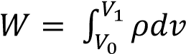(04marks)
If the piston is moved through a small distance dx, so that the pressure P is constant then dw = Fdx but F = PA; => dw = PAdx; also, Adx = dv
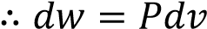
=> W = 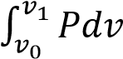
    - (i) State two differences between real and ideal gases (02marks)
Real gas | Ideal gas
Intermolecular force are appreciable | Intermolecular forces are negligible
Volume of molecules compared to the volume of the container is not negligible | Volume of molecules compared to the volume of container is negligible
Obey Boyle’s law at high temperature and very low pressure | Obey Boyle’s law at all temperatures and pressures.

(ii) Draw a labelled diagram showing P-V isothermals for a real gas above and below the critical temperature. (03marks)

        - Above the critical temperature a gas obeys Boyle’s law.
        - Below the critical temperature a gas exist as unsaturated vapour at low pressure when the pressure is increase it condenses until all the gas is turned into a liquid.

(d) Ten moles of a gas, initially at 27⁰C are heated at constant pressure of 1.01 x 10⁵Pa and volume increased from 0.25m³ to 0.375m³. Calculate the increase in internal energy.
[Assume C_{p} = 28.5Jmol⁻¹K⁻¹] (06marks) T₁ = 270C = 300K
Using 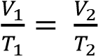
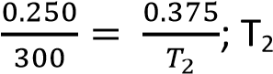= 450K
ΔQ = ΔU + Δw
= 10 x 28.5 x 150 – 10 x 8.31 x 150
= 3.03 x 10⁴J
- (a) (i) state Boyles law. (01mark)
Boyle’s law states that the pressure of a fixed mass of a gas at constant temperature is inversely proportional to the volume of the gas.
(ii) Describe an experiment that can be used to verify Boyles’ law. (06marks)
    - air in the closed limb of a U-tube barometer as shown above
    - mercury is poured to a height, h, and the length of the air column, L is noted.
    - the length h is varied to obtain different sets of values of h and L
    - Pressure of the gas is calculated from P = (H + h)ρg where H= height of barometer corresponding to atmospheric pressure, ρ = density of mercury, g = acceleration due to gravity. Note that h can be positive or negative.
    - If A is the cross section area, V =AL
    - Values of h, L, P, V and 1/V are tabulated
    - A plot of P against 1/V gives a straight line through the origin which verifies Boyle’s law.

(b) Explain the following observations using the kinetic theory.
(i) A gas fills any container in which is it placed and exerts pressure on its walls. (03marks)

A gas contains molecules with negligible intermolecular forces that are free to move in all directions. As they move, they collide with each other and with the walls of the container. The unrestricted movements make them to fill the available space and collisions with the walls contribute to the pressure exerted on the wall.

(ii) The pressure of a fixed mass of a gas rises when temperature is increased at constant volume. (02 marks)
When the temperature of a gas increases, the kinetic energy of the gas molecules increases. This increases the frequency and force of collision against the wall leading to increase in pressure.
(c) (i) What is meant by a reversible process. (01marks)
A reversible process in one that takes place in reverse direction through the same values of pressure, volume and temperature in small changes or steps.
(ii) State the conditions necessary for isothermal and adiabatic processes to occur, (04marks) Isothermal process occurs at constant temperature and therefore the gas must be enclosed in thin walled container of good thermal conductivity placed in a large heat reservoir and occurs slowly enough to allow heat exchange with the surrounding.

Adiabatic process requires no heat input or out and therefore should occur rapidly in well Insulated container like a thermos flask and gas should be ideal.
(d) A mass of an ideal gas of volume 200cm³ at 144K expands adiabatically to a temperature of 137K. Calculate its new volume. (Take γ =1.40)
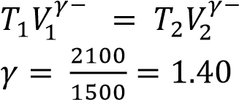
⇨ 144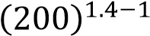 = 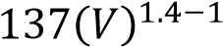
V = 226.5cm³
- (a)
A fixed mass of an ideal gas is confined in a cylinder by frictionless piston of cross section area A. the piston is in equilibrium under the action of force, F as shown in the figure above. Show that the work done, W, by the gas when it expands from V₁ to V₂ is given by 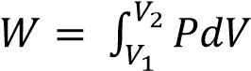(03marks)
Suppose the gas expands by dv so that the piston moves out through a small distance dx.
Work done by the gas, dW = Fdx = PAdx
= Pdv
Total work done during expansion from v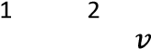 to v is given by
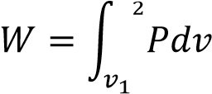
  - State the first law of thermodynamics and use it to distinguish between Isothermal and adiabatic changes in a gas. (05marks)
ΔQ = ΔU + ΔW = nC_{v}ΔT + ΔW
During isothermal expansion, ΔT = 0. Therefore all the energy supplied is equal to the work done by the gas during expansion.
In adiabatic expansion, no heat enters or leaves the gas. Therefore ΔQ = 0 and ΔU = -ΔW. In adiabatic expansion, work s done at the expense of its internal energy. Therefore the gas cools.

  - The temperature of 1mole of helium gas at a pressure of 1.0 x 10⁵Pa increases from 20⁰C to 100⁰C when the gas is compressed adiabatically.
Find the final pressure of the gas. (Take γ =1.67) (04 marks)
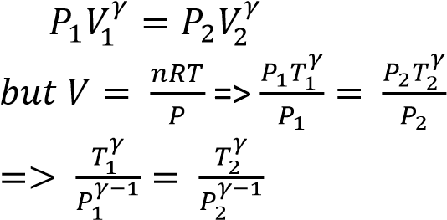
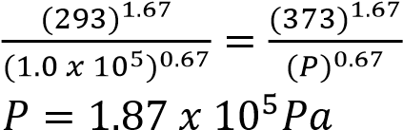

  - With the aid of a P-V diagram, explain what happens when a real gas is compressed at different temperatures. (04marks)
        - Above the critical temperature a gas obeys Boyle’s law.
        - Below the critical temperature a gas exist as unsaturated vapour at low pressure when the pressure is increase it condenses until all the gas is turned into a liquid.

  - The root-mean square speed of the molecules of a gas is 44.72ms⁻¹. Find the temperature of the gas if its density is 9.0 x 10⁻²kgm⁻³ and the volume is 42.0m³. (04marks)
P= 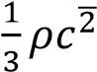
⇨ 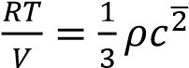
T = = 303.2K
- (a) Define saturated vapour pressure (S.V.P) (01mark)
Saturated vapour pressure in the one in dynamic equilibrium with its own liquid

  - Use the kinetic theory of matter to explain the following observations
      - saturated vapour pressure of a liquid increases with temperature. (03marks)
Increase in temperature increases the kinetic energy of the liquid molecules and the rate of evaporation increases. Therefore the pressure of the vapour rises. As the rate at which the molecules bombard the liquid surface increases, dynamic equilibrium is restored at a higher saturated vapour pressure.
      - saturated vapour pressure is not affected by decrease in volume at constant temperature.
(03marks)
A decrease in volume leads to momentary increase in the density of the vapour. The rate of condensation increases than the rate of evaporation. As the density of the vapour falls the rate of condensation also falls. Dynamic equilibrium is re-established to original values of density and pressure of vapour. Therefore no increase in saturated vapour pressure occurs.
  - Describe how saturated vapour pressure of a liquid at various temperatures can be determined. (07marks)

        - The pressure of the air in R is shown by the mercury manometer; if its height is h, the pressure in mm mercury is P = H-h, where H is the barometer height.
        - The tap is opened and the pressure above water varied using the pump to a suitable value.
        - The tap is closed and water in the flask in heated until it boil.
        - The temperature θ and difference in mercury levels, h, are noted and recorded.
        - The saturated vapour pressure, P = (H is calculated
        - The procedure is repeated other values of θ and h
        - A graph of P versus θ is plotted and the saturated vapour pressure at a particular temperature is obtained.

(d) (i) State Dalton’s law of partial pressures (01mark)
Daltons law of partial pressures states that the pressure of a mixture of gases that do not react chemically is the sum of partial pressures of its components.

(ii) A horizontal tube of uniform bore, closed at one end, has some air trapped by a small quantity of water. The length of the enclosed air column is 20cm at 12⁰C.
Find stating any assumptions made, the length of air column when the temperature is raised to 38⁰C.
[S.V.P of water at 12⁰C and 38⁰C are 10.5mmHg and 49.5mmHg respectively. Atmospheric pressure = 75cmHG] (05marks)
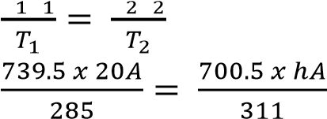
T₁ = 273 + 12 = 285K, T₂ = 273 + 38 = 311K; P₁ = 750 – 10.5 = 739.5mmHg, P₂ = 750-49.5 = 700.5mmHg
h = 23.04cm
Assumption: the tube does not expand when the temperature increases.

- (a)(i) What is meant by isothermal and adiabatic changes? (02marks) Isothermal expansion takes place at constant temperature.
Adiabatic expansion takes place at constant heat.
(ii) Using same axes and point, sketch graphs of pressure versus volume for fixed mass of a gas undergoing isothermal and adiabatic changes. (03marks)
(b) An ideal gas is trapped in a cylinder by a movable piston. Initially it occupies a volume of 8 x 10⁻³m³ and exerts a pressure of 108kPa. The gas undergoes an isothermal expansion until its volume is 27 x 10⁻³m³. It is then compressed adiabatically to the original volume of the gas.
(i) Calculate the final pressure of the gas (06marks) Under isothermal, P₁V₁ = P₂V₂
108 x 10³ x 8 x 10⁻³ = P₂ x 27 x 10⁻³
P₂ = 3.2 x 10³Pa
Under adiabatic, 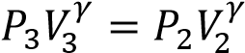
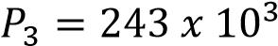 Pa

      - Sketch and label the two stages on a p-v diagram. (02marks)
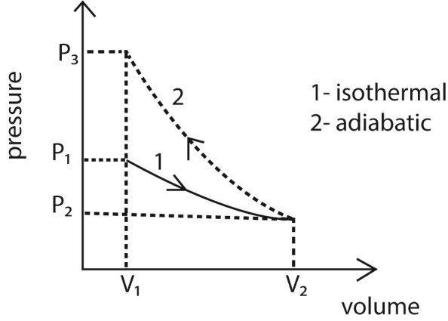
[The ratio of the principal molar heat capacities of the gas = 5:3] (c) (i) Define molar heat capacities at constant pressure. (01mark)

The specific heat capacity of a gas at constant pressure is the heat required to warm unit mass of it by one degree, when its pressure is kept constant.

      - Derive the expression C_{p} – C_{v} = R, for 1mole of a gas (05marks)
From dQ = dU + dW……………. (i)
But dQ = C_{p}dT, dU = C_{v}dT and dW= PdV = RdT
Substituting in (i)

C_{p}dT = C_{v}dT + RdT
C_{p} – C_{v} = R

      - In which ways does a real gas differ from an ideal gas? (02marks)
Real gas | Ideal gas
Intermolecular force are appreciable | Intermolecular forces are negligible
Volume of molecules compared to the volume of the container is not negligible | Volume of molecules compared to the volume of container is negligible
Obey Boyle’s law at high temperature and very low pressure | Obey Boyle’s law at all temperatures and pressures.
- (a) Derive the expression P = 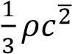 for the pressure, P, of an ideal gas of density ρ and mean square speed, 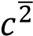. State any assumptions made (07marks)
Assumptions
        - The intermolecular forces are negligible
        - The volume of the gas is negligible compared the volume of the container
        - Collision are perfectly elastic
        - The duration of collision is negligible

Derivation
Consider a molecule of mass, m, moving in a cube of length, l and velocity, u.
Change in momentum = mu - ⁻mu = 2mu
Rate of change of momentum =
Time, t, between collision = 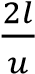
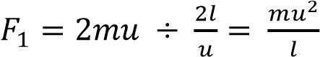
For N molecules, force on the wall,
F = 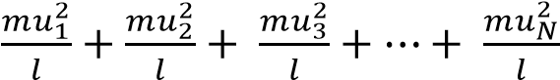
Pressure, P = 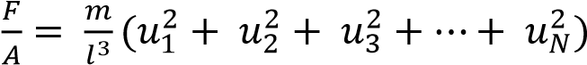 since A = l²
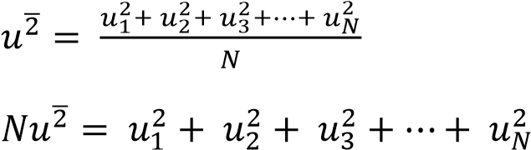
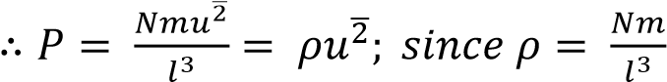
and
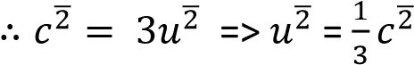
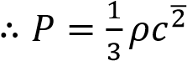

- A gas is confined in a container of volume 0.1m³ at a pressure of 1.0 x 10⁵Nm⁻² and temperature of 300K. If the gas is assumed to be ideal, calculate the density of the gas. (The relative molecular mass of the gas is 32) (05marks) PV = nRT
n = 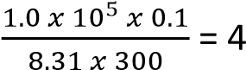
mass of gas, m =nM =4 x 32 x 10⁻³ =0.128kg
Density = 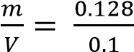 = 1.28kgm⁻³

- What is meant by
  - isothermal change
Isothermal expansion takes place at constant temperature.
  - adiabatic change (02marks)
Adiabatic expansion takes place at constant heat.

- A gas at a pressure of 1.0 x 10⁶Pa is compressed adiabatically to half its volume and then allowed to expand isothermally to its original volume. Calculate the final pressure of the gas.
[Assume the ratio of the principal specific heat capacities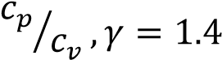] (06marks)
For adiabatic change PV^{γ} = constant
⇨ 1.0 x 10⁶ x V^{1.4}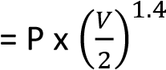
P =2.64 x 10⁶Pa
For isothermal change
PV = constant
2.64 x 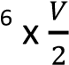10 = PV
P = 1.32x 10⁶Pa

- (a) (i)What is meant by kinetic theory of gases? (03marks)
Gases are composed of molecules which are in continuous random motion. The molecules collide elastically with one another and also with the walls of the container. When heat energy is supplied, their kinetic energy increases.

      - Define an ideal gas (01mark)
An ideal gas is one which exactly obeys Boyles law at all conditions
      - State and explain conditions under which real gases behave like ideal gases. (04mark)

At very high temperature, the intermolecular forces of attraction become negligible.
At low pressure, the volume of gas molecules become negligible compared to the volume of the container.

(b) (i) Describe an experiment to show that a liquid boils only when its saturated vapor pressure is equal to external pressure (05marks)
Experiment to show that a liquid boils off when its saturated vapour pressure equals the external pressure
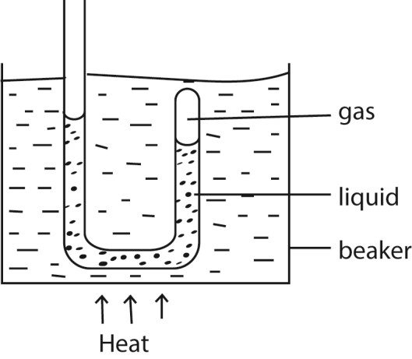
      - Air is trapped in the closed limb of the tube by water column.
      - The tube is heated in water bath.
      - When the water bath begins to boil, the water in the tube comes to the same level in each limb.
      - This shows that the vapor pressure in closed limb is equal to external pressure.

(ii) Explain how cooking at a pressure of 76cm of mercury and temperature of 100⁰C may be achieved on top of high mountains. (03marks)
Cooking pans are fitted with lids that possess safety valves that open when the pressure exceeds 76cmmmHg. During cooking the vapour pressure inside the cooking pan increase and the temperature increases to 100⁰C. The safety valves prevents pressure to exceed 76cmHg and therefore boiling occurs at 100⁰C.
(c) (i) Define root-mean-square speed of molecules of a gas. (01mark)
Root mean square speed of the gas is the average of the square speeds of individual molecules of a gas.
(ii) The mass of hydrogen and oxygen atoms are 1.66 x 10⁻²⁷kg and 2.66 x 10⁻²⁶kg respectively. What is the ratio of the root mean square speed of hydrogen to that of oxygen molecules at the same temperature? (03marks)
From 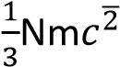 = RT
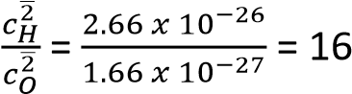
- (a) State the assumption made in the derivation of the expression P = 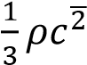 for pressure of an ideal gas (02marks)
      - The intermolecular forces are negligible
      - The volume of the gas is negligible compared the volume of the container
      - Collision are perfectly elastic
      - The duration of collision is negligible

(b) Use the expression in (a) above to deduce Dalton’s law of partial pressures. (03marks)

P = 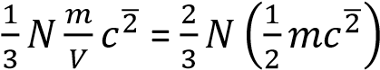
For gas 1, P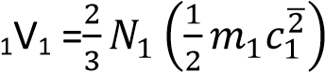
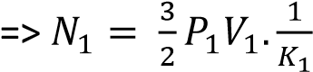
Similarly for gas 2
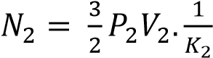
For a mixture of gases, N = 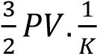; but N = N₁ + N₂
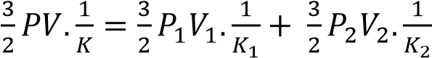
Since temperature is constant, K₁ = K₂ = K
        - PV = P₁V₁ + P₂V₂
        - But V = V₁ = V₂
        - 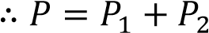

(c) Describe an experiment to determine the saturation vapor pressure of a liquid. (06marks)
  - The pressure of the air in R is shown by the mercury manometer; if its height is h, the pressure in mm mercury is P = H-h, where H is the barometer height.
  - The tap is opened and the pressure above water varied using the pump to a suitable value.
  - The tap is closed and water in the flask in heated until it boil.
  - The temperature θ and difference in mercury levels, h, are noted and recorded.
  - The saturated vapour pressure, P = (H is calculated
  - The procedure is repeated other values of θ and h
  - A graph of P versus θ is plotted and the saturated vapour pressure at a particular temperature is obtained.

- (i) What is meant by a reversible isothermal change? (02marks)

The change taking place at constant temperature and can be taken back from the final to initial states through exactly the same values of pressure and volume at every stage.
(ii) State the conditions for achieving a reversible isothermal change. (02marks)
Use vessels with thin good conducting walls having a frictionless piston, surrounded by constant temperature bath and the process must occur slowly.
- An ideal gas at 27⁰C and at a pressure of 1.01 x 10⁵Pa is compressed reversibly and isothermally until its volume is halved. It is then expanded reversibly and adiabatically to twice its original volume. Calculate the final pressure and temperature of the gas if γ=1.4 (05marks)
For isothermal: P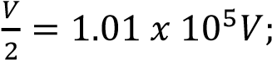 P = 2.02 x 10⁵Pa
For adiabatic; 2.02 x 105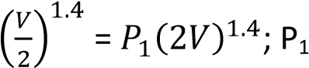 = 2.9 x 10⁴Pa
Final pressure = 2.9 x 10⁴Pa
Also,
TV^{γ-1} = constant.
⇨ 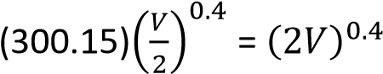; T = 172K
- (a) (i)Explain what happens when a quantity of heat is applied to a fixed mass of a gas (02marks) Heat supplied increase internal energy of the gas and used to overcome external pressure during the expansion.

(ii) Derive the relationship between the principal molar heat capacities C_{p} and C_{v} for an deal gas. (05marks)

From dQ = dU + dW……………. (i)
But dQ = C_{p}dT, dU = C_{v}dT and dW= PdV = RdT
Substituting in (i)
C_{p}dT = C_{v}dT + RdT
C_{p} – C_{v} = R

(b) (i) What is adiabatic process? (01mark)
An adiabatic process is one in which no heat is added or removed from the system.

(ii) A bicycle pump contains air at 290K. The piston of the pump is slowly pushed in until the volume of the air enclosed is one fifth of the total volume of the pump. The outlet is sealed off and the piston suddenly pulled out to full extension. If no air escapes, find its temperature
immediately after pulling the piston. 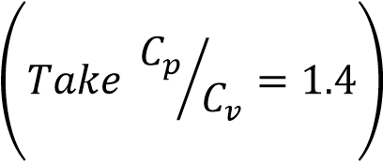 (03marks)
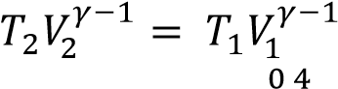
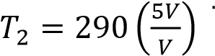= 152K
  - (i) Distinguish between unsaturated and saturated vapors. (02marks)
Unsaturated vapour is a vapour that is not in dynamic equilibrium with its own liquid while saturated vapour is a vapour that is in dynamic equilibrium with its own liquid.

(ii) Draw graphs to show the relationship between pressure and temperature for ideal gas and for saturated water vapour originally at 0⁰C. (03marks)
  - In an experiment, the pressure of a fixed mass of air at constant temperature is 10.4kPa. When the volume is halved, keeping the temperature constant, the pressure becomes
19.0kPa. Discuss the applicability of the above results in verifying Boyle’s law. (04marks)
From PV = constant
Halving the volume ta constant temperature doubles pressure. Since pressure was not doubled, Boyles’s law is not verified.

- (a) (i) State Boyles law. (01mark)
The pressure of a fixed mass of a gas is inversely proportional to volume.
(ii) What is meant by partial pressure of a gas? (01 mark)
Partial pressure is the pressure that would be exerted by a gas if it alone occupied the volume of the mixture.
(iii)
Two cylinders A and B of volumes V and 3V respectively are separately filled with a gas. The cylinders are connected as shown above with the tap closed. The pressures of A and B are P and 4P respectively. When the tap is opened the common pressure becomes 60Pa. Assuming isothermal conditions find the value of P. (04marks)
Solution
From PV = nRT
Moles n₁ of the gas in A before mixing= 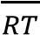
Moles n₂ of the gas in B before mixing = 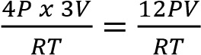
Moles n₃ of the gas when tap is opened = 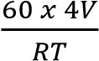
But moles of the gas before mixing = mole of the gas after mixing
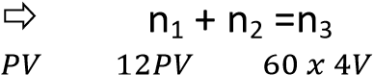
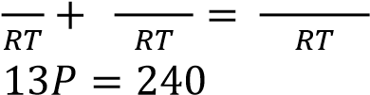
P = 18.46Pa
(b) (i) State three differences between ideal and real gases. (03marks)
Real gas | Ideal gas
Intermolecular force are appreciable | Intermolecular forces are negligible
Volume of molecules compared to the volume of the container is not negligible | Volume of molecules compared to the volume of container is negligible
Obey Boyle’s law at high temperature and very low pressure | Obey Boyle’s law at all temperatures and pressures.

(ii)Sketch a pressure versus volume curve for a real gas undergoing compression below its critical temperature. (01mark)
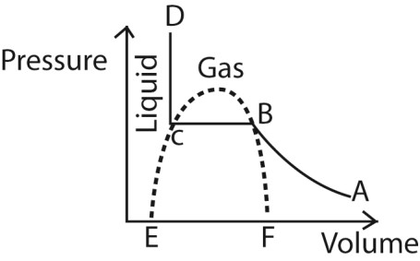
(iii) Explain the main features of the curve in (b)(ii) above (03marks)
- AB represents unsaturated vapour that approximately obey Boyle’s law.
- BC represents saturated vapour, the gas turns into a liquid at constant pressure.
- CD is a liquid, small decrease in volume leads to a big increase in pressure because liquids are incompressible

- Two similar cylinders P and Q contain different gases at the same pressure. When gas is released from P the pressure remains constant for some time before it starts dropping. When gas is released from Q the pressure continuously drops. Explain the observation above.
(05marks)
  - The gas in P is in form of a saturated vapour; that is, in dynamic equilibrium with a liquid. As the gas is released, more liquid turns into a gas to restore pressure until the gas becomes unsaturated and the pressure begins to drop as the moles of the gas decrease
  - The gas in Q is unsaturated, and thus pressure reduces as the moles of the gas reduces up on release.
- Using the expression for the kinetic pressure of an ideal gas, deduce the ideal gas equation of 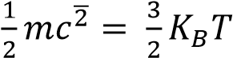(02marks)
Given 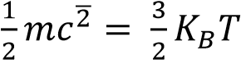
From P = 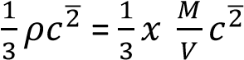
PV = 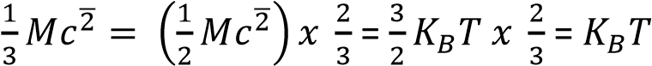 = Constant

TOPIC 7/7: THERMODYNAMICS
Competency: The learner appreciates the behaviour of compressed gas systems in relation to their domestic and industrial applications.
Thermodynamics is the branch of physics that studies the relationships between heat, work, energy, and temperature, governed by four fundamental laws. It explains how energy is transferred and transformed in physical systems, from engines to living organisms

Core Concepts of Thermodynamics
- System & Surroundings: A system is the part of the universe under study; everything else is surroundings.
- State Variables: Properties like pressure, volume, temperature, and internal energy describe the system’s condition.
- Processes: Changes in a system (isothermal, adiabatic, isobaric, isochoric) define how energy and matter interact.
- Equilibrium: A system is in thermodynamic equilibrium when macroscopic properties remain constant over time.

The Four Laws of Thermodynamics
Law | Statement | Key Implication
Zeroth Law | If two systems are each in thermal equilibrium with a third, they are in equilibrium with each other. | Defines temperature as a measurable property.
First Law | Energy cannot be created or destroyed, only transformed. | Basis of energy conservation.
Second Law | Entropy of an isolated system always increases. | Explains irreversibility and efficiency limits of engines.
Third  Law | As temperature approaches absolute zero, entropy approaches a constant minimum. | Sets the absolute zero scale.

Applications of Thermodynamics
- Engineering: Design of heat engines, refrigerators, turbines, and power plants.
- Chemistry & Biology: Explains chemical reactions, metabolic processes, and energy transfer in cells.
- Climate & Earth Science: Models atmospheric processes, ocean currents, and energy balance of Earth.
- Everyday Life: Cooking, heating, cooling, and even the functioning of smartphones rely on thermodynamic principles.

Thermal equilibrium
This is a state of the body in which there is no net flow or exchange of heat within it or between it and its surroundings.

The Zeroth law of thermodynamic
It states that if two bodies are each in thermal equilibrium with a third body, then all the three bodies are in thermal equilibrium with each other.

The principle of conservation of energy
The principle of conservation of energy can be expressed mathematically by the equation
ΔQ = ΔU + ΔW
Where
ΔQ is the quantity of heat given to the system
ΔU is the rise in internal energy, the rise in internal energy is indicated by the rise in temperature
ΔW is the external work done by the system such as expansion against atmospheric pressure.
External work done by expanding gas.
Suppose the gas expands by dv so that the piston moves out through a small distance dx.

Work done by the gas, dW = Fdx = PAdx
= Pdv
Total work done during expansion from v₁ to v₂ is given by
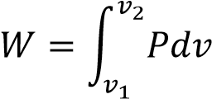

Example 1
When 1.5kg of water is converted to steam at (100⁰C) at standard pressure (1.01 x 10⁵Nm⁻²) 3.39MJ of heat is required. During the transformation from liquid to vapour, the increase in volume of water is 2.5m³.
- Calculate the work done against the external pressure during the process of evaporation. From ΔW = P(V₂ – V₁)
External work done = 1.01 x 10⁵ x 2.5 = 2.53 x 10⁵J

- Explain what happens to the rest of the energy.
The difference in energy is the increase in internal energy of water molecules.
i.e. 3.39 x 10⁶ – 2.53 x 10⁵ = 3.24 x 10⁶J = increase in internal energy of water molecules.

Molar Heat capacities
Definition
Molar heat capacity of a substance is the amount of heat required to raise the temperature of one mole of it by 1K. It is expressed in Jmol⁻¹K⁻¹.
Molar heat capacity at constant volume, c_{v}
Molar heat capacity at constant volume of a substance is the amount of heat required to raise the temperature of one mole of it by 1K at constant volume. It is expressed in Jmol⁻¹K⁻¹.
In a constant volume (isochoric) process, the volume of the system remains fixed, meaning the change in volume (Δ) is zero. Consequently, no work is done by the gas because it cannot expand or contract to move its boundaries (like a piston). Any heat added to the system goes entirely into increasing its internal energy and temperature, which results in an increase in pressure.
Formula: W=−P×0=0
Real-world application of constant volume(isochoric)process (e.g., Gas cooker, welding gas cylinders):
- Sealed gas cylinders represent a nearly constant volume system. The high-pressure gas inside does no work until a valve is opened, allowing it to escape.
- When using a gas cooker heat added increases the temperature and pressure of the contents only with no work done until the valve is opened to allow expansion and escape of gases.
Molar heat capacity at constant pressure, c_{p}
Molar heat capacity at constant pressure of a substance is the amount of heat required to raise the temperature of one mole of it by 1K at constant pressure. It is expressed in Jmol⁻¹K⁻¹.
In a constant pressure (isobaric) process, the pressure of the system remains constant, but the volume is free to change. In this scenario, work is done by the gas as it expands or work is done on the gas as it is compressed. Part of any heat added is used for this expansion work, and the rest changes the internal energy of the gas.
Formula: =−Δ (where P is pressure and Δis the change in volume)
Real-world application constant pressure (isobaric) process (e.g., Compressors for refrigerators/ACs):
- Refrigerators and air conditioners work is done by the compressor on the refrigerant gas to decrease its volume and increase its pressure as part of cooling cycle. o Inflation of a balloon does work against external atmospheric pressure o Gas cylinder, work is done when filling gas cylinders because it involves compression/decrease in volume of a gas but increase in pressure. o Gas compressors do work when the turn a gas into a liquid which involves a descrease in volume but increase in pressure
The relationship between the principal molar heat capacities C_{p} and C_{v} for an deal gas.
From dQ = dU + dW……………. (i)
But dQ = C_{p}dT, dU = C_{v}dT and dW= PdV = RdT
Substituting in (i)

C_{p}dT = C_{v}dT + RdT
C_{p} – C_{v} = R
Where R is the universal gas constant per unit mass.

Example 2
The temperature of 1mole of helium gas at a pressure of 1.0 x 10⁵Pa increases from 20⁰C to 100⁰C when the gas is compressed adiabatically.
Find the final pressure of the gas. (Take γ =1.67) (04 marks)
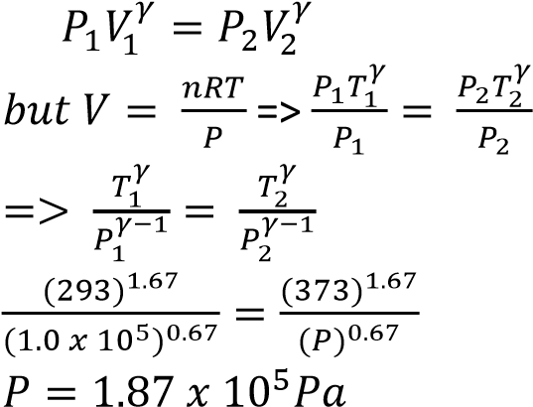

Example 3
Nitrogen gas is trapped in a container by a movable piston. If the temperature of the gas is raised from 0⁰C to 50⁰C at constant pressure of 4.0 x 10⁵Pa and the total heat added is 3.0 x 10⁴J, calculate the work done by the gas. [The molar heat capacity of nitrogen at constant pressure is 29.1Jmol⁻¹K⁻¹, C_{p}/C_{v}= 1.4]

ΔQ = ΔU + Δw ……………………. (i)
Cv = 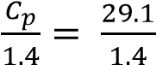 = 20.79Jmol⁻¹ ΔQ = nC_{p}ΔT
n = 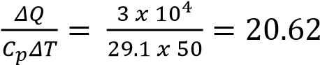
From equation (i)
3 x 10⁴ = 20.62 x 20.79 (50-0) + Δw Δw = 8.57 x 10³J

Example 4
Ten moles of a gas, initially at 27⁰C are heated at constant pressure of 1.01 x 10⁵Pa and volume increased from 0.25m³ to 0.375m³. Calculate the increase in internal energy.
[Assume C_{p} = 28.5Jmol⁻¹K⁻¹] (06marks) T₁ = 27⁰C = 300K
Using 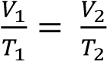
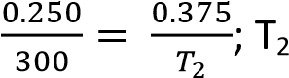= 450K
ΔQ = ΔU + Δw
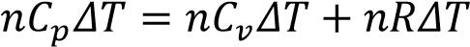
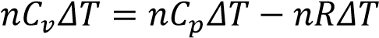
= 10 x 28.5 x 150 – 10 x 8.31 x 150
= 3.03 x 10⁴J

Example 5
An ideal gas at 18⁰C is compressed adiabatically until the volume is halved. Calculate the final
temperature of the gas. [Assume specific heat capacities of the gas at constant pressure and volume are 2100Jkg⁻¹K⁻¹ and 1500Jkg⁻¹K⁻¹] respectively. (04marks)
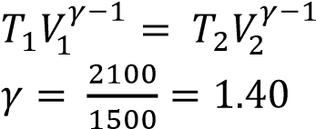
⇨ 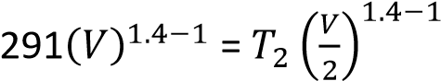
T₂ = 384K

Isothermal and adiabatic changes
Isothermal expansion takes place at constant temperature.
Adiabatic expansion takes place at constant heat.
Sketch graphs of pressure versus volume for fixed mass of a gas undergoing isothermal and adiabatic changes.
Condition necessary for realization of an isothermal change
- The gas must be held in thin-walled and highly conducting vessel
- The process must take place slowly so that heat pass into the gas to maintain constant temperature.
- The gas vessel must be surrounded by a constant temperature bath.
Conditions for adiabatic change
- The gas must be held in a thick walled and poorly conducting vessel
- The process must be carried out rapidly to minimize heat linkage through the walls.

Relationship between volume, pressure and temperature
  - For reversible isothermal change
PV = nRT where n is the number of mole of gas, R = gas constant
  - For reversible adiabatic change
Pv^{γ} = constant
TV^{γ-1} = constant

Example 6
Ten moles of a gas, initially at 27⁰C are heated at constant pressure of 1.01 x 10⁵Pa and volume increased from 0.25m³ to 0.375m³. Calculate the increase in internal energy.
[Assume C_{p} = 28.5Jmol⁻¹K⁻¹] (06marks) T₁ = 27⁰C = 300K
Using 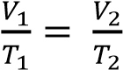
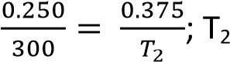= 450K
ΔQ = ΔU + Δw
= 10 x 28.5 x 150 – 10 x 8.31 x 150
= 3.03 x 10⁴J

Example 7
An ideal gas at 18⁰C is compressed adiabatically until the volume is halved. Calculate the final
temperature of the gas. [Assume specific heat capacities of the gas at constant pressure and volume are 2100Jkg⁻¹K⁻¹ and 1500Jkg⁻¹K⁻¹] respectively. (04marks)

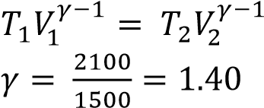
⇨ 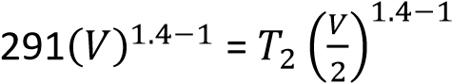
T₂ = 384K

Example 8
State the first law of thermodynamics and use it to distinguish between Isothermal and adiabatic changes in a gas. (05marks)
ΔQ = ΔU + ΔW = nC_{v}ΔT + ΔW
During isothermal expansion, ΔT = 0. Therefore all the energy supplied is equal to the work done by the gas during expansion.
In adiabatic expansion, no heat enters or leaves the gas. Therefore ΔQ = 0 and ΔU = -ΔW.
In adiabatic expansion, work s done at the expense of its internal energy. Therefore the gas cools.

Example 9
- (i) What is meant by isothermal process and adiabatic process? (02marks)
Isothermal process is the expansion or compression of a gas at constant temperature.
Adiabatic process is the expansion or compression of a gas where there is no heat loss or gain into the gas.
(ii) Explain why adiabatic expansion of a gas causes cooling (03marks)
During an adiabatic expansion of a gas, no heat is supplied to the gas. Molecules strike the receding piston and bounce off with reduced velocities and hence lower kinetic energy. Since kinetic energy is proportional to temperature, the gas cools during the expansion

- A gas at a temperature of 17⁰C and pressure 1.0 x 10⁵Pa compressed isothermally to half its original volume. It is then allowed to expand adiabatically to its original volume
  - Sketch a P-V curve the above process (02marks)
  - If the specific heat capacity at constant pressure is 2100Jmol⁻¹K⁻¹ and at constant volume is
1500Jmol⁻¹K⁻¹, find the final temperature of the gas (04marks) γ = 